Burgundy

Brigade

Handbook

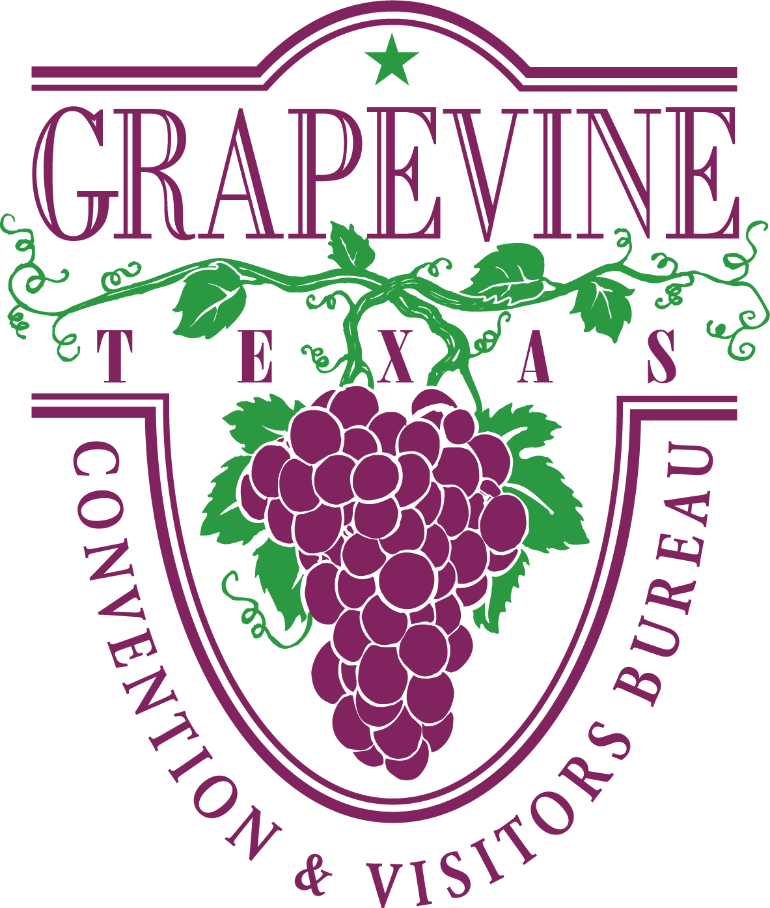

October 2024**GRAPEVINE CVB’S MISSION STATEMENT**:

The Convention & Visitors Bureau acts as the promotional arm of the City of Grapevine and is responsible for actively selling, marketing and publicizing Grapevine globally. The Bureau promotes the city’s hotels, meeting facilities, historic and family attractions, festivals and events, dining establishments and retail businesses to the group meetings and leisure markets.

**GRAPEVINE CVB’S BRAND PROMISE**

Grapevine is the premier destination city in North Texas. We offer visitors a unique blend of historic Texas heritage, combined with contemporary amenities. Whether in Grapevine for business or pleasure, visitors will find world-class hotels, excellent dining options, abundant live entertainment, diverse retail shopping, historic and family attractions and internationally award-winning festivals, all delivered with the finest in Texas hospitality.

**BURGUNDY BRIGADE MISSION STATEMENT:**

As members of the Burgundy Brigade Registration Assistance Team, our goal is to fulfill the Grapevine CVB’s mission statement. In addition, we are an extension of the hotel staff and meeting planner(s) whom we serve, as well as ambassadors for the City of Grapevine. Our actions must be beyond reproach, at all times.

MCj04350450000[1]

WELCOME!

**TABLE OF CONTENTS**

MCj04135520000[1]

* **BURGUNDY BRIGADE’S ROLE: Pages 4-6**
* **HUMAN RESOURCES: Pages 7-14**
* **KIOSK/CONCIERGE TABLE: Page 15-17**
* **SAFETY & OTHER ITEMS: Page 18-21**
* **GRAPEVINE HOTEL INFORMATION: Pages 22-31**

**-KNOW YOUR HOTELS**

* **HELPFUL WEBSITES: Page 32**

**The Burgundy Brigade’s Role**

The Burgundy Brigade is a vital link between meeting planners, convention delegates, exhibitors, visitors, hotels and the City of Grapevine. Often, the Burgundy Brigade may be the one contact that a visitor has with Destination Grapevine. We are hospitality specialists who serve in different capacities and extend the hand of friendship to our visitors while being an extension of the organization that hires our team.

The Burgundy Brigade offers individuals a wide-variety of tasks that change from day-to-day and group to group.

**Know Your Job**

The Burgundy Brigade’s position is to be on board to take direction for a plan that the meeting planner has spent months, or maybe years designing for their convention, meeting or event. In other words, we are foot soldiers. It is important to refrain from critiquing or evaluating how the meeting could work better. Since we do not know any of the behind the scenes goals, functions or budgets that must be achieved, input from us is inappropriate.

We are not working in executive positions nor are we the research & development consultants. If there is a problem within the meeting, we are only slowing down the process by making the meeting planners listen to our unsolicited brainstorming. In the past, each of us may have had jobs where we were the movers & shakers. However, the Burgundy Brigade position is not that job. Our job is to perform the tasks that have been outlined on our schedule; ready to be a second pair of hands.

**DO**:

* …Be ready to be trained and learn our client’s way. Be flexible, be focused, hospitable and have fun.
* …Be personable – the host/hostess with the mostess.
* …Be positive, about Grapevine and everything…at all times. You never know with whom you are speaking.
* …Read every issue of Grapevine Today as it has comprehensive and pertinent information.
* …Review and be knowledgeable about our CVB web site: [www.GrapevineTexasUSA.com](http://www.GrapevineTexasUSA.com).
* … Review the BB microsite for upcoming groups, press releases and important news. [www.GrapevineTexasUSA.com/Burgundy-Brigade](http://www.GrapevineTexasUSA.com/Burgundy-Brigade)
* …Treat the delegates and meeting planning staff as if they are guests in your home. Tell them about Grapevine’s history, landmarks and favorite places. Share your enthusiasm for Grapevine with them.
* …Be helpful. Go above and beyond to provide extraordinary service, without putting yourself in harm’s way.
* …Tell our guests about the Grapevine Visitors Shuttle (for shopping, dining and entertainment only, **NOT** for airport transfers) and other transportation options, i.e. Gaylord’s Executive SUV service, Hertz, etc. Some hotels offer complimentary airport transportation and complimentary shuttle service within a designated distance of their property.
* …Tell our guests about the Shop, Wine & Dine Grapevine rack card.
* …Tell our guests about hotel services (business center, restaurants, other services, etc.)
* …Tell our guests about Grapevine’s Kiosks (at Gaylord) two locations hotel front lobby servicing Vineyard Tower meetings/guests and Convention Center (adjacent to Fed-Ex Office). Concierge Table provided upon request at other hotels, if applicable. NEVER RECOMMEND a specific restaurant or business. Offer suggestions in the category and price range that interests the guest. Additional information is available in the information book to help guests with their decision.

Your job is to satisfy the guest’s need with services provided within the city limits of Grapevine. As Ambassadors of the City of Grapevine, our job is to ensure a return on investment (ROI) to those businesses that are in Grapevine.

* …Watch your body language: Smile…even if your hair is on fire!

* …Learn when to speak and when to refrain from speaking.
* …Be a good worker, a great plan follower, a gracious and knowledgeable Ambassador for Grapevine. Most of all, be a good friend: one who refrains from giving unsolicited advice especially during the trying moments.
* …Attend all training classes i.e. Destination Grapevine, Workplace Standards etc. as required by the City and/or CVB.

**DO NOT**:

* …Think of better ways to organize the meeting.
* …Interrupt or be overzealous. Listen carefully to the client’s explanation and ask only relevant questions after receiving instructions.
* …Change a procedure because you think there is a better way. A meeting planner has a reason for asking that a job be executed in a certain manner, which is not always evident to our team.
* …Discuss the last good or bad meeting.
* …Give your executive advice from a previous job.
* …Discuss how planners or participants look or dress.
* …Ever hint that you desire anything (working tools, promotional items, food, etc.) provided for the delegates.
* …Take sides or discuss “inner conflicts” among the planners. Always remain neutral.
* …Protest or expect to remain on the job if you are released early. Schedules are subject to adjustment. The person with the most hours or overtime hours should be first to volunteer to leave early.
* …Discuss politics, sex or religion – ever.
* …Use cell phones while on the job unless you are assisting a guest. Cell phones are to be turned on vibrate mode during your assigned shift. Check your messages **during breaks only**.
* …Gossip. It is unacceptable. Keep your personal comments regarding other Burgundy Brigade members out of the workplace. If it is an issue that requires discussion, please contact David or Human Resources.

**HUMAN**

**RESOURCES**



**Human Resources**

Burgundy Brigade staff is classified by the City of Grapevine as ‘casual’ or ‘as-needed’ employees. This means that all legally-mandated benefits i.e. workers’ compensation, Employee Assistance Program (EAP) are extended. However, this position is not eligible for city sponsored benefit programs. A casual employee may work up to 999 hours within a year which begins on January 1. **Each member of the Burgundy Brigade is expected to work at least 150 hours per year. Please visit with us if you are not able to make this commitment.**

**PRE AND POST ASSIGNMENT ACTIVITIES**

**Training**

Orientation will be provided as well as a guided tour of the Gaylord Texan Resort. All training will be “on the job” training. You will be assigned with a more experienced staff member for a minimum of five jobs.

**Required Training**

At times it will be mandatory for you to complete training that is require by the City of Grapevine i.e. Work Place Standards or other types required training. You will be required to clock in and out when you start and finish the training. A comment code will be provided in advance for you to enter in Paycom.

**Communication**

Email is the primary and most effective method of communication when working with a staff as large as the Burgundy Brigade. Please be sure to check your email **daily** since it is the Burgundy Brigade’s lifeline. It is also wise to check your spam folders as sometimes emails are mysteriously redirected to spam.

**Texting**

Used in most cases for last minutes job request or possible Paycom action needed items. Your cell phone provider is needed in order to set this up. If you change your cell phone provider, please let us know, so there is no interruption in receiving text.

**Scheduling**

Be sure to promptly submit your availability when it is requested. It is our goal to fairly distribute the work opportunities. Individuals who have submitted their schedules will be contacted first for positions. Everyone needs to submit their availability whether they are available or not.

You will be contacted **primarily via email** about an assignment. **Be sure to reply within 24-48 hours**. If a response is not received within 48 hours, the opportunity will be offered to another team member. If time is of the essence, you will be given a response deadline. If your ability to fulfill a shift is in question, please do not accept the assignment**.**

When last minute staffing requests are received, an email blast and/or text message will be used to communicate the request. Since time is of the essence, it may be filled based on who responds first. Calls to individual members will be the last resort.

For larger groups we may ask for your availability to hold certain dates well in advance of the 6-week staffing time frame. If we do, and you say you are available, we ask that you keep your commitment (unless an unforeseen emergency arises) since we are making a commitment to the group that we have the available staff to fill their requested shifts.

If you have accepted an assignment and have not received your work confirmation

at least 3 days prior to your assignment (unless it was a last-minute request) contact whomever requested you to work it, either Betty Torres at 817.410.3538 or Lauren Price at 817-410-3121. Never assume you are working or not working an event if you have not received your confirmation. Always expect a confirmation email with full assignment details.

If you accept an assignment and it is canceled, you will be notified by either email, text to check your email or phone/voice message depending on how far out it is. **A reply back is required, to ensure you received the cancellation**. If the planner cancels your shift 48 hours or less, you will be paid the 4-hour minimum**.** We will add this as a unit to Paycom, which you will need to approve. See Paycom Handbook.

**Canceling Your Shift**

If you are unable to fulfill your commitment to work your shift, please provide as much advance notice as possible in order to find a replacement.

Canceling your shift24 hours or less outside of normal office hours, Saturday, Sunday or holidays:

* **DO NOT SEND AN EMAIL - You must text first, if no reply follow-up with a call***.*Please refer to your confirmation for contact/phone information for specific instructions on whom to contact and what order.

Canceling your shiftduring normal business hours, Monday-Friday, 8 a.m.- 5 p.m. (excluding holidays):

* 24 hours or less **- you must call** whomever appears first on your work confirmation.
* If more than 24 hours - you can email or call. If emailing the subject line must stand out i.e.: **Cancel Shift for XYZ for June 21 & 22**
* If you can’t reach Betty or Lauren then contact David.

**NOTE:** **In all cases, it is your responsibility to follow-up with us to ensure we received your voice message and or email.**

Running late or sick

If you are running late for your shift or are sick on the **day of your** **shift, YOU are to call the meeting planner,** listed on your work confirmation to let them know your expected time of arrival. If you are sick, please ask the planner if a replacement is needed and if so, follow the instructions on your work confirmation on whom to contact.

**Overtime Policy**

The City of Grapevine work week begins on Sunday and ends on Saturday. Hours worked over 40 including any CVB or City assignments during that week is overtime. Overtime is not permitted without approval in advance of the occurrence. **It is important that you know the total number of hours that you are scheduled to work within a week (sum of all assignments that week).**

If a planner asks you to stay, causing you to incur overtime, then the planner must agree to pay the overtime. If you worked other jobs during the same week (Sun.-Sat.) those hours must be considered if you are being asked to extend your shift. If this is the case and by extending your shift puts you into overtime, please let them know the overtime rate will apply. If they approve, document it in Paycom in the comments section: name of the planner who authorized the overtime, with date and time you were asked to extend to. If there are any concerns regarding this procedure/policy, please follow procedure on who to call on your work confirmation.

When scheduling, the hours of each team member are tracked to avoid overtime. **However, it is your responsibility to know your schedule and to avoid overtime.**

Prior approval is not needed if the request to stay longer does not put you into overtime or if the planner is willing to pay overtime. A note in Paycom as described above is still required. If you cannot stay as requested, politely tell the meeting planner that you have other commitments and are unable to stay. Be gracious. Avoid any abrupt or curt tones.

Sometimes groups are willing to pay overtime in order to keep the same people. In this case, if the planner asks for volunteers to leave early, those people that have overtime should be the first to offer to leave.

**Paycom**

Please see Paycom Handbook – Show Me How.

**ON THE JOB - PREPARING FOR YOUR ASSIGNMENT DAY(S)**

Preparation means that you are physically and mentally ready to work. Once you accept the assignment, please be prepared to work. While the Burgundy Brigade works in the hospitality industry which naturally creates a social environment, the client, guests and work come first. Socializing is for breaks and personal time.

**Review your paperwork…**

**Read the email** that is sent with your schedule/work confirmation it contains important information about your assignment. Review your schedule when received to verify the day(s) and time you are to report to work.

**The Day of…**

* **Be sure to have yourself well-nourished before you start your day**. You should be prepared to work five (5) hours before expecting a 15-minute break. If the onsite contact or their designee asks you to take a break sooner or later than you would prefer, please accept their request graciously and abide by their meeting schedule.
* **Check your email prior to leaving for your shift.** Last minute shift changes may be communicated later in the evening, so always a good idea to check your email.
* **Always arrive at the work location at least 15 minutes before your shift begins**. This is to allow extra time for unexpected “Red Flag” days, heavy traffic or other unexpected occurrences. You must be in place and ready to start at the designated time on your schedule. You can clock in 5 minutes prior to your scheduled start time. You should always wait for the planner (first day only) to get there before you go behind the counter and start working. **Never** dismiss the security guard.
* **Know where to check-in**. Your schedule states your designated area and

on-site contact’s name and cell phone number. You have officially reported for your assignment once you have checked-in with the on-site contact. Present yourself. If you are having difficulty finding the on-site contact, call their cell phone, or find a hotel staff member and ask them to help you. Do not expect the on-site contact to look for you. We are proactive not reactive.

* **Be ready to find your position and task for the assignment**. Visit with other team members before arriving at the work area. It is not appropriate to visit with other work buddies while on task. If you need to “catch-up” call your friend the day before, get together for lunch the week before or meet before your shift starts. While our team enjoys each other’s company, it needs to be done on your own time, and not on the client’s or CVB’s dollar.
* **Break and meal policy (this is a guideline)**
  + ▪ 5 hours: one 15-minute break
  + ▪ 6 hours: one 30-minute break
  + ▪ 7-8 hours: one 15-minute break and one 30-minute meal break
  + ▪ 9 hours: two 15-minute breaks and one 30-minute meal break
  + ▪ 10 or more hours: two 15-minute breaks and two 30-minute meal breaks
  + *NOTE: Vineyard Tower assignments at Gaylord receive a 40-minute meal break to allow time to and from Gaylord’s employee cafeteria. 15-minute break remains the same.
* Staff may not partake in delegate coffee breaks in any public areas, meeting

rooms, etc. even if the client offers. This is because the Burgundy Brigade is an extension of the hotel/facility staff. If invited, staff may partake in coffee breaks in the client’s private office or break area.

* All groups receive our break and meal policy information. The planner is

told that our staff relieves each other for breaks and staggers the time they go

during **non-peak times** only, to ensure appropriate coverage at all times.

However, if an organization has a different arrangement on how to handle

breaks, we have asked them to let you know onsite. You cannot take your

break at the end and leave early.

* Always be considerate of your co-workers by returning from your breaks on time. Before leaving, confirm your return time with your co-workers. Do not stay beyond your committed time as others are waiting for your return. If a meeting planner is so kind as to invite you into a private staff area to lunch, please stay within your timeframe. If needed, the bathroom break is to be scheduled inside the meal break period. This applies to all meals, in all areas.
* Do not eat or drink in public. Water is ok, if authorized by the on-site contact. Be sure to keep the water out of sight and out of the way since you may be working around electrical equipment. Use your discretion. If water is delivered to you, please be discreet.
* Supervisors – supervision is provided primarily by each organization’s on-site contact. When an organization insists on a supervisor, one will be designated to be the planner’s single-point-of contact.

On occasion, an onsite contact may designate one of our staff to be the point of contact after the program begins. In either case, please be respectful of your co-worker who has been appointed this position, and give them your full support as they have been asked to handle a directive from the planner.

* Gifts/convention promotional items – occasionally, a meeting planner may give you promotional items. For security purposes and to protect you, be sure to obtain the meeting planner’s business card and note stating that the item was given to you as a gift.
* Excess convention materials at the end of the meeting – occasionally, convention bags or other premiums are left over at the end of the meeting. The shipping expense often exceeds the value of the items. In some cases, the meeting planner is interested in donating the items to a local charity (i.e. GRACE, GCISD, etc.) and ask if our staff will facilitate the donation. Get a detailed note from the meeting planner stating they are donating these goods to a local charity. The note should include their name, title and cell phone number in case Gaylord security personnel has questions. Bring the items through the convention center security exit and meet your party there to load the donations (or load them in your own vehicle to be dropped off to the charity). Do not take the items through the guest hotel entrance.

**REGISTRATION ASSISTANT-UNIFORM AGREEMENT**

Burgundy Brigade has a uniform that is professional and makes our team easily identifiable to meeting planners, delegates and hotel staff. You will be asked to sign a form agreeing to the below as part of your onboarding.

* Standard Uniform: Burgundy blazer, long-sleeved white collared shirt, black or navy slacks or skirt, dark-colored (black, brown or navy) shoes –comfortable, closed toed, good condition and Grapevine CVB Gold name badge.
  + The official uniform is as follows:
  + Burgundy blazer (provided). Black is acceptable, until one is provided for you.
  + A long-sleeved white and a long sleeve black collared shirt. Collarless shirts/blouses/polos acceptable when specified by the client (no t-shirts). All shirts must be nicely pressed.
  + Black or navy slacks or skirt
  + Dark-colored (black, brown or navy) shoes –comfortable, closed toed, good condition.
  + Grapevine CVB Gold name badge (provided)
  + CVB staff polo shirt (provided)
  + Khaki slacks
* You will be issued (1) burgundy blazer and (1) CVB staff polo shirt you must sign for. Upon termination or resignation your last paycheck will be held until you return your blazer, CVB staff polo shirt, name badge and business cards. Blazers should be dry cleaned before returning it. If you lose any of the provided items, you will be required to replace it at your own expense.
* Employees are responsible for obtaining their own shirts (excluding CVB staff polo shirt) pants, and shoes.
* No substitutions (different colored shirts or slacks) in the dress code will be allowed.
* No jewelry on jackets except for a Grapevine cloisonné lapel pin, name badge or button(s) that you may be asked to wear while working a convention.
* Men do not have to wear ties unless the planner requests you to do so.
* The blazer is to remain on at all times, if possible. If taken off, your name badge should be worn on your blouse/shirt.
* Casual attire-nice jeans or khakis are acceptable provided the planner has approved. If approved, the information will be included on your confirmation email or detailed schedule. Crop pants, capris or open-toed-shoes are not acceptable.
* The Burgundy Brigade uniform is required for all jobs, unless otherwise noted.
* All attire is to be neatly pressed.

**GAYLORD** **KIOSK & CONCIERGE TABLE**

**Kiosks:** HotelFront Lobby = Leisure Guests or Vineyard Tower Groups

Adjacent to FedEx Office = Convention Center Groups

**When working the kiosks**–being attentive to your surroundings is important. When people are in the vicinity, staff must be standing and ready to assist. Walk outside of the kiosk to engage guests in conversation and show that you are interested in helping them. **Sitting is only allowed when no one is in the vicinity and only behind the kiosk**. NEVER recommend a specific restaurant. Guide the guest based on their preferred type of food and their budget. Let us know how the shift went by filling out the “Daily Kiosk Checklist.”

**Restocking**: Bankers’ boxes / dividers have been added in the cabinets underneath both kiosks that have a supply of organized brochures! Please look here for additional brochures if the bins are low. Please make sure **before and after** your shift you restock the bins. For any inventory that is low or depleted, please see “**Additional CVB Brochures**” section below on how to request.

Please make sure personal books and magazines etc. are not to be left in the kiosk. Materials unrelated to kiosk or information desk operations are to be discarded at the end of the shift. Any non-Grapevine information can be discarded (items magically appear!).

**Additional CVB Brochures**: The two visitor and convention services kiosks are stocked once per week or as needed based on demand.

If brochure inventory in the kiosk you are working is low or depleted please email [LDalton@GrapevineTexasUSA.com](mailto:LDalton@GrapevineTexasUSA.com) as soon as possible. Please check racks to make sure you have the most up to date publications. It can take up to one week to schedule a brochure delivery, so please don’t wait till stock is depleted, make note and email Lisa Dalton when inventory is low. This prevents emergencies and helps streamline the brochure distribution team efficiencies.

The Grapevine Visitor Information Center Concierge Desk telephone is 817-410-3189 and email is [GVMVC@GrapevineTexasUSA.com](mailto:GVMVC@GrapevineTexasUSA.com), if you have any questions, please do not hesitate to contact one of our professional concierges, they are a tremendous resource and available to help you.

**Brochures obtain the following items from Gaylord:**

\***Know Your Stuff (KYS)**– Pick up at security entrance. Please make sure you destroy at the end of the day since the information is confidential.

\***Gaylord Hotel Map**: Obtain maps at the Concierge Desk or Front Desk near front of hotel. Ask the person on duty for a shrink-wrapped package. If not available, then a 4-inch stack (approx. 500). Fill the plastic holder on top of the kiosk with the map of the Convention Center visible. Put the extras in the kiosk.

For the most up-to-date Visitor information visit: [www.grapevinetexasusa.com/plan/visitor-information](https://gcc02.safelinks.protection.outlook.com/?url=http%3A%2F%2Fwww.grapevinetexasusa.com%2Fplan%2Fvisitor-information&data=04%7C01%7Cdanderson%40grapevinetexasusa.com%7Cd90958ee2a204e1d543308d99ef30fcb%7Cf4c8bf84c7c145b490b1c7247654a6c0%7C1%7C0%7C637715589052739149%7CUnknown%7CTWFpbGZsb3d8eyJWIjoiMC4wLjAwMDAiLCJQIjoiV2luMzIiLCJBTiI6Ik1haWwiLCJXVCI6Mn0%3D%7C1000&sdata=bFAOm8UmcpsfO03cvRJawvelGUn1JZOmtU2FvXK%2BWp0%3D&reserved=0)

**Satellite KIOSK/GRAPEVINE INFORMATION**

If at an alternate hotel we will need to recreate the Grapevine Information Kiosk. Please follow these steps when picking up the satellite kiosk suitcase.   
**Note:** instructions will be provided with your email confirmation/schedule.

**CVB Headquarter Hours**: **Mon. – Fri. 8 a.m.-5 p.m.**

**Sat. 10 a.m.- 4 p.m**. (seasonal); **Sun.** – Subject to change. Check website for updates/changes. Hours may be adjusted during Festivals & CCOT.

**Picking UP the Suitcase/Banner:** If the time you are scheduled to work allows you to swing by the CVB first then head to your shift, please do the following:

* Once you arrive inside at the CVB HQ, please clock in using the group comment code provided on your schedule. Once you picked up the supplies, you will proceed to the location for your shift.
* If the shift time does not allow you to stop by prior OR you prefer to pick it prior we will get the suitcase/banner ready for you to pick up the day before your shift. We will add unit of 15 minutes to your time for picking up the supplies. If we see there is not enough time to pick it up prior to your shift, we will automatically have it ready the day before for you to pick up.

**Returning the Suitcase/Banner:**

If returning supplies back to the CVB HQ immediately after you shift, do the following:

* DO NOT CLOCK OUT. After packing up supplies/banner, you will remain clocked in when you return the supplies to CVB HQ. Once you have dropped of the supplies, then select **OUT DAY**. Remember to verify the CVB HQ hours if open on weekend(s) and/or there is enough time for you to return supplies before the CVB HQ closes. You can always call 817-410-3185 to verify.
* OR if you prefer to bring the suitcase/banner back the following day or the CVB HQ is closed you may do so the next day (Monday’s always after 8 a.m.) When doing so let Destination Services know once you dropped of the supplies so we can add a unit of time of 15 minutes for this.

**PACKING THE SUITCASE:**

When your shift is over, please repack the suitcase as you received it. Brochure racks should ALWAYS be place at the bottom where the wheels are, otherwise if at the other end, they will all fall out and be bent etc.

**SYB Sign** – best kept **OUT OF THE SUITCASE** and on the side pocket of the suitcase. Past experience has shown it usually comes back cracked/chipped etc. if packed inside. RIGHT WAY TO PACK:

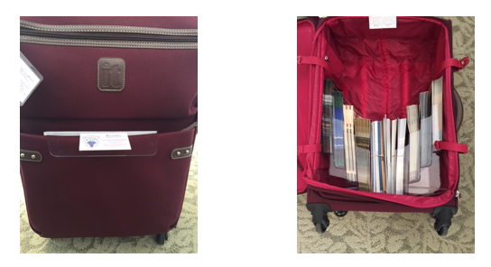

**WRONG WAY TO PACK:**

**Brochure racks were placed at the other end (not wheel end) all falling out of the holder.**

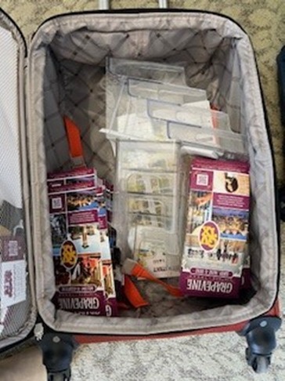

**SAFETY**

We work in large hotels and public venues with thousands of people. While we have the assurance of video cameras and security personnel to help maintain a safe environment, you are still in an area where thieves know people have more cash and valuables than usual due to travel. It is up to you to take responsibility for your personal safety and your belongings. Please have the same awareness as you would inside a mall or mall parking garage.

**At All Times:**

* Be aware, *watch your back.* If possible, enter and leave with someone you know. If you feel uneasy, ask for a security escort to or from the parking lots/garages.
* Secure your vehicle. Do not leave valuables in sight. Put them out of sight before you arrive at your assignment.
* Keep your belongings near you or in a designated secure place. Do not bring valuables i.e. unnecessary cash, credit cards, jewelry or sentimental items.
* Take your personal items with you for breaks, meals, etc. Do not leave them in the kiosk.
* Never leave food or beverages unattended. Do not consume if they have been out of your sight.
* Keep personal bags and totes zipped-up when walking in crowds.
* Do not go alone into empty corridors or rooms.
* Be selective about providing good deeds i.e. taking a guest for errands in your personal car. While this is very hospitable, we do not know the individuals with whom we are interacting and do not want to have our staff put in harm’s way. Politely review transportation options with the guest.
* For security reasons, do not watch a guest’s or anyone’s personal belongings. Have the guest check their belongings with the bell stand or coat check, if available.

**OTHER ITEMS**

**Winter weather/Ice Storms**-Regardless of the weather, our commitment to the client must be fulfilled. When an ice storm is being forecasted, staff should allow plenty of time to get to the work assignment safely. The CVB will make every effort to accommodate staff members who do not feel comfortable driving in winter weather conditions. Please follow your normal procedures for during office hours/and after office hours and contact the appropriate person if the need should arise.

**Direct deposit** - One of the most important services Finance provides is paying employees accurately and timely. We will no longer be **printing and distributing** payroll checks. We are requesting all employees who do not currently take advantage of direct deposit **to set up direct deposit in PAYCOM through the ESS app or online**.  This is a very easy process and should only take a minute of your time.

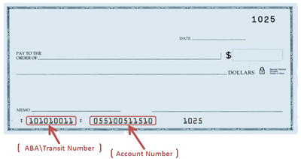

Below are the directions to follow in ESS to update your direct deposit information**.**

DIRECTIONS

Log in to your ESS profile on a computer or through the Paycom app on your phone.

In your ESS profile

Choose Payroll

Choose Direct Deposit

Select your account type (checking or savings)

Enter your bank name, routing number and account number.

Make sure and scroll to the bottom and click the box to agree to the terms and then click “update.”

**Employee & Family Clinic**

The City of Grapevine provides a program for All Active City employees and their dependents are eligible to use the program. An eligible dependent is defined as a spouse and/or dependent children under the age of 26.

* Clinic ID card must be presented at the time of service
* Walk-in for a same day office visit; call ahead for same day appointment, if possible
* No copay for clinic visits
* Acute care includes coughs, colds, flu, sinus infections, sore throats, ear aches, and other minor illnesses
* Current list of Drs. as of 10/2024

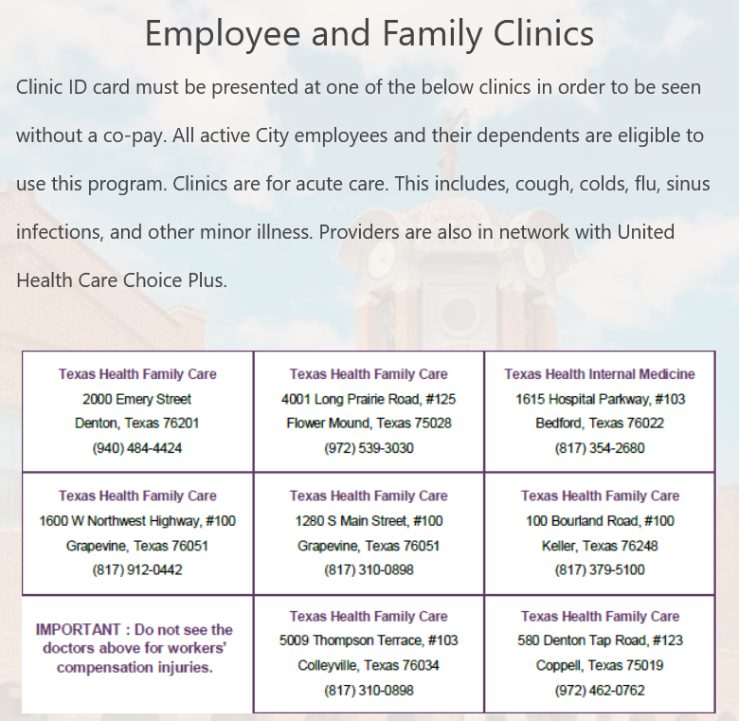

**Public Agency Retirement System (PARS-AR 457 Account)**

Part-time, casual and temporary employees who are not eligible to participate in the Texas Municipal Retirement System will contribute 6.2% of gross wages into their tax-deferred PARS-AR 457 Account. The City will contribute 1.3% of the employee’s gross wage into the employee’s account. Employees are 100% vested immediately in the PARS-AR 457 Account. [www.pars.org](http://www.pars.org)

**Address & Name Changes**-**you are required to make the updates in Paycom**. Once, updated you will also **need to advise Destination Services so we can update our system** also (CRM) if you have a change of address.

**KNOW YOUR HOTELS & GRAPEVINE**

It is important that you are familiar with all of Grapevine’s hotels: layout, restaurants, transportation options, etc. For the most up-to-date information, please visit

[www.GrapevineTexasUSA.com](http://www.GrapevineTexasUSA.com), hotel websites, [www.downtowngrapevinetexas.com](http://www.downtowngrapevinetexas.com)

and any resources that will be helpful to you in assisting Grapevine’s visitors.

[**Gaylord Texan Resort & Convention Center**](https://www.marriott.com/en-us/hotels/dalgt-gaylord-texan-resort-and-convention-center/overview/?scid=f2ae0541-1279-4f24-b197-a979c79310b0)

**1501 Gaylord Trail**

**(817) 778-1000**

**(866) 782-7897 – toll free**

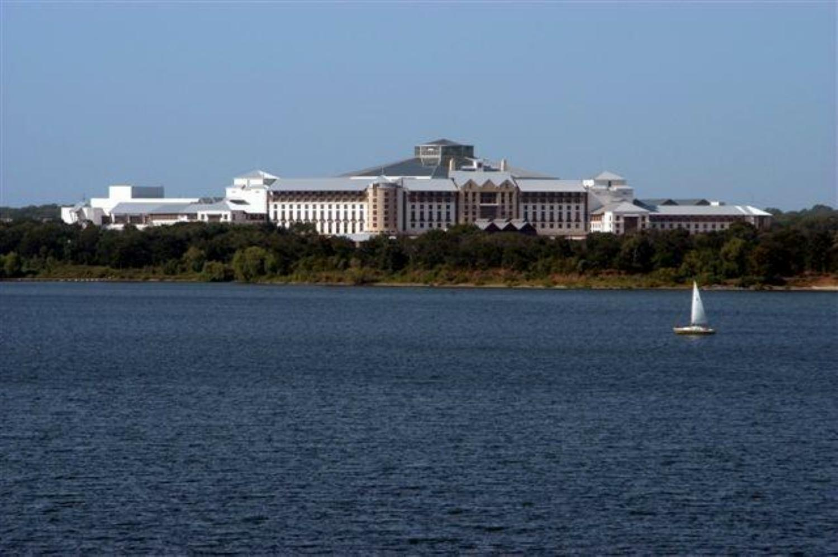

Brimming with authentic Texas style and hospitality, the awe-inspiring Gaylord Texan Hotel and Convention Center is Grapevine’s largest hotel with 1814 stylish [guest rooms](http://www.gaylordhotels.com/gaylord-texan/grapevine-dallas-hotel-rooms-suites/), including 127 [spectacular suites](http://www.gaylordhotels.com/gaylord-texan/grapevine-dallas-hotel-rooms-suites/suites), and 490,000 square feet of meeting space.

**Smoking -** The only approved smoking area for STARS and Vendors is the area across from the Ice Tent area, near the storage shack. Please insure that all STARS and Vendors are aware that smoking is not allowed in any other area of the property, including parking lots, exit landings, stairwells, guest smoking areas, etc.

**The Chuck Wagon** is the employee cafeteria. As of November 2023, the entire hotel including the Chuck Wagon is now cashless.

**Lost and Found**: 817-778-2453

**Information for the guests...**

**ATM:** There are ATM’s located in both the convention center and the hotel.

In the Convention Center, an ATM is located on the Longhorn Exhibit Hall level (level one), near the escalators. Please look for the ATM symbol. In the hotel, the ATM is located across from Old Hickory Restaurant, adjacent to the guest elevators.

**Business Services:** The FedEx Business Center is located in the Convention Center on the Longhorn Exhibit Hall Level (level one) and across from the Grapevine CVB Information Kiosk.

The hotel’s shipping and receiving center is located in the Convention Center, on the Longhorn Exhibit Hall level (level one) along the corridor going towards Longhorn F.

**Transportation:** Gaylord Texan Shared Ride - This is a walkup service, no reservation required. For transportation needs, guests should visit the transportation desk on the front drive. The services depart on the hour and half hour from

5 a.m.-2 p.m. daily to Dallas/Fort Worth International Airport. Rate is $15.00 per person and includes all taxes, fees and tolls. Rate does not include driver gratuity. For groups with advance notice the hours can be adjusted as needed. Fleet includes: suburban’s, mini-buses and Gaylord’s driver team.

**Hertz Rental Car** is located in the convention center, garage level.

[**Restaurants/Bars**](https://www.marriott.com/en-us/hotels/dalgt-gaylord-texan-resort-and-convention-center/dining/) **(hour’s subject to change):**

[**Zeppole**](https://www.taptastego.com/dalgt/outlet/order/7cd92a89-5527-4f8c-8106-1ee7a8db430e) **-** Enjoy Italian-American cuisine including freshly made pasta, specialty dishes, brick-oven pizzas and homemade charcuterie in a villa-style courtyard setting. Dinner 5-10pm; Bar 4:30-11pm

[**Texan Station Sports Bar & Grill**](https://www.taptastego.com/dalgt/outlet/order/77dea334-5d0d-4343-b12b-ff64d1b2866b)  **-** Lunch and Dinner 11am-1:00am;

[**Riverwalk Cantina**](https://www.taptastego.com/dalgt/outlet/order/d7a2b7c9-e4e5-49e5-80d3-dadba196f9dd) **-** Watch the tranquil koi swim by and feel as though you have been transported to the famed San Antonio Riverwalk as you enjoy delicious Tex-Mex made with the freshest ingredients.

**Mission Plaza Market Place –** 6:30am-9pm; serves an array of coffee, pastries, salads, sandwiches and more. Swing by before a day in Grapevine or join us at the bar in the evening when we offer a first-rate selection of beer and wine.

**Cocoa Bean** – Fuel up with an energizing cup of freshly brewed Starbucks® coffee and flaky pastry before your adventure begins. Grab-and-go snacks are also available for guests on the move. Across from the Bell Stand; 6am-8pm.

**Silver Bar -** reminiscent of a saloon from the Old West. Unwind at the bar after your eventful day in Grapevine and enjoy a round of drinks. We offer multiple draft beers, cocktails, wine and more.

[**Glass Cactus Nightclub**](https://glasscactus.gaylordtexan.com/) **–**This is a restaurant where legends play on a grand performance stage and sunsets over lake shores reflect a thousand dreams. It's the spot where extraordinary events of every size make waves

Mon-Thu, Sun Closed / Fri-Sat9:00 PM-2:00 AM (as of 8/2023)

[**Paradise Springs Pool Bar and Grill**](https://www.taptastego.com/dalgt/outlet/order/49428144-0638-4d8d-9088-7748ee1885e2) – Open seasonally, the Paradise Springs pool Grapevine bar and grill provides cocktails and snacks while you lounge poolside and enjoy Grapevine's beautiful weather.

[**Hyatt Regency DFW**](https://www.hyatt.com/en-US/hotel/texas/hyatt-regency-dfw-international-airport/dfwap)

**International Parkway (Terminal C)**

**DFW Airport, Texas**

**(972) 453-1234**

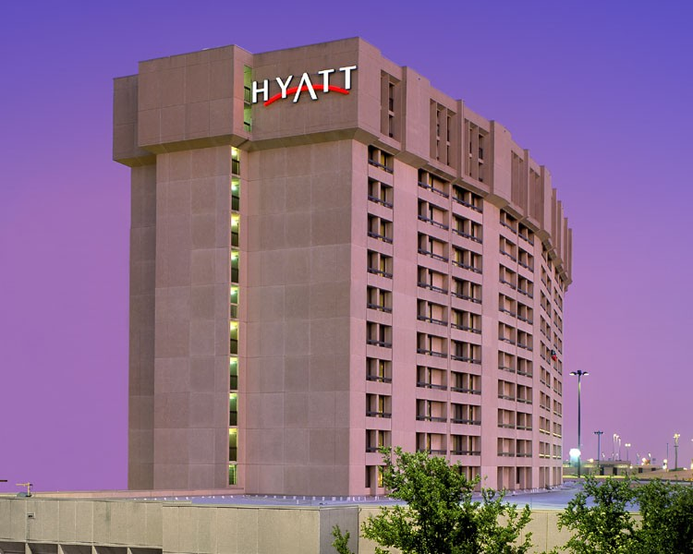

Hyatt Regency DFW is the second largest hotel in Grapevine with 811 rooms including 17 suites and 100,000 square feet of meeting space.

**Burgundy Brigade** receive 25% off at **Jett’s Coffee Bar**. In order to receive the discount, you must be in your Burgundy Brigade Uniform/or CVB Staff polo shirt and show your name badge

[**Restaurants:**](https://www.hyatt.com/hyatt-regency/en-US/dfwap-hyatt-regency-dfw-international-airport/dining)Check website for times

**Jacob’s Spring Grille** – Start your day with classic American fare in our relaxing, aviation-themed restaurant featuring a breakfast buffet and a la carte breakfast and lunch options. Open Daily- 6am-10am and 11am-2pm

**Aces Lobby Bar** Indulge in signature cocktails, a variety of domestic and imported beer or snacks off our nightly menu. With seven flat screen HDTVs offering programming for the year-round sports enthusiast, there’s bound to be something you’re going to enjoy. Whether winding down from a day of meetings or meeting up with some friends, ACES is the perfect DFW Airport restaurant and bar setting.

Monday – Friday from 4:00 pm – Midnight, Kitchen closes at 11:00 pm

Saturday – Sunday from 11am - Midnight, Kitchen closes at 11:00 pm

**Jett’s Coffee Bar** – open 24 hours; Fuel up at our main lobby coffee bar with your favorite espresso and gourmet Starbucks® coffee brews as well as market-fresh items. Relax in our comfortable lobby seating area and enjoy bagels, pastries, sandwiches and much more. Jett’s offers grab-and-go options that are perfect for those on the way to a meeting or waiting for their flight.

**Mister G’s** – Savor the taste of your favorite sushi at Mister G’s.

**Great Wolf Lodge**

**100 Great Wolf Drive**

**817-488-6510 main, 800-693-9653 toll free**

[**www.greatwolf.com/grapevine**](http://www.greatwolf.com/grapevine)

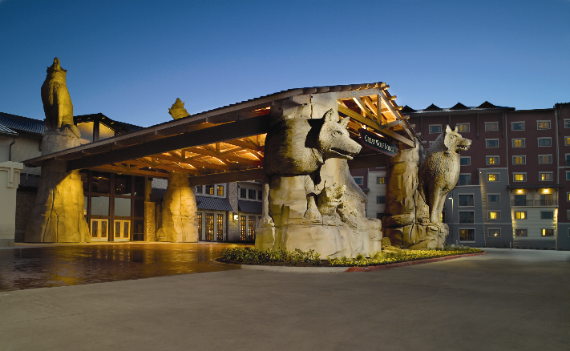

Great Wolf is a northwoods-themed all-suite family resort featuring an 80,000 square-foot indoor water park and a 100,000 square-foot outdoor water park. It has 605 suites and over 20,000 square feet of meeting space.

**Information for the guests:**

**ATM:** Lobby level by Starbucks and lower level by entrance to the water park.

**Business Services:** full range of supplies and services you've come to expect from the finest conference hotels. Just ask an associate to help you.

**Transportation:** Guests arrange their own.

**Restaurants:**

**The Watering Hole** – Ice cold refreshments 11am-8pm

**Wood’s End Creamery** – Ice Cream 3pm-10pm

**Hungry as a Wolf** – Pizza, pasta, salads and more! 11:30am-10pm

**Fireside** - A variety of food and drinks to choose from. 4pm-11pm

**Starbucks** - Just off the 2nd floor main lobby 7am-7pm

**Buckets Incredible Craveables** – daily. Snack, treats, lunch and drinks.

**Pretzelmaker** – Fresh made pretzels daily 10am-10pm

**Hilton DFW Lakes Executive Conference Center**

**1800 State Highway 26 East**

**817-481-8444**

[www.hiltondfwlakesecc.com](http://www.hiltondfwlakesecc.com)



Hilton DFW Lakes has 393 guest rooms and 40,000 square feet of meeting space.

**Transportation:**

Complimentary 24-hour transportation to and from DFW International Airport. Complimentary shuttle service at 15 minutes after the hour to Grapevine Mills and restaurants close by. There is an additional charge to Historic Downtown.

**Restaurants:**

**The Vineyard** – Mon.-Fri. 6am-3pm Sat & Sun 6am-11am

**Bonnie & Clyde’s Hideout** – Monday-Friday 3pm-11pm,

Saturday & Sunday Noon-11pm

**Java –** Monday-Sunday 6am-2pm

**Meritage Grill –** dining room used for conferences and special events only.

**Windfall –** dining room used for conferences and special events only.**Embassy Suites by Hilton DFW Airport North**

**2401 Bass Pro Drive**

**972-724-2600**

[**www.embassysuitesdfwnorth.com**](http://www.embassysuitesdfwnorth.com)

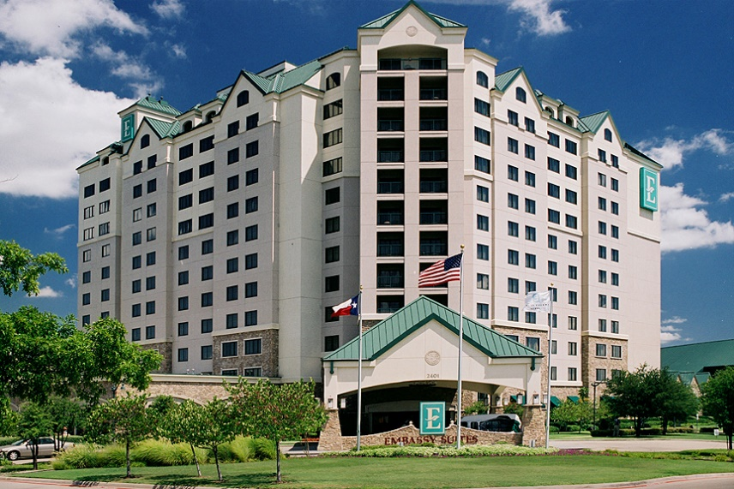

Embassy Suites Outdoor World has 329 suites and 20,000 sq. ft of meeting space.

**ATM:** Located on the first floor by the restrooms.

**Business Services:** There is a complete business center, with one computer for hotel guests.

**TRANSPORTATION:** Complimentary 24-hour transportation to and from DFW International Airport every 30 minutes. Complimentary shuttle service to and from Grapevine Mills, based on availability.

**RESTAURANTS:**

**Lobby** – complimentary full made-to-order breakfast during designated hours. Complimentary Manager’s reception during designated hours.

**Hallford’s Restaurant & Bar** – Monday-Saturday 11:30am-11pm, Sunday 5pm-11pm

**Hallford’s Mercantile** (located in main lobby) -Monday-Friday 6am-2pm, Saturday & Sunday 7am-Noon

**Grand Hyatt DFW**

**International Parkway (Terminal D) - DFW Airport, Texas**

**972-973-1234**

[Grand Hyatt DFW](https://www.hyatt.com/grand-hyatt/en-US/dfwgh-grand-hyatt-dfw?src=adm_sem_crp_chico_crp_ppc_NAM-UnitedStates-TX-Dallas-GH-DFWGH_google_Evergreen2022_e_grand%20hyatt%20dfw&gad_source=1&gclid=EAIaIQobChMIsfH1hv-DiQMVxDbUAR0xmwtCEAAYASAAEgLR0vD_BwE)

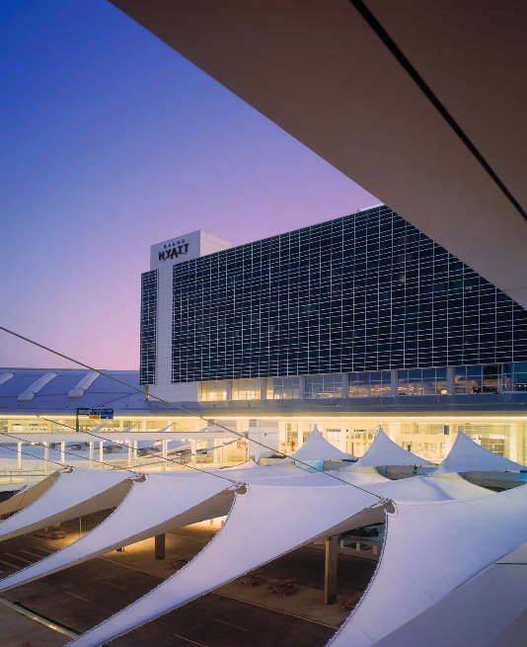

Grand Hyatt has 298 guest rooms and 34,000 square feet of meeting space.

**Restaurants:**

**Grand Met –** Daily. Breakfast 6:00 – 11:00am, Lunch 11:00am -2pm, Dinner 5:00 – 11:00pm

**Grand Met Lounge-** Daily. 11:00am – Midnight

**Other Full Service Hotels**

* **Silverlake Crossings:** [Hilton Garden Inn Grapevine Silverlake Crossings](https://www.hilton.com/en/hotels/dfwscgi-hilton-garden-inn-grapevine-at-silver-lake-crossings/),

[Courtyard](https://www.marriott.com/en-us/hotels/dfwgv-courtyard-dallas-dfw-airport-north-grapevine/overview/?scid=f2ae0541-1279-4f24-b197-a979c79310b0) and [TownePlace Suites by Marriott](https://www.marriott.com/en-us/hotels/daltg-towneplace-suites-dallas-dfw-airport-north-grapevine/overview/?scid=f2ae0541-1279-4f24-b197-a979c79310b0)**-** 453 total rooms

* **Hotel Vin, Autograph Collection-** 120 rooms

[www.hotelvin.com](http://www.hotelvin.com)

**Select Service Hotels/Campgrounds**

* **Residence Inn by Marriott DFW Airport North/Grapevine-**133 rooms

[www.marriott.com/dalgp](http://www.marriott.com/dalgp)

* **Hyatt Place Grapevine**-125 rooms

[www.dallasgrapevine.place.hyatt.com](http://www.dallasgrapevine.place.hyatt.com)

* **SpringHill Suites by Marriott Dallas Airport North/Grapevine**-111 rooms [www.marriott.com/hotels/travel/dalgv-springhill-suites-dallas-dfw-airport-north-grapevine](http://www.marriott.com/hotels/travel/dalgv-springhill-suites-dallas-dfw-airport-north-grapevine)
* **Hilton Garden Inn DFW North/Grapevine-**110 rooms

[www.dfwnorthgrapevine.hgi.com](http://www.dfwnorthgrapevine.hgi.com)

* **Homewood Suites by Hilton DFW Airport North/Grapevine**-105 rooms

[www.dallasgrapevine.homewoodsuites.com](http://www.dallasgrapevine.homewoodsuites.com)

* **Comfort Inn**–SH114 & Main Street -100 rooms

[www.choicehotels.com](http://www.choicehotels.com)

* **Super 8 Hotel Grapevine**-100 rooms

[www.super8grapevine.com](http://www.super8grapevine.com)

* **Comfort Suites DFW North/Grapevine**-SH121 & Bass Pro Dr.-96 rooms

[www.choicehotels.com](http://www.choicehotels.com)

* **Holiday Inn Express Hotel & Suites DFW/Grapevine**-95 rooms

[www.hiexpress.com/grapevinetx](http://www.hiexpress.com/grapevinetx)

* **Hampton Inn & Suites DFW North/Grapevine**-94 rooms

[www.hamptoninn.com](http://www.hamptoninn.com)

* **Minute Suites DFW**-Terminal A38-7 rooms; Terminal D23-10 room

[www.minutesuites.com](http://www.minutesuites.com)

* **Vineyards Campground & Lakefront Cabins**-15 cabins

[www.vineyardscampground.com](http://www.vineyardscampground.com)

**GRAPEVINE INFORMATION**

Vintage Texas®

1M+ sq. ft. of Meeting Space

11,000 Area Hotel Rooms

1,800+ Flights Daily • 200+ Restaurants

Historic Downtown - Grapevine Mills

LEGOLAND® Discovery Center – SEA LIFE Grapevine Aquarium

Meow Wolf

Grapevine Glockenspiel’s Would-Be Train Robbers

Bass Pro Shops Outdoor World - 81 Holes of Premier Golf

Grapevine Vintage Railroad – Urban Wine Trail

Palace Arts Center

MCj04238700000[1]

**Helpful websites:**

* + [GrapevineTexasUSA.com](http://www.GrapevineTexasUSA.com)
  + [www.grapevinetexas.gov](http://www.grapevinetexas.gov)
  + [www.GrapevineChamber.org](http://www.GrapevineChamber.org)
  + [www.ILoveGrapevineTexas.com](http://www.ILoveGrapevineTexas.com)
  + [www.GrapevineMills.com](http://www.GrapevineMills.com)
  + [www.BassPro.com](http://www.BassPro.com)
  + [www.GrapevineTowneCenter.com](http://www.GrapevineTowneCenter.com)
  + [www.passporthealthtexas.com](http://www.passporthealthtexas.com)
  + [www.dfwairport.com](http://www.dfwairport.com)
  + [www.traveltex.com](http://www.traveltex.com)
  + [www.visitdallas-fortworth.com](http://www.visitdallas-fortworth.com)
  + [www.txwines.org](http://www.txwines.org)
  + [www.dfwconnector.com](http://www.dfwconnector.com)
  + [www.GrapevineToday.com](http://www.GrapevineToday.com)
  + [www.ridetrinitymetro.org](http://www.ridetrinitymetro.org)
  + www.grapevinetexasusa.com/destination-grapevine/