

Handbook

Show Me How

**November 17, 2022** **pAYCOM**

**Show Me How Videos** – instructional videos are located under Learning, My Learning; Paycom University(click on); Filter; Topics, **Show Me How**. These are not considered required training.

**Training in Paycom** - if you see any type of training in Paycom, please wait for an email from the Destination Services Team to see if it is required training. If it is required, we will let you know that you have to complete it, the amount of time you will be paid to complete the required training as well as the appropriate comment code to use for clocking in.

Clocking-In Video: <https://share.vidyard.com/watch/rDKeLMfFYBUtAjG3E1sU1M>

Punch Change Request Video: <https://share.vidyard.com/watch/HhWZLdTA5Y3ERb8TKps9ux>

Editing a Punch Video: <https://share.vidyard.com/watch/Qx3NU6ra2s5bvg7Ho3XNAP>

Approve Timecard Video: <https://share.vidyard.com/watch/v87uxqnx2DS9eJruF5gYvr>

**Breaking Down the Required Fields…**

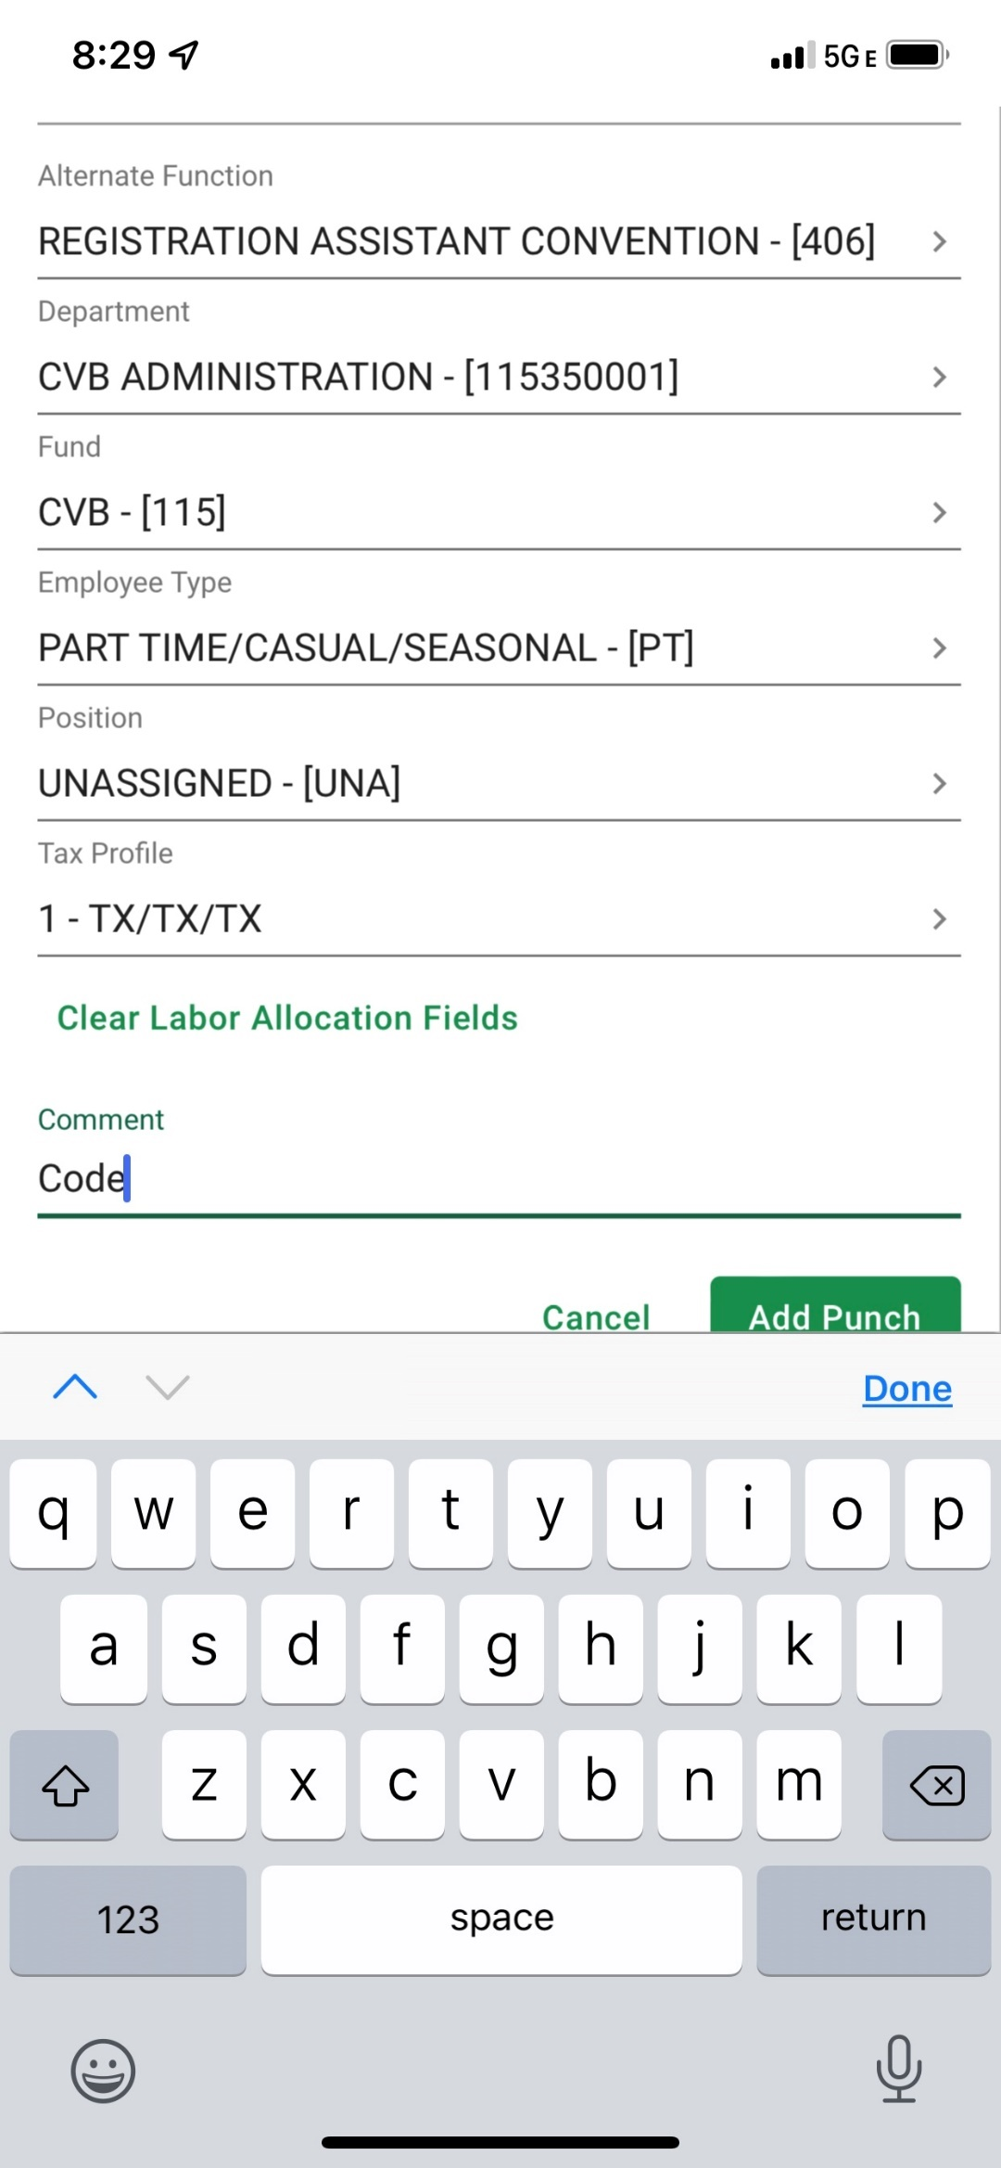

**Alternate Functions:**

**1. Registration Assistant (405)** (default) **FIRST before selecting IN DAY In comments**, type in the area based on the codes below where you are working, **no deviations**, since we will need to run reports based on the information that is in the comments section.   
**2. Registration Assistant Convention (406) FIRST before selecting IN DAY** **In comments** type the name of the Convention you are working, included on your email confirmation (like we have done in the past). Type exactly has it appears on the work confirmation NO deviations. We have to have consistency with the name of the convention otherwise we will NOT be able to run a report of everyone working that convention.   
**3. Registration Assistant Hanging Signs (410) FIRST before selecting IN DAY** **In comments** type the name of the Convention you are hanging signs for it will be written on the sign hanging procedures that we leave with the sign. Same as the above, **consistency is a must**.

**(Only one option to select from drop down)**

**Department:** CVB ADMINISTATION – [115350001]

**Fund:** CVB – [115]

**Employee Type:** PART TIME/CASUAL/SEASONAL – [PT]

**Position:** UNASSIGNED – [UNA]

**Tax Profile:** 1 – TX/TX/TX

**Comment Code:** to make it easier entering the required “code” in the comments section, since it defaults to a capital letter we will always have the first letter be capitalized and the rest small letters and will eliminate any periods. The code will either be on the work confirmation & schedule, look for it. This needs to be written **exactly** as listed on your work confirmation, and must always come FIRST. Triple check before clicking “IN DAY”.

**Comment Codes are Important**! This is how we track the groups/events that your work. For groups it helps us to bill the client correctly. For other event, i.e. Festivals it helps us to track how many BB hours were spent working the festivals. So, remember to always enter your Comment Code provided, before selecting **IN DAY**!

A list of current comment codes his provided at the end.

**Comment Code:** To find your convention specific comment code, which is normally the acronym for the group or abbreviated convention name look at:

**Work Confirmation:** 

**Staffing Schedule:** 

**CLOCKING IN** – See attached **SHOW ME HOW** Document – quick punch is the preferred method.

**RULE OF THUMB** – do NOT clock in more than 5 minutes prior to your scheduled shift time

Web Time Clock will show the current status if in questions – In Day 07:55 a.m.

Web Time Clock or QUICK PUNCH are used when you are physically onsite.

Web Time Sheet Read Only – normally used to Request New Punch, Add Comment or Fix your Time.

**CLOCKING OUT** – once clocked in, you will see OUT DAY button to clock out.

You are expected to clock out at the conclusion of your shift OR if the planner releases you earlier than your scheduled end time. A comment will be required if released early than scheduled.

**APPROVING YOUR TIME**

It is a policy you must approve your time after you completed your shift assignment for that day. If it is incorrect, **do not approve**, you must take the appropriate action to fix your time via new punch request or edit punch change to fix, see helpful hints below:

**Approving Your Shift After Completion:**

Go to: **Time Management**, **Web Time Sheet Read** **Only** -After verifying your time is correct and you have the correct allocation code (405/406 or 410) and your comment code entered and correct, you may approve your time. However, if you need to review you time, select the drop-down arrow on the right of the date you wish to review, if all looks good, you can select **Approve by Date**.

NOTE: it will automatically put check marks in on past days that you have not worked, so leave them there so you approve them. However, if you approve your time the day after you work, it will automatically put a check mark in on the current date. So, if you are working that day, you would just uncheck that box before hitting the approve button.

**Approving First Week:** At the end of the first week pay period, you must approve your time worked and any additional days within that pay week. All must be yellow for that week only. Go to: **Time Management**, **Web Time Sheet Read Only** (towards the bottom) **Approve by date.** Once done, your entire two-week time period will turn yellow.

**Approving Your Entire Two Weeks:** At the end of the two-week pay period, even if you have only worked 1 day during that two-week time period, you are required to approve the entire two weeks.

Go to: **Time Management**, **Web Time Sheet Read Only** (towards the bottom) **Approve Pay Period.** Once done, your entire two-week time period will turn yellow.

NOTE: If by chance during the course of the two weeks you accidently hit Approve Pay Period by mistake and you are scheduled to work, you will need to take the approval off, otherwise you will not be able to clock in. See **How to Unapprove Your Time** section.

**IMPORTANT** - Monday mornings it is very important if you do have a punch request submitted watch for us to approve it so you can approve it, since we have a deadline to approve all time. We are in a meeting each Monday until approximately 9 a.m. so please expect a punch approval after this time.

**YOU have to approve your time**, we can NOT do it for you. If you do not and you miss the deadline you will be asked to approve and submit your approval to City Hall via this link: [payroll@grapevinetexas.gov](mailto:payroll@grapevinetexas.gov)

**Helpful Hints for Add/Fix time – Add/Modify Comments:**

**Missed Punch or Incorrect Time:** GO TO:  **Time Management**, **Web Time Sheet Read Only**, click the **v** (drop down arrow) on the day you need to correct. If you see ?? it means missed punch, click on ?? / ?? (blue indicates IN and red indicates OUT) depending on the need to correct. Or if the time you have clocked in or out is showing incorrect click on the time (i.e. 7:52 a.m. or 5:09 p.m.) you need to fix. Once you click on what needs to be fixed a **REQUEST PUNCH EDIT SCREEN** appears: **DATE**: click on calendar to enter date (verify correct date);**IN DAY/OUT DAY** use the drop-down arrow to select what you are adding; **PUNCH TIME:** enter the time i.e. 8:00 AM (verify you have correct a.m. or p.m.); **ALLOCATION** (click on, should be in blue): depending on what you are working (refer to alternate function above); **REASON FOR PUNCH CHANGE RQUEST**: ALWAYS enter the comment code provided for the Group/Event FIRST: i.e. Reason: XYZ and then add additional comments if need, if not, scroll down and select **Add Request**. It will then add to request for us review and approve. You will NOT be able to see the change, until we approve it. Watch for it to be approved, then please approve.

**Forgot Your Phone at Home To Enter Your Time:** GO TO:  Time Management, Web Time Sheet Read Only , hit the blue dot with the +  select “*Request New Punch”* , fill out the information: **DATE**: click on calendar to enter date (verify correct date); **IN DAY/OUT DAY** use the drop down arrow to select what you are adding; **PUNCH TIME:** enter the time i.e. 8:00 AM (verify you have correct a.m. or p.m.); **ALLOCATION** (click on, should be in blue): depending on what you are working (refer to alternate function above); **REASON**: ALWAYS enter the comment code provided for the Group/Event FIRST: i.e. Reason: XYZ and then add additional comments if need, if not, scroll down select,

**ADD REQUEST**.  Repeat steps above to add your out-day time.

It will then add to request for us review and approve. You will NOT be able to see the change, until we approve it. Watch for it to be approved, then please approve

**Remember:** On any request to change or add time, we have to approve it first before you are able to see the change.  Once you have requested/made a change, to verify it is in there (so you don’t do several) go to **Time Management,**  **Punch Change Request** selecting the drop down to view it. If your request is incorrect, you can edit what is there (click on the pencil) or you can delete it (click on trash can).  You can check this area to view to see when we approve your requests since it will no longer be listed if approved. Or you can try and approve it and if we have not, it will show by the date (pending PCR) and won’t let you approve.

**Forgot Your Comment Code or Information About Your Shift:** GO TO:Time Management, Web Time Sheet ready only & hit the blue dot with the +  second one down is “*Add Comment*” **DAY(s)** enter the to and from date where you want the comment to be entered (click on calendar); **ADD COMMENT** line: ALWAYS enter the comment code provided for the Group/Event FIRST i.e. Reason: XYZ and then add additional comments.

Select **ADD COMMENT**

**NOTE**: The purpose of adding additional information in the comment section about your shift is to document it in Paycom, in case the client ever questions anything about the shift. It also helps to eliminate the need to email Destination Services since we can just read from your comment.

**Edit your Comment Code:** Go to: **Time Management**, **Web Time Sheet Ready Only**, select the **v** (drop down arrow) next to the hours on the date you need to make the update (you may have to turn your phone sideways) scroll down to **Comments** to the right, is a grey comment box, click on it ….a pop up that says: **View Comments Stand-Alone Comments.**  ALWAYS enter the comment code provided for the Group/Event FIRST  remove your wrong comment or add to it etc.; select **Update Comments**.

**UNIT** – a unit of time will be added to your shift as mentioned below. to your time if you were released earlier than 4 hours (conventions only). Your time will show the actual hours you worked. To view the units that were added to meet the 4-hour minimum, scroll down when you are in Web Time Sheet Read Only under WEEKLY TOTALS.  The units will be listed here. Do not wait for us to add the unit, approve your time after your shift has ended.

If doing any of these “fixes” on [www.Paycom.com](https://gcc02.safelinks.protection.outlook.com/?url=http%3A%2F%2Fwww.paycom.com%2F&data=04%7C01%7Cdanderson%40grapevinetexasusa.com%7Ca5c129581c4747e41cef08d99fb7db18%7Cf4c8bf84c7c145b490b1c7247654a6c0%7C1%7C0%7C637716434280419811%7CUnknown%7CTWFpbGZsb3d8eyJWIjoiMC4wLjAwMDAiLCJQIjoiV2luMzIiLCJBTiI6Ik1haWwiLCJXVCI6Mn0%3D%7C1000&sdata=ODwvOUFwqemq4kcMpYLNusz1eAA2fdhGAVP%2BbBrBcOk%3D&reserved=0) it is quite similar, not exactly as on the mobile app, but knowing the above you should be able to figure it out.

**Early Release/Extended Shift/Four Hour Minimum**

*A comment always needs to be added if the *time you worked is different than what you were scheduled* for.

*The comment needs to be added before or after clocking in depending on the situation. If clocking in then your group comment code always comes first then type the reason.

**In Paycom you must enter in comments the information similar to below for any of these situations:**

-Planner releases you earlier than your scheduled end time, you are only paid for the time worked and **NOT** what you were scheduled for. If your time is correct, then you may approve it. (comment code A)

-Planer releases you early and tells you they will pay you until your regular scheduled end time. If your time is correct, then you may approve it. We will add the additional time as a **unit** so you are paid for your entire shift. You **do not** need to wait for us to add this in, at the completion of your shift approve your time. (comment code B)

-Planner releases you less than 4 hours, you will get paid a 4-hour minimum. If your time is correct, then you may approve it. We will add a **unit** of time for the difference so you are paid the 4 hours. You **do not** need to wait for us to add this in, at the completion of your shift approve your time. (comment code A)

-Onsite planner cancels your shift for the next day, you get paid a 4-hour min. since your shift was cancelled within 48 hours. You will need to enter a new punch to enter your 4-hour min. for the day you were to work. We will have to approve your punch request before you see it. (comment code C)

-Planner asks you to stay longer than originally scheduled. (comment code D)

-Planer asks you to start your shift earlier than what you were scheduled. (comment code E)

**COMMENT CODE EXAMPLES:**

A. Jane released at 2 p.m. (add before clocking out, if you were released earlier that what you were scheduled)

B. Jane released at 2p.m. ok to pay to end of shift (add before clocking out)

C. Jane xncld shift w/48 hrs. (date cancelled) 4 hr. min.

D. Jane extended shift til 5 p.m. (add before clocking out)

E. Jane rqst to start early (add before clocking in)

**Four Hour Minimum** - You may be asked to work at the CVB, festivals, holiday events, consumer tradeshows or attend meetings/training. These assignments are exempt from the four-hour minimum and are paid only for the time you are there.

**Miscellaneous Timesheet Notes/Reminders/FYI:**

* The pay period begins on Sunday and ends on Saturday.
* RULE OF THUMB – do NOT clock in more than 5 minutes prior to your scheduled shift time.
* You are expected to clock out at the conclusion of your shift OR if the planner releases you earlier than your scheduled end time. A comment will be required if released early than scheduled.
* Though you are paid for their convention breaks/lunch there are times that you may be scheduled with an unpaid break in-between in this case, use the Out Lunch then upon return use the IN lunch, thus preventing to have to retype group code in comment area. Or if working non-convention work and allowed a break, use the Out Lunch & In Lunch. Do not use” BREAK”.
* If you are making a punch request for a day other than the current day please make sure the correct day is selected.
* Your comment code for the group/event MUST be entered first before selecting “IN DAY” or anywhere it says REASON. Normally anything that has to do with an “out day” time would not require the group/event comment code, just on the IN DAY.
* To get the number of hours worked in a year, in Paycom go to Payroll, select View Pay Stubs and then Year-To-Date Totals.

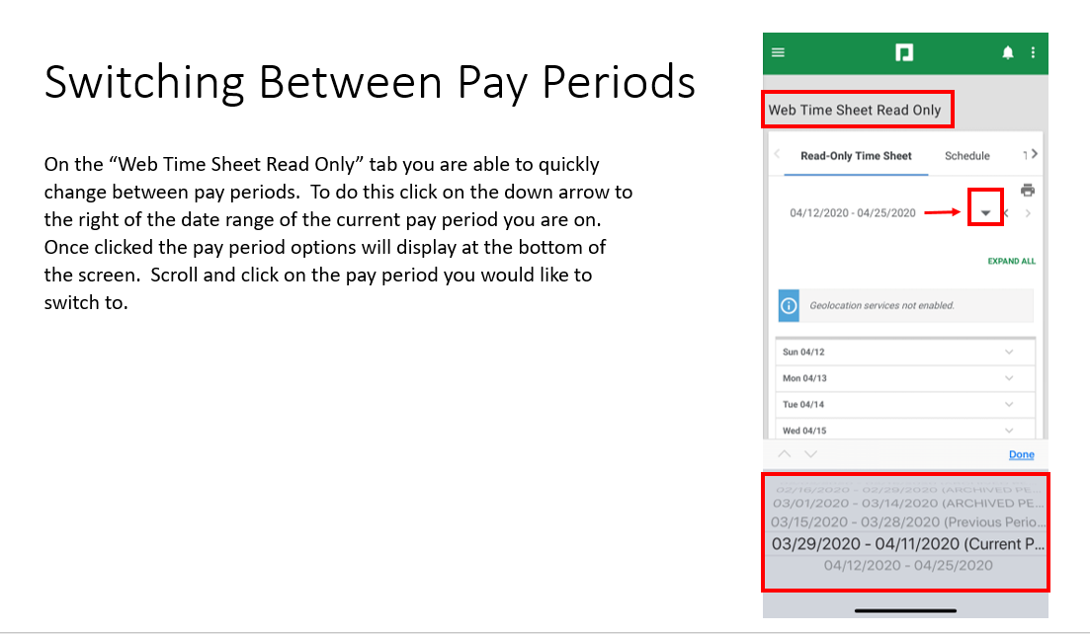

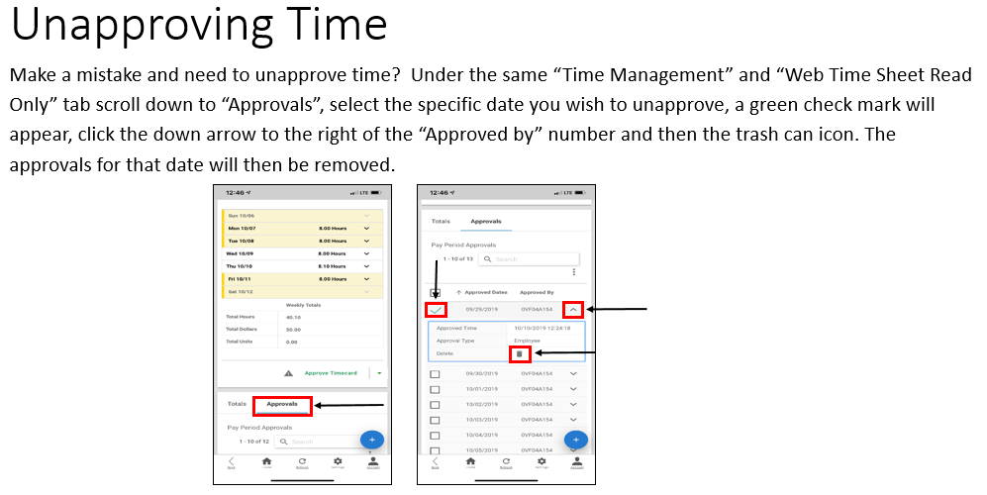

**How to Unapprove Your Time** (example below): Go to: **Time Management**; **Web Time Sheet Read Only**; Scroll down to where you see TOTALS  / **APPROVALS** (under the Approve Timecard); Click the box next to the date your need to delete the approval; click the drop-down arrow next to the date; click trash can to delete scroll up to verify the yellow is gone. **NOTE:** if your time sheet is blue/green you will not be able to delete your approval since we approved it already. If you accidentally approved your entire time sheet you can revoke all approvals. To do (still in the approvals area) click the box next to the date(s) you need to unapprove, click on **3 dots (vertical)**, it will say **REVOKE APPROVALS**, select. This will remove all approvals even those you have already approved, so you may need to go back and reapprove.

**Who to Contact:**

For password reset or technical issues signing in etc. contact:

* **HR at 817- 410-3176**

For issues regarding incorrect pay, hours incorrect:

* **First email Destination Services Department or call (817-410-3538 or 817-410-3191) if we can resolve it then;**
* **Pat Burkholder @ 817-410-3116**

It is recommended you keep a file for everything PAYCOM! Cheat sheets provided etc. so you can refer to them. Please try and resolve the error yourself with the information that is provided, then if you can’t, contact Destination Services for help. We refer back to these documents also. Until PAYCOM becomes easy for you, please refer to the information in the email that is sent, your handbook, or the biweekly email sent reminding you to approve your entire two weeks.

**COMMENT CODES (provided on the documentation you receive from Destination Services:**

**Admin** always include the area you are working.Use when working in other departments w/in the CVB if a code is not provided below. **Example:** Admin accounting; Admin marketing  
**Bb** always include what this is for. Use when attending any training, orientation, meetings, Destination Grapevine (DG) etc. **Example:** Bb dg or Bb meeting or Bb orientation **Brochure delivery**-use for those that are assigned to deliver brochures.   
**Npx** use for anything if working at North Pole Express (ticketing; info booth etc.) **Palace** use when working at the Place  **Ccot lobby** use when working CVB lobby/switchboard for Hometown Christmas **Conv center** OR **Palace**–use if working these areas (i.e. movies or events at the Palace, **non CCOT**)   
**Switchboard**-use when covering the CVB Phones.   
**Gallery**-use when working a gallery event/reception.  
**Depot**-use for working at the Depot regular train runs, not NPX.   
**Dest services** – use for those staff that come in and help cover in the office or help with other projects for Destination Services.   
**Grapefest**–use for any work involving GrapeFest (will call, ticket sales etc.)   
**Hf**-use for working any Heritage Foundation events (i.e. First Friday, Candlelight Tour of Homes Nash Farm events etc.).  
**Leisure kiosk** – when working the hotel lobby kiosk at Gaylord (unless you are assigned their working for a specific group, then look on your confirmation.   
**~~Ice~~** ~~– use when working the Kiosk for ICE.~~ **Msf**–use for any work involving Main Street Fest (will call, ticket sales etc.)  
**~~Market~~** ~~– use for working Grapevine Market.~~   
**Phone bank** – always use no matter what event you are working it for.