

Handbook

Show Me How

**Updated 10/2024**  **pAYCOM**

**Show Me How Videos** – instructional videos are located under Learning, My Learning; Paycom University(click on); Filter; Topics, **Show Me How**. These are not considered required training.

Clocking-In Video: <https://share.vidyard.com/watch/rDKeLMfFYBUtAjG3E1sU1M>

Punch Change Request Video: <https://share.vidyard.com/watch/HhWZLdTA5Y3ERb8TKps9ux>

Editing a Punch Video: <https://share.vidyard.com/watch/Qx3NU6ra2s5bvg7Ho3XNAP>

Approve Timecard Video: <https://share.vidyard.com/watch/v87uxqnx2DS9eJruF5gYvr>

Paycom is available via mobile app or website [www.paycomonline.net](http://www.paycomonline.net). If you are unable to use your phone everything can be done on the website to get your time in.

**Training in Paycom** - if you see any type of training in Paycom, please wait for an email from the Destination Services Team to see if it is required training. If required, we will let you know you have to complete it & the allotted time to complete the training and comment code to use for clocking in.

**Who to Contact:**

For password reset or technical issues signing in etc. contact:

* **HR at 817- 410-3176**

For issues regarding incorrect pay, hours incorrect:

* **First email Destination Services Department or call (817-410-3538 or 817-410-3191) if we can’t resolve it then;**
* **Pat Burkholder @ 817-410-3116**

___________________________________________________________________________________________

**CLOCKING IN**

**\*\*\*\*\*Rule of thumb - Do NOT clock in more than 5 minutes prior to your scheduled shift time\*\*\*\*\***

**Option 1:**

**-QUICK PUNCH** is used when you are physically onsite for your assignment. From the home screen, select the blue dot . This is the preferred way to clock in since dropdowns are in order with **“IN DAY”** your last option.

See **SHOW ME HOW** document–Quick Punch on Mobile.

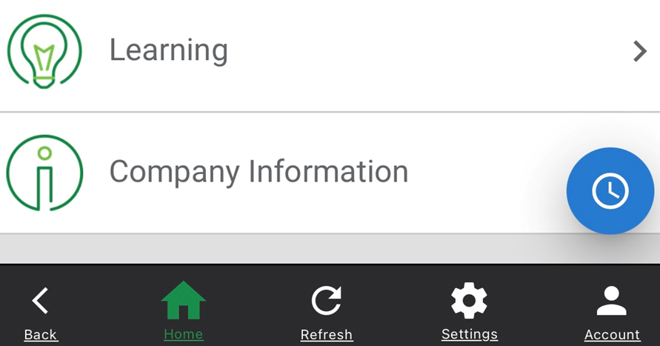

**Option 2:**

**-Web Time Clock** another way to clock in. Also used when you are physically onsite for your assignment. With this option you are more likely to overlook putting your comment code in so we recommend using the quick punch. You can us this option to view your current status to see if you are clock in or out.  See **SHOW ME HOW** document–Manage My Web Time Clock on Mobile.

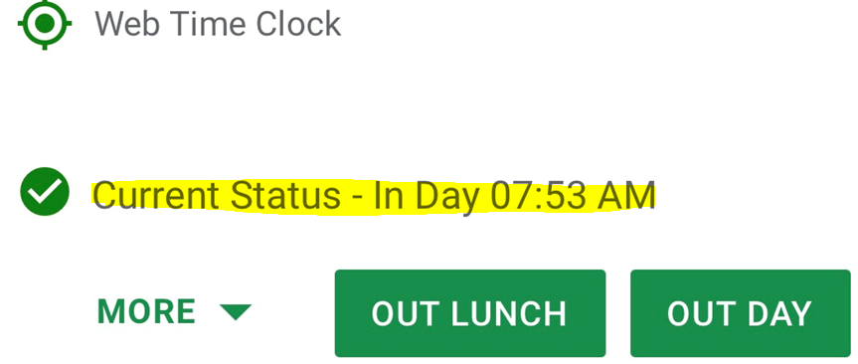

**Breaking Down the Required Fields…**

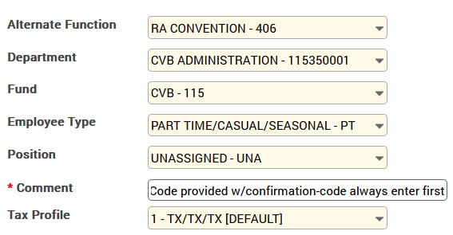

**NOTE:** If an allocation is not selected it defaults to RA 405.

**Alternate Functions Choices:**

 **RA 405** (default). This code should be selected when working non-convention work. Examples are D.G. Class; RA meetings etc. You will be instructed when to use this code. Same drop downs as above example, only options to choose.  
------------------------------------------------------------------------------------------------------------------------------------------

**RA Convention - 406.** Example above.

------------------------------------------------------------------------------------------------------------------------------------------



**RA Hanging Signs - 410.** Same drop downs as above example, only options to choose.

------------------------------------------------------------------------------------------------------------------------------------------

**CVB - Festivals – 408.** You **must select** PART TIME/CASUAL/SEASONAL-PT from the drop down. All other drop downs only one option to choose. 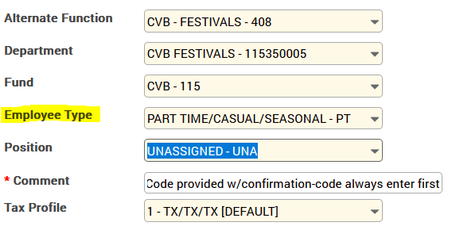

**Comment Code** (see additional info on comments code examples towards the end):   
*Always enter your Comment Code provided **before selecting** **IN DAY.** Using the Quick Punch (preferred option) for clocking in since it puts each step-in order when clocking in and last option is to select IN DAY at the end.

*Standard format is capital letter (default) and small letters after (thus preventing you from having to capitalize). For working Festivals/CCOT we may ask you to include the area where you worked.   
Examples: **Quake, Namc, Ccot ticket, Ccot lobby, Gf info, Gf lobby, Msf sales, Msf info, Msf lobby** etc.

*Do not deviate or add dashes etc. just type the code that is provided with your scheduled.

*Comment codes are how are how we track the groups/events that are worked. For groups it helps us to bill the client correctly. Festivals/Events helps to track # hours worked by the Burgundy Brigade for future planning/budgeting.   
*The code is normally an acronym for the group. It will either be on the work confirmation and/or schedule, or possibly just on the email confirmation.

**Comment Code:** To find your convention specific comment code, or abbreviated convention name look at:

**Work Confirmation:** 

**Staffing Schedule:** 

**CLOCKING OUT** select **OUT DAY** (out time will be **red)**. You are expected to clock out at the conclusion of your shift **OR** if the onsite contact releases you earlier than your scheduled end time. **A comment is always need if the time you were scheduled for does not match your clock in/clock out time.**

**IMPORTANT:** Check your hours, allocation code & comment code to ensure correct before you approve your time. Time must be approved the day the job was worked, unless it is incorrect.

**Totals Tab** **-** A good way to check to see if you have selected the correct allocation is to scroll down to the bottom under the Totals Tab (under Web Time Sheet Read Only). Example below shows a clock in as Part-Time Festivals (make sure doesn’t say full time). A clock in as working a Convention and a unit of time of 1 hour was added to meet the 4-hour minimum for conventions. (example below is from computer, app looks different, but still found under the Totals Tab).

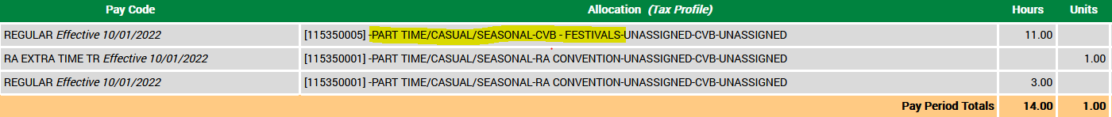

**HOW TO APPROVE YOUR TIME -** It is a policy you must approve your time after you completed your shift assignment **for that day**. If your time is incorrect, **do not approve**, take the appropriate action to fix your time. See helpful hints section. See **SHOW ME HOW** document–Approve My Timesheet.

Only **YOU** can approve your time, no one else. If you are unable to approve your time, we will send you an email with a screen shot of your Paycom entry. You will need to reply back to the email and authorize us (if correct) to approve your time. Same if we have to enter your time for you.

**TO APPROVE:**

* Go to: **Time Management**, **Web Time Sheet Read** **Only** -Verify your time is correct, allocation is correct and comment code are correct, if so, you may approve your time. In addition to reviewing the allocation in the Totals Tab, you can also see your allocation by selecting the drop-down arrow on the right of the date you wish to review. If all looks good, you can select **Approve by Date**.
* NOTE: it will automatically put check marks in on past days that you have not worked, leave them there so you approve them as you go. **However,** if you approve your time the day after you work, it will automatically put a check mark in on the current date. So, if you are working that day, you would just uncheck that box before hitting the **Approve by Date**.

**NOTE:** If you accidently hit Approve Pay Period and you are scheduled to work, you will need to take your approval off, otherwise you will not be able to clock in. See How to Unapprove Your Time section.

**TIME PERIOD** – Runs Sunday through Saturday. You will be asked to approve your first week then the second week at the conclusion of each week. If you have **not worked** within the two-week time period, you do not have to approve anything. Only those that have worked even 1 day during this time period need to approve their entire two weeks.

* Approving First Week**:** You should be approving your time as you work, thus any days you have not worked, you may need to go in and approve to close out the first week. Make sure you select **Approve by Date** and select the dates needing approved to close out the first week, it will be yellow.
* Approving Second Week: At the end of the two-week pay period, even if you have only worked 1 day during the two-week time period, you are required to approve the entire two weeks. Select **Approve Pay Period** to close out the second week, again turning it yellow. **Make sure SATURDAY is also checked if you are not working it.**

**IMPORTANT** - Monday mornings it is very important if you do have a punch request submitted watch for us to approve it so **you** can approve it, since we have a deadline to approve all time. We are in a meeting each Monday until approximately 9 a.m. so please expect a punch approval after this time. As a reminder, you will not see your corrected time until we approve the punch.

**HELPFUL HINTS FOR:**

**NOTE: Currently there is a new “default” drop down list to choose the reason which enable you from putting the comment code in first. We are working with HR to try and get this removed over add one that is free form for us to put the provided comment code first then the reason.**

**Incorrect Time:** GO TO:  **Time Management**, **Web Time Sheet Read Only** Click the **v** next to hours for the date you need to correct:  Click on the incorrect time (blue indicates IN / red indicates OUT) a **REQUEST PUNCH EDIT** screen comes up, see below.

**REQUEST PUNCH EDIT**:   
**DATE**: click on calendar to enter date (verify correct date);  
**IN DAY/OUT DAY** use the drop-down arrow to select what you are adding;  
**PUNCH TIME:** enter the time i.e. 8:00 AM (verify you have correct **a.m.** or **p.m.**);   
**ALLOCATION** (click on, should be in blue): select the correct allocation for the job you are working:   
**REASON FOR PUNCH CHANGE RQUEST**: ALWAYS enter the comment code first that was provided. i.e. Reason: XYZ and then add additional comments if need, if not, scroll down and select;

**Add Request**. It will then add to request for **us** to review and approve. You will NOT be able to see the change, until we approve it. It will show as one approved by us it will show as  Watch for us to approve your request for the change, so you can approve it

____________________________________________________________________________________________

**Missing Punch** -*Missing Punch* - If you see ?? / ?? (blue indicates IN / red indicates OUT) it means a missed punch, once you click on the ?? a **REQUEST NEW PUNCH** Follow instructions above (same for request punch edit). See **SHOW ME HOW** document–Request a Punch Change.

**\*Note** any incorrect time or missed punch should be corrected by doing the above.   
___________________________________________________________________________________________________________________________________________________________

**Forgot Your Phone at Home:** GO TO: **Time Management, Web Time Sheet Read Only**, tap the

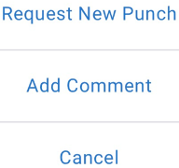 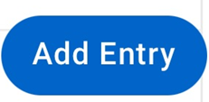 Add Entry, you will see:

Select **REQUEST NEW PUNCH** Follow instructions above (same for request punch edit) for your new punch request. Use this option when you need to **add** your time.

See **SHOW ME HOW** document–Add Punches with the Web Time Sheet

____________________________________________________________________________________________

**Forgot Your Comment Code or Information About Your Shift:** Follow steps above for *Forgot Your Phone at Home*, **select Add Comment.**

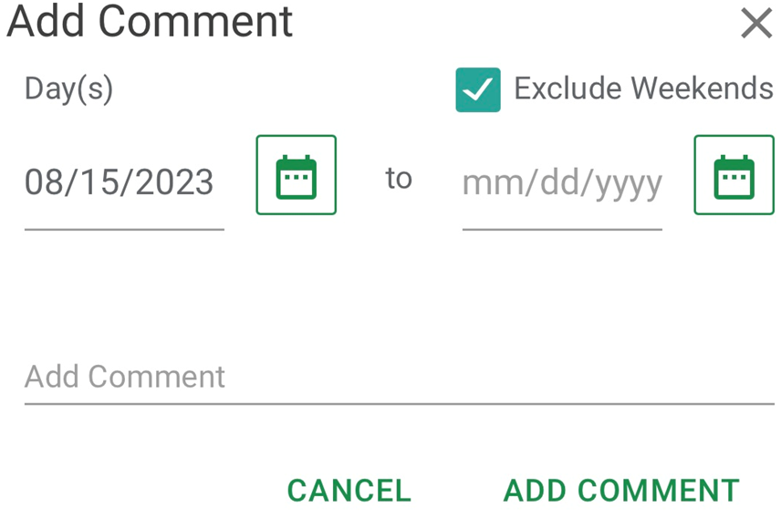

**DAY(s)** Click on calendar & enter the to and from date where you want the comment to be entered;   
**ADD COMMENT:** **ALWAYS enter the comment code provided for the Group/Event FIRST** i.e. Reason: XYZ Pam rlsd early at 12:15pm;

Select **ADD COMMENT**

__________________________________________________________________________________________

**Edit your Comment Code:** GO TO:  **Time Management**, **Web Time Sheet Read Only** Click the **v** next to hours for the date you need to make the update (you may have to turn your phone sideways). 

Scroll to the grey comment box you need to edit, click on it the below screen will display. Edit your comment then select, Update Comments. Be sure to ALWAYS enter the comment code provided for the Group/Event FIRST.

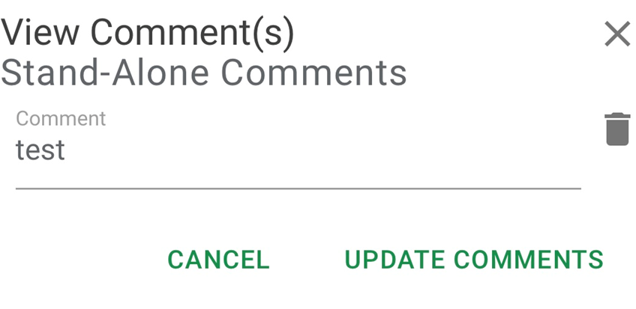______________________________________________________________________________________

**Remember:**

* Any request to change or add time we have to approve it first, before you are able to see the change.
* Once you have requested/made a change, to verify it is in there (so you don’t add it several times) go to **Time Management, Punch Change Request** selecting the drop down to view it. If your request is incorrect, you can edit what is there (click on the pencil) or you can delete it (click on trash can) and start over.
* You can also check here to see if we have approved your requests, if we did it will no longer show.
* You will not be able to make any request/updates if you have approved your time. You must take your approval off any order to make updates.

If doing any of these updates/request/edits on [www.paycomonline.net](http://www.paycomonline.net) it is quite similar, not exactly as on the mobile app, but knowing the above you should be able to figure it out.

**UNIT** – A unit of time will be added to your shift if you were:

* Released earlier than 4 hours (conventions only). Your time will show the actual hours you worked. Do not wait for us to add the unit, approve your time after your shift has ended.
* Onsite planner cancels your shift for the next day, you get paid a 4-hour min. since your shift was cancelled within 48 hours. We will enter the time as a unit, all you need to do is approve it. You will need to enter a new punch to enter your 4-hour min. for the day you were to work. We will have to approve your punch request before you see it. (comment code C)

To view the unit added go to Web Time Sheet Read Only, scroll down to the Totals Tab.

**Comment Codes - Additional Information:**

Additional information about your shift can be entered in the comment section. The comment code only needs to be entered on the “IN DAY” with additional information about your shift added after if need. Providing additional information about your shift in Paycom helps in case the client ever questions your shift. When documenting it in Paycom, there is no need to send us an email, since it is documented in Paycom so anyone from the Destination Services Team/Accounting etc. can see it. By sending an email it may only reach one person, who may not be in that day, so please enter it in Paycom AFTER the code we provide you OR before selecting “OUT DAY”.

*Reasons for entering additional information in comments section:*

A comment always needs to be added if the *time you worked is different than what you were scheduled* for.  
Always get the name of the person and include in the comments along with the time. It is important to include the time, since sometimes there are variations on when the planner tells you and when your Paycom actually clocks you out.

* Planner releases you earlier than your scheduled end time, you are only paid for the time worked and **NOT** what you were scheduled for. If your time is correct, then you may approve it. (comment code A)
* Planner releases you early and tells you they will pay you until your regular scheduled end time. If your time is correct, then you may approve it. We will add the additional time as a **unit** so you are paid for your entire shift. You **do not** need to wait for us to add this in, at the completion of your shift approve your time. (comment code B)
* Planner releases you less than 4 hours, you will get paid a 4-hour minimum (convention work only). If your time is correct, then you may approve it, you do not need to wait for us to add the unit. (comment code A) **Note:** If you are scheduled for less than 4 hours, then no comment is needed, we will add the unit automatically.
* Planner asks you to stay longer than originally scheduled. (comment code C). You do not need approval from the office to extend your shift. However, if it puts you into overtime, then you need to get the clients approval to pay the overtime. (comment code E)
* Planer asks you to start your shift earlier than what you were scheduled. (comment code D)

**COMMENT CODE EXAMPLES:**

A. Jane released at 2 pm (add before clocking out, if you were released earlier than what you were scheduled)

B. Jane released at 1:30 pm ok to pay to end of shift (add before clocking out)

C. Jane extended shift til 5 pm (add before clocking out)

D. Jane rqst to start at 6:30 am (add before clocking in)  
E. Jane extended shift til 8pm agreed to pay OT (add before clocking out)

**Four Hour Minimum** - You may be asked to work at the CVB, festivals, holiday events, consumer tradeshows or attend meetings/training. These assignments are exempt from the four-hour minimum and are paid only for the time you are there.

**Timesheet Notes/Reminders/FYI:**

* The pay period begins on Sunday and ends on Saturday.
* Anything over 40 hours is considered OT.
* RULE OF THUMB – do NOT clock in more than 5 minutes prior to your scheduled shift time.
* You are expected to clock out at the conclusion of your shift OR if the planner releases you earlier than your scheduled end time. A comment will be required if released early than scheduled.
* Breaks/lunch are paid when working conventions. However, if you are scheduled with an unpaid break in-between use the **Out Lunch** then upon return use the **IN Lunch**, thus preventing you to have to retype in the comment code. Or if working non-convention work and allowed a break, use the Out Lunch & In Lunch.
* If you are making a punch request for a day other than the current day please make sure the correct day is selected and you have selected a.m. or p.m. correctly.
* Your comment code for the group/event MUST be entered first before selecting “IN DAY”. Same with anywhere you see REASON (editing time, punch request).
* To get the number of hours worked in a year, in Paycom go to Payroll, select View Pay Stubs and then Year-To-Date Totals.
* You will not be able to make any request/updates if you have approved your time. You must take your approval off any order to make updates.
* Web Timesheet Read Only is where you go for most everything except clocking in and out. This is your timesheet, where you go to approve, view your time sheet and correct anything that is wrong.

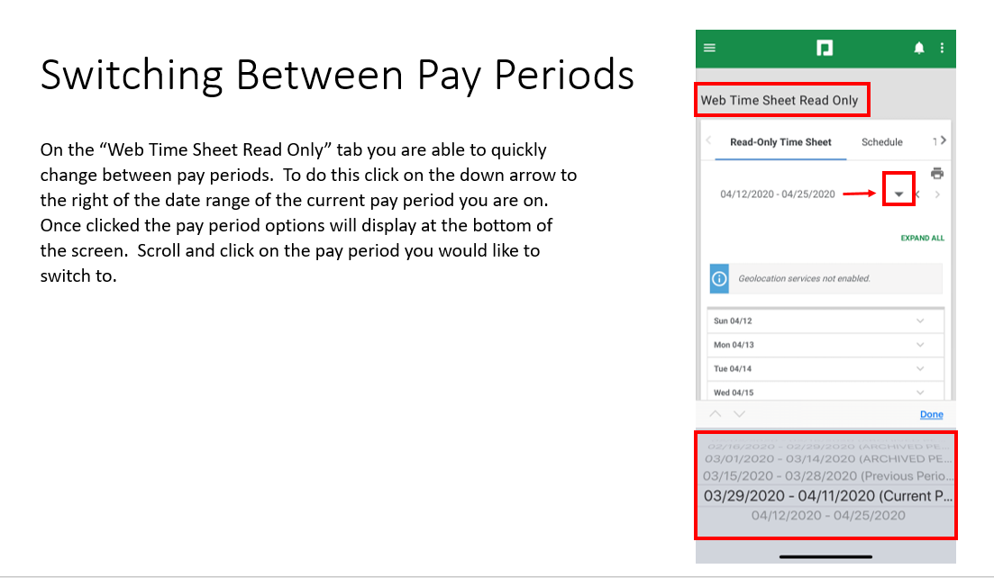

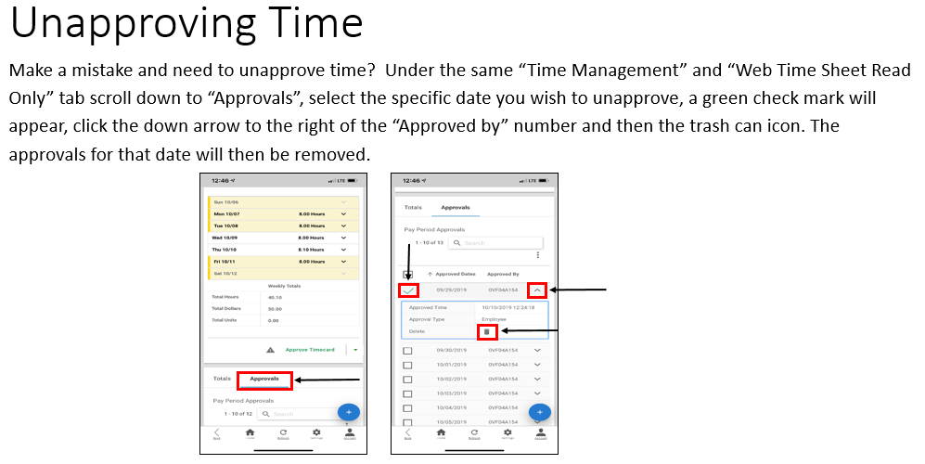

**NOTE:** if your time sheet is blue/green you will not be able to delete your approval since we approved it already.

**REVOKE ALL APPROVALS** - If you accidentally approved your entire time sheet you can revoke all approvals all at once. To do (still in the approvals area) click the box to the left of Approved Dates, it will automatically check the dates (you can uncheck a date if you do not want to remove an approval on a certain date), click on **3 dots (vertical)**, it will say **REVOKE APPROVALS**, select.

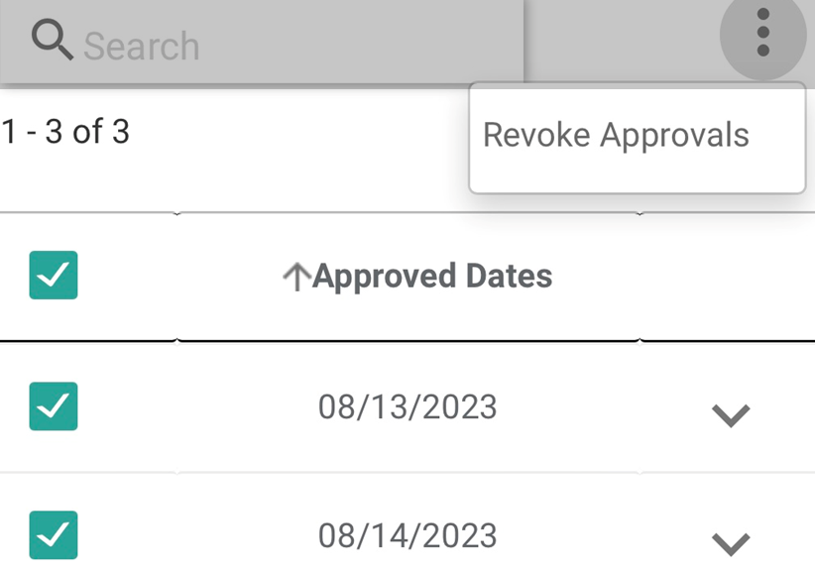

It is recommended you keep a file for everything PAYCOM! Cheat sheets provided etc. so you can refer to them. Please try and resolve the error yourself with the information that is provided, then if you can’t, contact Destination Services for help. We refer back to these documents also. Until PAYCOM becomes easy for you, please refer to the information in the email that is sent, your handbook, or the weekly emails sent reminding you to approve your first and second week.

**COMMENT CODES** (provided on the documentation you receive from Destination Services):

**Admin** always include the area you are working.Use when working in other departments w/in the CVB if a code is not provided below. **Example:** Admin accounting; Admin marketing  
**Bb** always include what this is for. Use when attending any training, orientation, meetings, Destination Grapevine (DG) etc. **Example:** Bb dg or Bb meeting or Bb orientation **Brochure delivery**-use for those that are assigned to deliver brochures.   
**Ccot** + area working: Ccot decorate; Ccot tkt; Ccot greeter; Ccot lobby (switchboard/hometown Christmas); Ccot helpers; Ccot phone bank; Ccot tkt prep

**Conv center** rare, but used if asked to work the convention center.  **Depot**-use for working at the Depot regular train runs, not CCOT work   
**Dest services**–use for those staff that come in and help cover in the office or help with other projects for Destination Services.   
**Gf+ area working**: Gf lobby; Gf Sales; Gf info; Gf phone bank etc. use for any work involving GrapeFest

**Gallery-**use when working a gallery event/reception.

**Hf**-use for working any Heritage Foundation events (i.e. First Friday, Candlelight Tour of Homes Nash Farm events etc.).  
**Leisure kiosk** – when working the hotel lobby kiosk at Gaylord. If you are assigned to work the front lobby kiosk for a group, then use the comment code provided on your staffing sheet to track the hours to that group   
**Msf** - Msf lobby; Msf Sales; Msf info; Msf phone bank etc. use when working Main Street Fest   
**Palace** use when working ANY including CCOT at the Place  **Switchboard** use when covering the CVB Phones when Lisa Doss is on vacation or out sick.   
  
Additional documents **Show Me How**:

-To Use Quick Punch on Mobile  
-To Manage my Web Time Clock on Mobile  
-To Approve My Timecard

-To Request a Punch Change

-To Add Punches with Web Time Sheet