Festival

&

Event Worker

Handbook



April 2025**GRAPEVINE CVB’S MISSION STATEMENT**:

The Convention & Visitors Bureau acts as the promotional arm of the City of Grapevine and is responsible for actively selling, marketing and publicizing Grapevine globally. The Bureau promotes the city’s hotels, meeting facilities, historic and family attractions, festivals and events, dining establishments and retail businesses to the group meetings and leisure markets.

**GRAPEVINE CVB’S BRAND PROMISE**

Grapevine is the premier destination city in North Texas. We offer visitors a unique blend of historic Texas heritage, combined with contemporary amenities. Whether in Grapevine for business or pleasure, visitors will find world-class hotels, excellent dining options, abundant live entertainment, diverse retail shopping, historic and family attractions and internationally award-winning festivals, all delivered with the finest in Texas hospitality.

**F&E WORKER MISSION STATEMENT:**

As members of the F&E Assistance Team, our goal is to fulfill the Grapevine CVB’s mission statement. In addition, we are an extension of the Festival & Events Management staff and steering committees whom we serve, as well as ambassadors for the City of Grapevine. Our actions must be beyond reproach, at all times.

MCj04350450000[1]

WELCOME!

**TABLE OF CONTENTS**

MCj04135520000[1]

* **FESTIVAL & EVENT WORKER ROLE: Pages 4-6**
* **HUMAN RESOURCES: Pages 7-12**
* **SAFETY & OTHER ITEMS: Page 13-16**
* **GRAPEVINE FESTIVAL INFORMATION: Pages 17-18**

**-KNOW YOUR EVENTS**

* **NOTES: Page 19**

**The Festival & Event Worker’s Role**

The F&E Team is a vital link between Festival & Event Management, steering committee members, vendors, attendees, and the City of Grapevine. We are hospitality specialists who serve in different capacities and extend the hand of friendship to our attendees while being an extension of Festival & Event Management.

The F&E Team offers individuals a wide-variety of tasks that change from day-to-day and event to event.

**Know Your Job**

The F&E’s position is to be on board to take direction for a plan that the Festival & Event planner has spent months, or maybe years designing for their festival or event. In other words, we are foot soldiers. It is important to refrain from critiquing or evaluating how the event could work better. Since we do not know any of the behind the scenes goals, functions or budgets that must be achieved, input from us is inappropriate.

We are not working in executive positions nor are we the research & development consultants. If there is a problem within the event, we are only slowing down the process by making the Festival & Event planners listen to our unsolicited brainstorming. In the past, each of us may have had jobs where we were the movers & shakers. However, the F&E position is not that job. Our job is to perform the tasks that have been outlined on our schedule; ready to be a second pair of hands.

**DO**:

* …Be ready to be trained and learn our planner’s way. Be flexible, be focused, hospitable and have fun.
* …Be personable – the host/hostess with the mostess.
* …Be positive, about Grapevine and everything…at all times. You never know with whom you are speaking.
* …Read every issue of Grapevine Today as it has comprehensive and pertinent information.
* …Review and be knowledgeable about our CVB web site: [www.GrapevineTexasUSA.com](http://www.GrapevineTexasUSA.com).
* …Treat the attendees and vendors as if they are guests in your home. Tell them about Grapevine’s history, landmarks and favorite places. Share your enthusiasm for Grapevine with them.
* …Be helpful. Go above and beyond to provide extraordinary service, without putting yourself in harm’s way.
* …Tell our guests about the variety of Festival & Events conducted in Grapevine each year.
* …Watch your body language: Smile…even if your hair is on fire!

* …Learn when to speak and when to refrain from speaking.
* …Be a good worker, a great plan follower, a gracious and knowledgeable Ambassador for Grapevine. Most of all, be a good friend: one who refrains from giving unsolicited advice especially during the trying moments.
* …Attend available training classes i.e. Destination Grapevine, Workplace Standards etc. as required by the City and/or CVB.

**DO NOT**:

* …Think of better ways to organize the event.
* …Interrupt or be overzealous. Listen carefully to the planner’s explanation and ask only relevant questions after receiving instructions.
* …Change a procedure because you think there is a better way. A Festival & Event planner has a reason for asking that a job be executed in a certain manner, which is not always evident to our team.
* …Discuss the last good or bad event.
* …Give your executive advice from a previous job.
* …Discuss how planners or attendees look or dress.
* …Ever hint that you desire anything (working tools, promotional items, food, etc.) provided for the delegates.
* …Take sides or discuss “inner conflicts” among the planners. Always remain neutral.
* …Protest or expect to remain on the job if you are released early. Schedules are subject to adjustment. The person with the most hours or overtime hours should be first to volunteer to leave early.
* …Discuss politics, sex or religion – ever.
* …Use cell phones while on the job unless you are assisting an attendee. Cell phones are to be turned on vibrate mode during your assigned shift. Check your messages **during breaks only**.
* …Gossip. It is unacceptable. Keep your personal comments regarding other F&E members out of the workplace. If it is an issue that requires discussion, please contact either Lauren or David or Human Resources.

**HUMAN**

**RESOURCES**



**Human Resources**

F&E Worker staff is classified by the City of Grapevine as ‘casual’ or ‘as-needed’ employees. This means that all legally-mandated benefits i.e. workers’ compensation, Employee Assistance Program (EAP) are extended. However, this position is not eligible for city sponsored benefit programs. A casual employee may work up to 999 hours within a year which begins on January 1. **Each member of the F&E Team is expected to work at least 50 hours per year. Please visit with us if you are not able to make this commitment.**

**PRE AND POST ASSIGNMENT ACTIVITIES**

**Training**

Orientation will be provided. All training will be “on the job” training.

**Required Training**

At times it will be mandatory for you to complete training that is require by the City of Grapevine i.e. Work Place Standards or other types required training. You will be required to clock in and out when you start and finish the training.

**Communication**

Email is the primary and most effective method of communication when working with a staff as large as the F&E team. Please be sure to check your email **daily** since it is the F&E’s lifeline. It is also wise to check your spam folders as sometimes emails are mysteriously redirected to spam.

**Texting**

Used in most cases for last minutes job request or possible Paycom action needed items. Your cell phone provider is needed in order to set this up. If you change your cell phone provider, please let us know, so there is no interruption in receiving text.

**Scheduling**

You will be contacted **primarily via email** about an assignment and most assignments will be “first come first serve”. **Be sure to sign up within 24-48 hours**. If time is of the essence, you will be given a response deadline. If your ability to fulfill a shift is in question, please do not accept the assignment**.**

When last minute staffing requests are received, an email blast and/or text message will be used to communicate the request. Since time is of the essence, it will be filled based on who responds first. Calls to individual members will be the last resort.

For larger events we may ask for your availability to hold certain dates well in advance of the 6-week staffing time frame. If we do, and you say you are available, we ask that you keep your commitment (unless an unforeseen emergency arises).

If you have accepted an assignment and have not received your work confirmation

at least 72 hours prior to your assignment (unless it was a last-minute request) contact whomever requested you to work it, either Lauren Price at 817.410.3121 or David Taylor at 817-410-3191. Never assume you are working or not working an event if you have not received your confirmation. Always expect a reminder email with assignment details.

If you accept an assignment and it is canceled, you will be notified by either email, text to check your email or phone/voice message depending on how far out it is. **A reply back is required, to ensure you received the cancellation**. If the planner cancels your shift 48 hours or less, you will be paid the 4-hour minimum**.** We will add this as a unit to Paycom, which you will need to approve. See Paycom Handbook.

**Canceling Your Shift**

If you are unable to fulfill your commitment to work your shift, please provide as much advance notice as possible in order to find a replacement.

Canceling your shift24 hours or less outside of normal office hours, Saturday, Sunday or holidays:

* **DO NOT SEND AN EMAIL - You must text first, if no reply follow-up with a call***.*Please refer to your confirmation for contact/phone information for specific instructions on whom to contact and what order.

Canceling your shiftduring normal business hours, Monday-Friday, 8 a.m.- 5 p.m. (excluding holidays):

* 24 hours or less **- you must call and/or text** whomever appears first on your work confirmation.
* If more than 24 hours - you can email or call. If emailing the subject line must stand out i.e.: **Cancel Shift for XYZ for June 21 & 22**
* If you can’t reach Lauren then contact David.

**NOTE:** **In all cases, it is your responsibility to follow-up with us to ensure we received your voice message and or email.**

Running late or sick

If you are running late for your shift or are sick on the **day of your** **shift, YOU are to call the event planner,** listed on your work confirmation to let them know your expected time of arrival. If you are sick, please ask the planner if a replacement is needed and if so, follow the instructions on your work confirmation on whom to contact.

**Overtime Policy**

The City of Grapevine work week begins on Sunday and ends on Saturday. Hours worked over 40 including any CVB or City assignments during that week is overtime. Overtime is not permitted without approval in advance of the occurrence. **It is important that you know the total number of hours that you are scheduled to work within a week (sum of all assignments that week).**

If a planner asks you to stay, causing you to incur overtime, then the planner must agree to pay the overtime. If you worked other jobs during the same week (Sun.-Sat.) those hours must be considered if you are being asked to extend your shift. If this is the case and by extending your shift puts you into overtime, please let them know the overtime rate will apply. If they approve, document it in Paycom in the comments section: name of the planner who authorized the overtime, with date and time you were asked to extend to. If there are any concerns regarding this procedure/policy, please follow procedure on who to call on your work confirmation.

When scheduling, the hours of each team member are tracked to avoid overtime. **However, it is your responsibility to know your schedule and to avoid overtime.**

Prior approval is not needed if the request to stay longer does not put you into overtime or if the planner is willing to pay overtime. A note in Paycom as described above is still required. If you cannot stay as requested, politely tell the meeting planner that you have other commitments and are unable to stay. Be gracious. Avoid any abrupt or curt tones.

Sometimes events are willing to pay overtime in order to keep the same people. In this case, if the planner asks for volunteers to leave early, those people that have overtime should be the first to offer to leave.

**Paycom**

Please see Paycom Handbook – Show Me How.

**ON THE JOB - PREPARING FOR YOUR ASSIGNMENT DAY(S)**

Preparation means that you are physically and mentally ready to work. Once you accept the assignment, please be prepared to work. While the F&Es work in the hospitality industry which naturally creates a social environment, the client, guests and work come first. Socializing is for breaks and personal time.

**Review your paperwork…**

**Read the email** that is sent with your schedule/work confirmation it contains important information about your assignment. Review your schedule when received to verify the day(s) and time you are to report to work.

**The Day of…**

* **Be sure to have yourself well-nourished before you start your day**. You should be prepared to work five (5) hours before expecting a 15-minute break. If the onsite contact or their designee asks you to take a break sooner or later than you would prefer, please accept their request graciously and abide by their event schedule.
* **Check your email prior to leaving for your shift.** Last minute shift changes may be communicated later in the evening, so always a good idea to check your email.
* **Always arrive at the work location at least 15 minutes before your shift begins**. This is to allow extra time for unexpected hard to find parking days, heavy traffic or other unexpected occurrences. You must be in place and ready to start at the designated time on your schedule. You can clock in 5 minutes prior to your scheduled start time.
* **Know where to check-in**. Your schedule states your designated area and

on-site planner’s name and cell phone number. You have officially reported for your assignment once you have checked-in with the on-site planner. Present yourself. If you are having difficulty finding the on-site planner, call their cell phone, or find a event staff member and ask them to help you. Do not expect the on-site contact to look for you. We are proactive not reactive.

* **Be ready to find your position and task for the assignment**. Visit with other team members before arriving at the work area. It is not appropriate to visit with other work buddies while on task. If you need to “catch-up” call your friend the day before, get together for lunch the week before or meet before your shift starts. While our team enjoys each other’s company, it needs to be done on your own time, and not on the planner’s or CVB’s dollar.
* **Break and meal policy (this is a guideline)**
  + ▪ 5 hours: one 15-minute break
  + ▪ 6 hours: one 30-minute break
  + ▪ 7-8 hours: one 15-minute break and one 30-minute meal break
  + ▪ 9 hours: two 15-minute breaks and one 30-minute meal break
  + ▪ 10 or more hours: two 15-minute breaks and two 30-minute meal breaks
* Always be considerate of your co-workers by returning from your breaks on time. Before leaving, confirm your return time with your co-workers. Do not stay beyond your committed time as others are waiting for your return. If a event planner is so kind as to invite you into a private staff area to lunch, please stay within your timeframe. If needed, the bathroom break is to be scheduled inside the meal break period. This applies to all meals, in all areas.
* Do not eat or drink in public. Water is ok, if authorized by the on-site planner. Be sure to keep the water out of sight and out of the way since you may be working around electrical equipment. Use your discretion. If water is delivered to you, please be discreet.
* Supervisors – supervision is provided primarily by each event’s on-site contact.

On occasion, an onsite contact may designate one of our staff to be the point of contact after the program begins. In either case, please be respectful of your co-worker who has been appointed this position, and give them your full support as they have been asked to handle a directive from the planner.

* Gifts/event promotional items – occasionally, an event planner may give you promotional items. For security purposes and to protect you, be sure to obtain the meeting planner’s business card and note stating that the item was given to you as a gift.

**SAFETY**

We work in large public venues with thousands of people. While we have the assurance of video cameras and security personnel to help maintain a safe environment, you are still in an area where thieves know people have more cash and valuables than usual due to the event. It is up to you to take responsibility for your personal safety and your belongings. Please have the same awareness as you would inside a mall or mall parking garage.

**At All Times:**

* Be aware, *watch your back.* If possible, enter and leave with someone you know. If you feel uneasy, contact the event manager.
* Secure your vehicle. Do not leave valuables in sight. Put them out of sight before you arrive at your assignment.
* Keep your belongings near you or in a designated secure place. Do not bring valuables i.e. unnecessary cash, credit cards, jewelry or sentimental items.
* Take your personal items with you for breaks, meals, etc.
* Never leave food or beverages unattended. Do not consume if they have been out of your sight.
* Keep personal bags and totes zipped-up when walking in crowds.
* Do not go alone into empty corridors, tents or rooms.
* Be selective about providing good deeds i.e. taking a guest for errands in your personal car. While this is very hospitable, we do not know the individuals with whom we are interacting and do not want to have our staff put in harm’s way. Politely review transportation options with the guest.
* For security reasons, do not watch a guest’s or anyone’s personal belongings. Have the guest check their belongings with the visitor information concierge at Grapevine Main Station, if available.

**OTHER ITEMS**

**Winter weather/Ice Storms**-Regardless of the weather, our commitment to the planner must be fulfilled. When an ice storm is being forecasted, staff should allow plenty of time to get to the work assignment safely. The CVB will make every effort to accommodate staff members who do not feel comfortable driving in winter weather conditions. Please follow your normal procedures for during office hours/and after office hours and contact the appropriate person if the need should arise.

**Direct deposit** - One of the most important services Finance provides is paying employees accurately and timely. We will no longer be **printing and distributing** payroll checks. We are requesting all employees who do not currently take advantage of direct deposit **to set up direct deposit in PAYCOM through the ESS app or online**.  This is a very easy process and should only take a minute of your time.

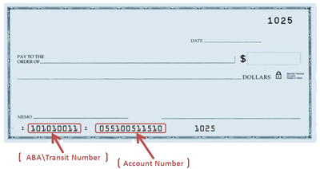

Below are the directions to follow in ESS to update your direct deposit information**.**

DIRECTIONS

Log in to your ESS profile on a computer or through the Paycom app on your phone.

In your ESS profile

Choose Payroll

Choose Direct Deposit

Select your account type (checking or savings)

Enter your bank name, routing number and account number.

Make sure and scroll to the bottom and click the box to agree to the terms and then click “update.”

**Employee & Family Clinic**

The City of Grapevine provides a program for All Active City employees and their dependents are eligible to use the program. An eligible dependent is defined as a spouse and/or dependent children under the age of 26.

* Clinic ID card must be presented at the time of service
* Walk-in for a same day office visit; call ahead for same day appointment, if possible
* No copay for clinic visits
* Acute care includes coughs, colds, flu, sinus infections, sore throats, ear aches, and other minor illnesses
* Current list of Drs. as of 8/2023

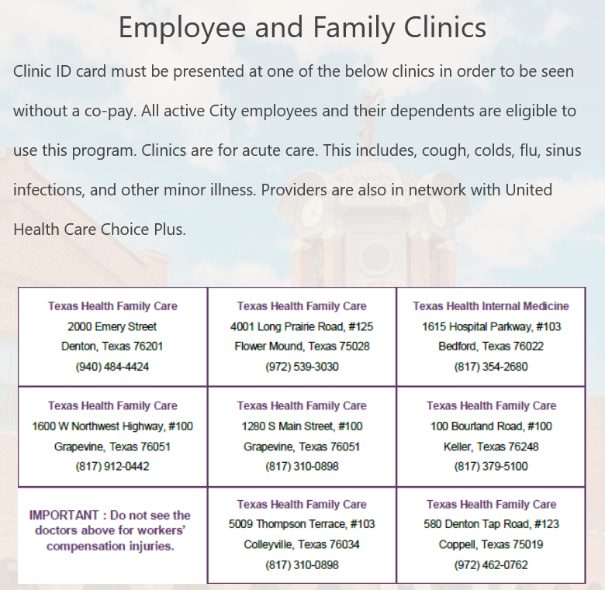

**Public Agency Retirement System (PARS-AR 457 Account)**

Part-time, casual and temporary employees who are not eligible to participate in the Texas Municipal Retirement System will contribute 6.2% of gross wages into their tax-deferred PARS-AR 457 Account. The City will contribute 1.3% of the employee’s gross wage into the employee’s account. Employees are 100% vested immediately in the PARS-AR 457 Account. [www.pars.org](http://www.pars.org)

**Address & Name Changes**-**you are required to make the updates in Paycom**. Once, updated you will also **need to advise Destination Services so we can update our system** also (CRM) if you have a change of address.

**KNOW YOUR FESTIVALS & GRAPEVINE**

It is important that you are familiar with all of Grapevine’s festivals & events, for the most up-to-date information, please visit [www.GrapevineTexasUSA.com](http://www.GrapevineTexasUSA.com), event websites, <https://www.grapevinetexasusa.com/events/>, and any resources that will be helpful to you in assisting Grapevine’s visitors.

**Helpful websites:**

* + [GrapevineTexasUSA.com](http://www.GrapevineTexasUSA.com)
  + [www.grapevinetexas.gov](http://www.grapevinetexas.gov)
  + [www.GrapevineChamber.org](http://www.GrapevineChamber.org)
  + [www.ILoveGrapevineTexas.com](http://www.ILoveGrapevineTexas.com)
  + [www.GrapevineMills.com](http://www.GrapevineMills.com)
  + [www.BassPro.com](http://www.BassPro.com)
  + [www.GrapevineTowneCenter.com](http://www.GrapevineTowneCenter.com)
  + [www.passporthealthtexas.com](http://www.passporthealthtexas.com)
  + [www.dfwairport.com](http://www.dfwairport.com)
  + [www.traveltex.com](http://www.traveltex.com)
  + [www.visitdallas-fortworth.com](http://www.visitdallas-fortworth.com)
  + [www.txwines.org](http://www.txwines.org)
  + [www.dfwconnector.com](http://www.dfwconnector.com)
  + [www.GrapevineToday.com](http://www.GrapevineToday.com)
  + [www.ridetrinitymetro.org](http://www.ridetrinitymetro.org)

**GRAPEVINE INFORMATION**

Vintage Texas®

1M+ sq. ft. of Meeting Space

11,000 Area Hotel Rooms

1,800+ Flights Daily • 200+ Restaurants

Historic Downtown - Grapevine Mills

LEGOLAND® Discovery Center – SEA LIFE Grapevine Aquarium

Meow Wolf

Grapevine Glockenspiel’s Would-Be Train Robbers

Bass Pro Shops Outdoor World - 81 Holes of Premier Golf

Grapevine Vintage Railroad – Urban Wine Trail

Palace Arts Center

MCj04238700000[1]

**NOTES**