2025



Handbook

Show Me How

## **Getting Started:**

* It’s highly recommended that you **keep a dedicated Paycom folder** (digital or physical) for all cheat sheets, weekly emails, and helpful resources.
* Please **attempt to resolve any issues yourself** using the provided documentation before reaching out for help.
* If you're still having trouble, contact **Destination Services** for assistance — they also refer to the same documents you’ve been given.
* Until Paycom becomes second nature, refer to:
  + Emails from Destination Services
  + Your Paycom handbook
  + Weekly Reminder Emails (to approve your 1st & 2nd week of time)

**Paycom Access:**

* **Paycom can be accessed via mobile app (this is required to clock in) or** [**Paycom website**](https://www.paycomonline.net)**.**

**Quick Access to Training Videos:**

* **Clocking-In**: [Watch Video](https://share.vidyard.com/watch/rDKeLMfFYBUtAjG3E1sU1M)
* **Punch Change Request**: [Watch Video](https://share.vidyard.com/watch/HhWZLdTA5Y3ERb8TKps9ux)
* **Editing a Punch**: [Watch Video](https://share.vidyard.com/watch/Qx3NU6ra2s5bvg7Ho3XNAP)
* **Approve Timecard**: [Watch Video](https://share.vidyard.com/watch/v87uxqnx2DS9eJruF5gYvr)

**Accessing Other Show Me How Videos:**

* **Location**: on **Paycom** Under **Learning > My Learning > Paycom University**, then filter by **Topics of Interest.**
* These videos are for reference, not required training.

**Need Help/Who to Contact:**

* **Password/Technical Issues**: Contact HR at (817) 410-3176.
* **Pay Issues**: Email the Destination Services Department or call (817) 410-3538 or (817) 410-3191.
* For unresolved issues, contact Pat Burkholder at (817) 410-3116.

**Clocking In – Key Steps:**

**Rule of Thumb**: **Do not clock in more than 5 minutes prior to your scheduled shift.**

1. **Option 1: Quick Punch (Preferred Method)**
   * When onsite for your assignment, use the **blue dot**  from the home screenon your Paycom App.
   * Quick Punch is the preferred method, as it directly takes you to the **"IN DAY"** option.

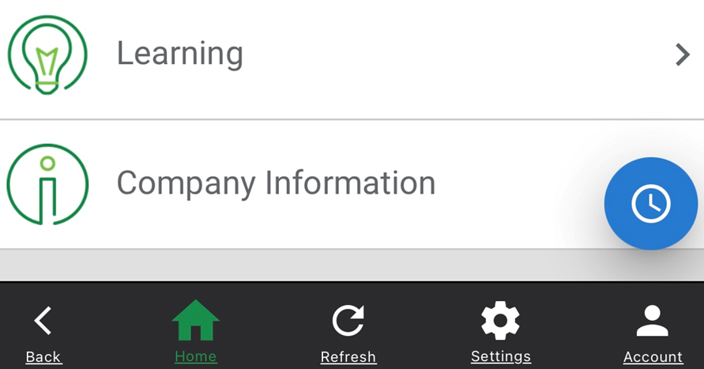

1. **Option 2: Web Time Clock**
   * Another method to clock in.
   * You can also check your status (clocked IN or OUT), but it may be easier to miss adding a comment code, so **Quick Punch** is recommended.

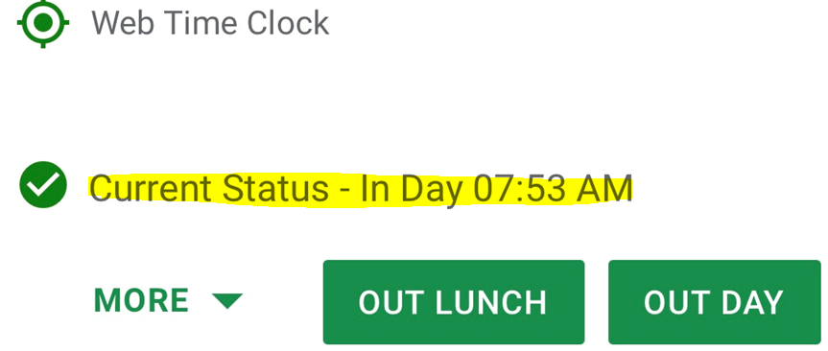

**Alternate Functions (Allocation):**

**YOU REQUIRED TO SELECT ONE OF THE FOLLOWING**

* **RA 405 (Default Code)**: (Less Common)
  + **This is the default Alternate Function chosen** if no other code is selected. It’s used for non-convention work.
  + **Examples**:
    - Destination Grapevine Class
    - Burgundy Brigade Meetings
  + You will be instructed when to use this code.

**Alternate Function Choices:**

1. **RA Convention - 406**: (Common)
   * This code should be used for convention-related work, as shown in the example below.

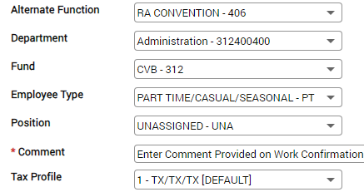

1. **CVB Festivals - 408**: (Used Frequently During CCOT)
   * When working Festivals/CCOT, you **must select “PART TIME/CASUAL/SEASONAL-PT”** from the dropdown.
   * All other dropdowns will only allow one option to choose, which simplifies the rest of the selection process.
2. **RA Hanging Signs - 410**: (Less Common)
   * Use this code only when hanging signs, with the same options selected as RA Convention - 406, Comment will be provided by Betty or Lauren.

**Key Takeaways:**

* **RA 405** is the default for non-convention work unless otherwise specified (less common)
* **RA Convention - 406** is used for convention work. (most common)
* **CVB Festivals - 408** is used for Festivals/CCOT (used frequently during CCOT)
* **RA Hanging Signs - 410** applies to hanging signs positions (less common)

**Comment Codes:**

1. **Comment Code Entry**:
   * **Always enter your Comment Code before selecting "IN DAY."**
   * **Quick Punch** is the preferred method for clocking in since it automatically puts each step-in order, and the last option will be selecting "IN DAY."
2. **Standard Comment Code Format**:
   * **Capital Letter (default)** followed by **small letters**. This prevents you from having to manually capitalize the code.
   * For **Festivals/CCOT**, you may be asked to **include the area** where you worked (Ex. Ccot lobby, Gf info)
   * You should **not deviate**, add dashes or other characters. Simply type the provided code exactly as instructed.
3. **Where to Find Your Comment Code?**:
   * The comment code (or the abbreviated convention name) can usually be found on:
     + Your **work confirmation** and/or **schedule.**
     + Sometimes, it may be in the **email confirmation** for your assignment.

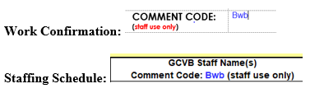

1. **Purpose of Comment Codes**:
   * Comment codes help track **groups/events** worked, which is important for:
     + Accurate **billing** to clients.
     + Tracking the **hours worked by the Burgundy Brigade** for **future planning** and **budgeting**.

**Clocking Out and Approving Time – Key Points**

**Clocking Out:**

* **Select "OUT DAY"** when clocking out.
* **Clock Out Expectations**:
  + You are expected to clock out **at the conclusion of your shift** or if the **onsite contact releases you earlier** than your scheduled end time.
  + If your actual clock-in/clock-out times differ from the scheduled times, you **must add a comment** explaining the discrepancy before clocking out in the comment section (Ex. Jane released early, Jane asked me to stay 30 min extra)

### ****Approving Your Time – Pay Period****

#### ****Policy Reminder****:

* **You must approve your time after completing each shift.**
* **If your time is incorrect, do not approve** it. Take the necessary steps to fix your time.
* **Only YOU can approve your time**—no one else can do it for you. If you're unable to approve your time, you will receive an email with a screenshot of your Paycom entry. **Reply to authorize approval** if everything looks correct. If we enter your time for you, we will also need your authorization to approve it.
* **Your Time for the ENTIRE week must be approved by Monday morning** **each week.**
* If you have a **punch request submitted over the weekend** we will have to approve the correction on our end before you can. *This typically happens after* ***9 a.m. on Mondays****.*
* **You cannot approve your time** until a punch request is approved so be sure to check back for approval.

**Pay Period Overview:**

* **The pay period runs Bi-Weekly from Sunday to Saturday**.
* **You must approve the entire two-week period** if you’ve worked even **one day** during this time. If you **haven’t worked** during the two-week period, you **don’t need to approve** anything for the pay period.

**Approving the First Week:**

* Approve your time as soon as you clock out for the day (if all is correct)
* If any days haven’t been approved, go to the **first week’s dates** (Sun. – Sat.) and select **Approve by Date** to close out the week. The first week will turn **yellow** once approved.

**Approving the Second Week:**

* At the end of the two-week period, approve **all days**, even if you’ve worked just **one day**.
* Select **Approve Pay Period** to close out the second week. This will turn **yellow**.
* If you’re not working on Saturday, **make sure Saturday is checked as well** (sometimes this is unchecked)

### ****How to Approve Your Time****:

1. **Go to Time Management**:
   * Navigate to **Web Time Sheet Read Only** to review your hours.
2. **Verify Your Details**:
   * Make sure your **time**, **allocation code**, and **comment code** are correct.
   * You can verify your allocation by:
     + Selecting the **drop-down arrow** next to the date you want to review.
3. **Approve Your Time**:
   * If everything looks good, select **Approve by Date** for the days you worked or **Entire Pay Period** if you are not scheduled to work for the remainder of the pay period.

**Color Indications:**

**Yellow Dates**: These are the dates you have approved, but we have not yet approved on our end.

**Green Dates**: These are the dates that both you and DS team have approved.

**White Dates**: These are the dates you have not yet approved, and we will not approve them on our end until you approve them (Yellow).

### ****Important Notes****:

* **Automatic Checkmarks**:
  + If you haven’t worked on past days, **checkmarks** will automatically appear. Leave them checked as you approve.
  + If you’re approving time **the day after** you worked, **a checkmark will appear for the current day**. Uncheck this if you're still working on that day before hitting **Approve by Date**.
* **Accidentally Selecting "Approve Pay Period"**:
  + If you accidentally select **Approve Pay Period** while still scheduled to work additional days in the pay period, **unapprove it** immediately, or you won’t be able to clock in. For help, see **How to Unapprove Your Time**.

**REQUEST PUNCH EDIT:**

* **Navigate to:** **Time Management** > **Web Time Sheet** (Read-Only).
* **Fix the time:** Click the drop-down next to the hours on the date you need to correct.
* **Edit Time:**
  + Click on the blue "IN" or red "OUT" to bring up the ***REQUEST PUNCH EDIT*** screen.
  + **Date:** Use the calendar to verify and select the correct date.
  + **IN/OUT:** Select what you're adding using the drop-down.
  + **Punch Details/Punch Time:** Enter the correct time (verify AM/PM).
  + **Allocation:** Select the appropriate allocation (in blue).
  + **Reason for Punch Change Request:**
  + **Additional Comments:** **Always enter the provided comment code from your work confirmation** first then enter **reason for request** (ex. Forgot to clock out)
  + Click **Add Request** to submit the request for review. *You won't see changes until we approve request.*
  + **Request will appear as this PENDING >**
  + **Request will appear as this once APPROVED by us>**

After we approve you can then APPROVE your time.

**Missing Punch:**

* **Missing Punch Indicator:**  **"?? / ??"** (blue indicates IN / red indicates OUT).
* **Fix Missing Punch:** Click the **"??"** and follow the same steps as the "**Requesting Punch Edit**"

**Forgot Your Phone at Home?:**

* **Fix:** Go to **Time Management** > **Web Time Sheet** (Read-Only) > Tap ***Add Entry*** 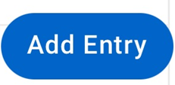
* **Follow Steps:** Select ***REQUEST NEW PUNCH*** and complete the process as described above.

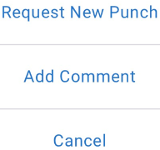

**Forgot Your Comment Code or Shift Information:**

* **Fix:** Same as "**Forgot Your Phone**" process.
* **Steps:**
  + **Enter Dates:** Use the calendar to specify the "**From**" and "**To**" dates.
  + **Add Comment:** enter the provided **comment code from your work confirmation** first then enter **reason for request** (ex. Jane released early at 12:15pm).
  + Click **Add Comment**.

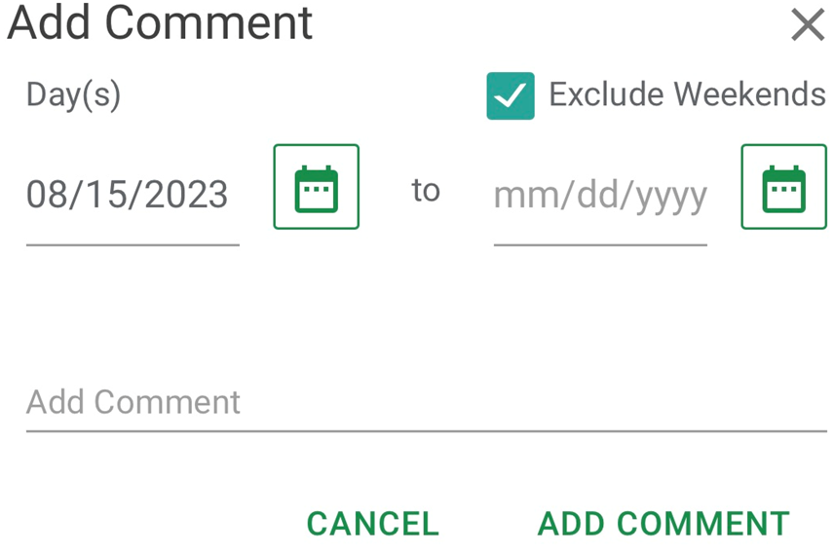

**Editing Your Comment Code:**

* **Fix:** Go to **Time Management** > **Web Time Sheet** (Read-Only), tap the drop-down arrow next to the date. > 
* **Edit Comment:**
  + Scroll to the **grey** **comment box**, click to **edit**, update your comment, and click **Update Comments**.

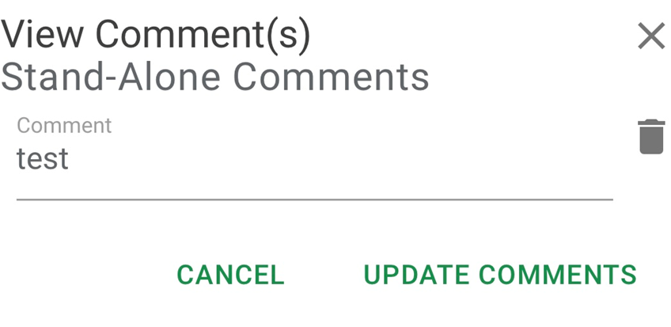

**Revoking Approvals**

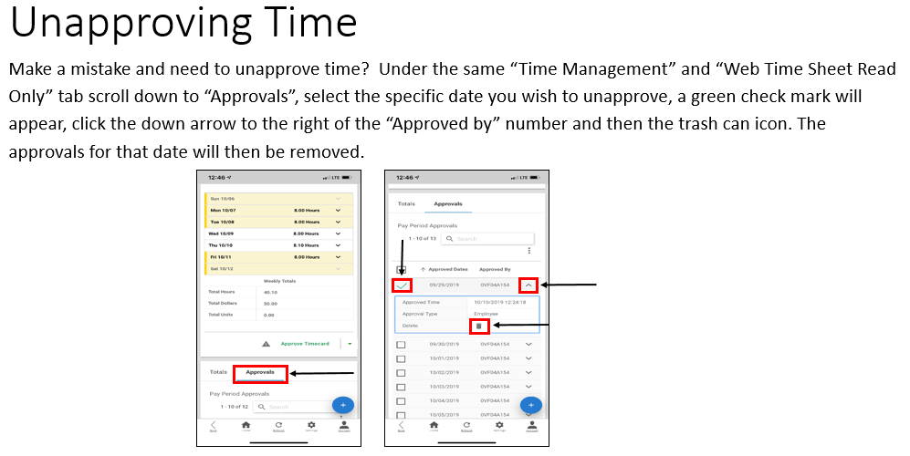

**Confirmation:**

* + Once you select "Revoke Approvals," the approvals for the selected dates will be removed, and you can now make changes or updates to your timesheet.
  + **NOTE:** if your time sheet is blue/green you will not be able to delete your approval since we have approved it already.

**Need to Switch Pay Periods?**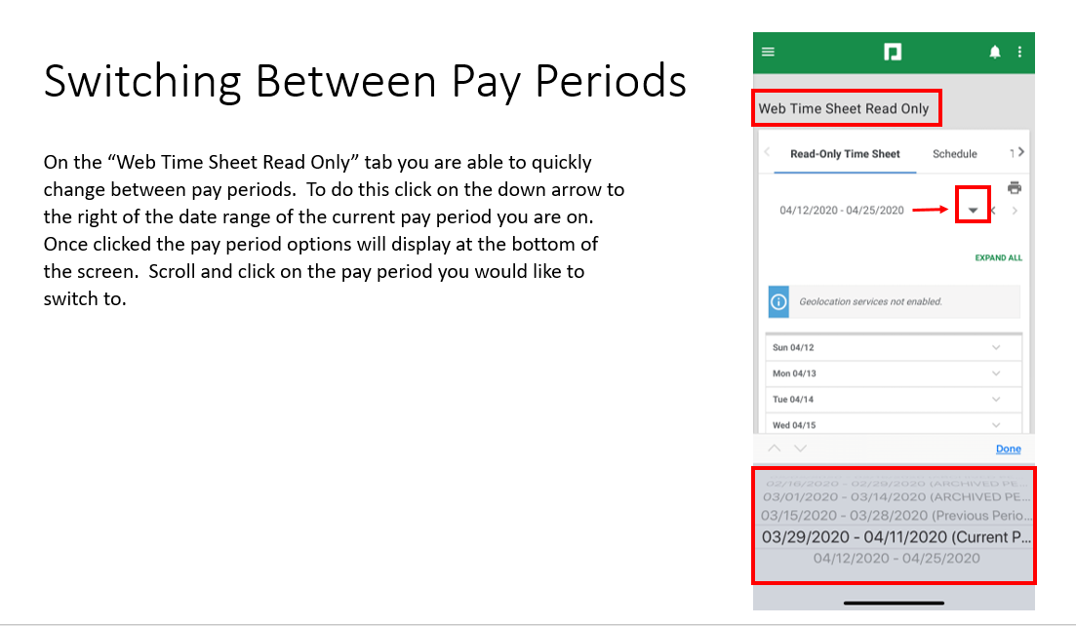

**Comment Codes (Cheat Sheet)**

Be sure to use the correct **comment code** when logging hours. These codes help track where and how time is spent.

**General Codes:**

* **Admin + Area** – Use when working in departments without a specific code.  
  *Example: Admin Accounting, Admin Marketing*
* **Bb + Event/Training** – Use for training, meetings, orientations, or DG-related work.  
  *Example: Bb dg, Bb meeting, Bb orientation*
* **Brochure Delivery** – Use if assigned to deliver brochures.
* **Conv Center** – Rare; only use if assigned to work at the Convention Center.
* **Depot** – Use when working regular train runs (not CCOT).
* **Dest Services** – Use when assisting Destination Services with office work or projects.

**Special Events/Projects:**

* **Ccot + Area** – Use for Christmas Capital of Texas events.  
  *Examples: Ccot decorate, Ccot tkt, Ccot greeter, Ccot lobby, Ccot helpers, Ccot phone bank, Ccot tkt prep*
* **Gf + Area** – Use for GrapeFest assignments.  
  *Examples: Gf lobby, Gf Sales, Gf info, Gf phone bank*
* **Msf + Area** – Use for Main Street Fest work.  
  *Examples: Msf lobby, Msf Sales, Msf info, Msf phone bank*
* **Hf** – Use for Heritage Foundation events.  
  *Examples: First Friday, Candlelight Tour of Homes, Nash Farm events*
* **Gallery** – Use when working a gallery event or reception.
* **Leisure Kiosk** – Use when staffing the hotel lobby kiosk at the Gaylord. If working a **group kiosk** in the front lobby, use the **group-specific code** listed on your staffing sheet.
* **Palace** – Use for all work at the Palace Theatre, including CCOT activities.
* **Switchboard** – Use when covering CVB phones during Lisa Doss’s absence.