Extranet User Guide For Businesses

🖰 Log into the extranet using this URL - https://extranet-tse.newmindets.net/

🖰 On the login screen, enter your username and password.
The first time you log, in, your username is set up to be your email address.
Your password can be created by clicking on the ‘Forgotten your password’ link.
If this doesn’t work, please contact The Great Sussex Way who can reset his for you.

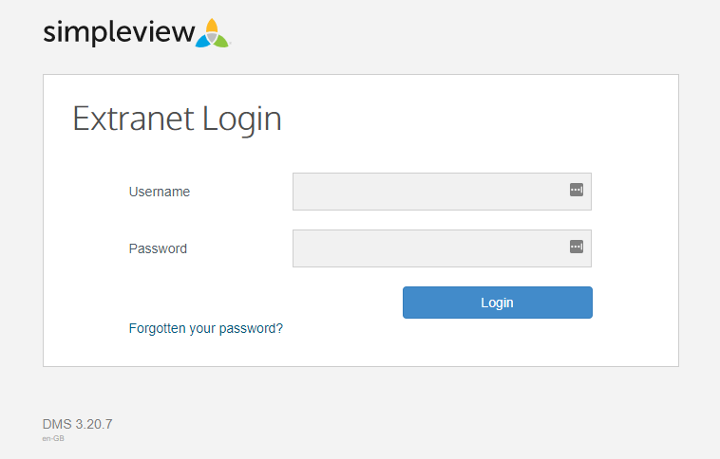

🖰 Once logged in you will see your business record listed on the screen.

If you have more than one business these will all be listed in this section. Click on the product record name that you wish to update.

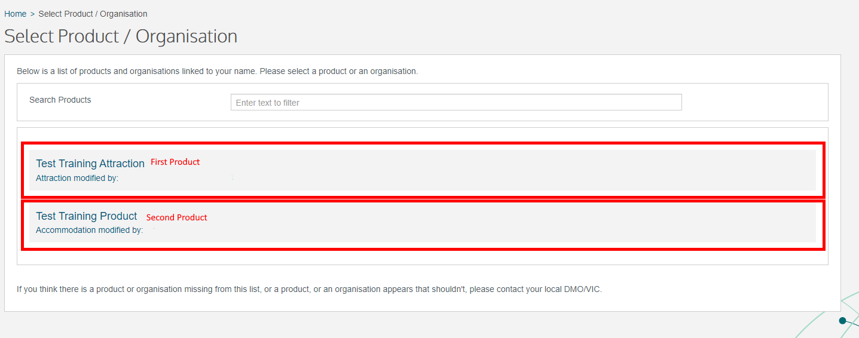
🖰 A summary of your business details will then be displayed:
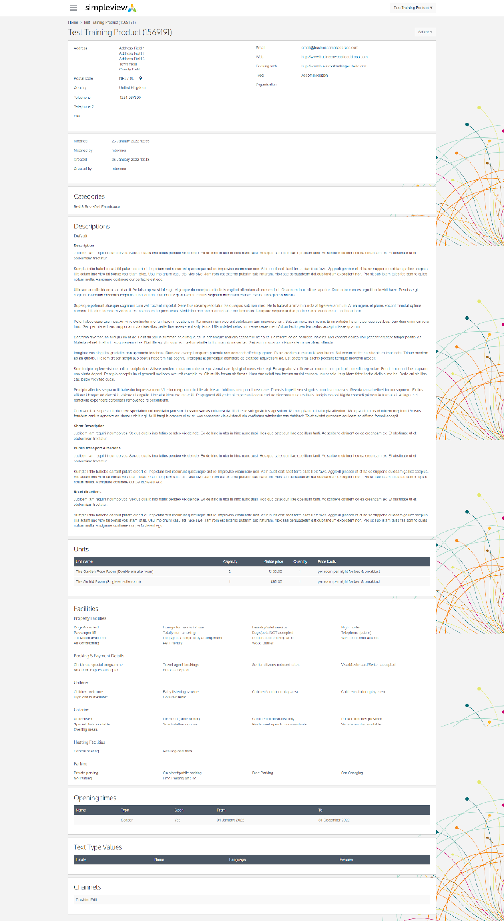

🖰 To update this product record, click on Actions > Edit Product

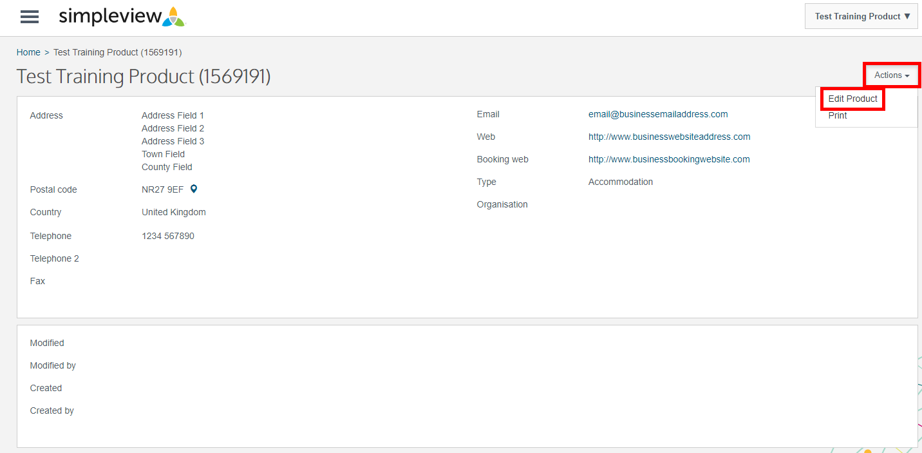

🖰 You will now be able to access the various sections of your product listing to make any necessary updates or amendments. Clicking on any of the tabs on the left-hand side will take you to the relevant fields.

Further information on each of the tabs can be found overleaf.

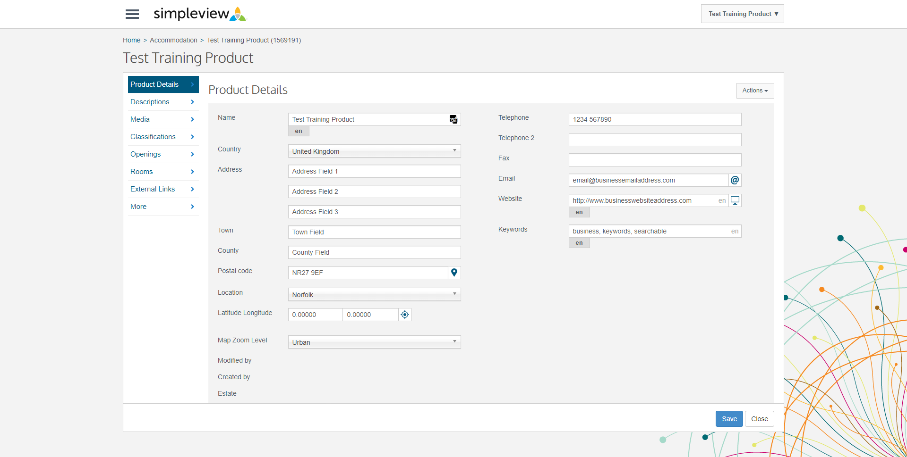

Product Details

Here you can amend your address, town, county, postal code, longitude/latitude, map zoom level and contact details.

On the postcode field – clicking on the pin drop icon will automatically populate the address fields based on the post code.

On the latitude/longitude field – clicking on the compass icon will open a map which will allow you to place the marker exactly where your business is located. This section is reflected in the ‘Map’ that sits on your listing on the website.

Please ignore the field: ‘Booking Website’ – redundant

Once you have completed the changes, click ‘Save’.

Descriptions

Here you can find the long description (Description field) for your business listing. It is recommended to add as much description as possible including any keywords associated with your business. The site searches will pick this up.
There is no limit on the amount of text you can include on your listing, the text description is used to highlight your business features and explain what the images are depicting. Google ideally likes 300 words or more per description – focus on making it meaningful.

Write a description for your listing that is unique and targets individual markets. If your business has a USP include this or explain why you’re great for walkers, cyclists, families, couples or if you are dog-friendly.

Your listing will be indexed by Google so try and include some keywords that will help make your page more favourable for important searches – e.g. “we are a dog friendly hotel…”, etc.

Write a separate short description to your main text, the short description is what appears in the search results. Make it snappy and attractive, so visitors click on your record, not others.

Example of long description:

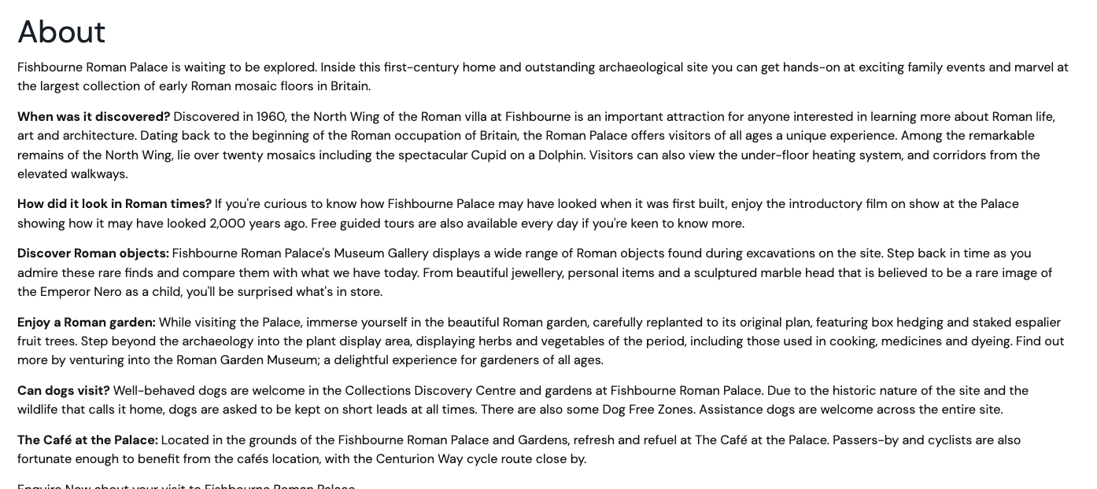

Examples of the short description field is the text which displays in product lists across the website.

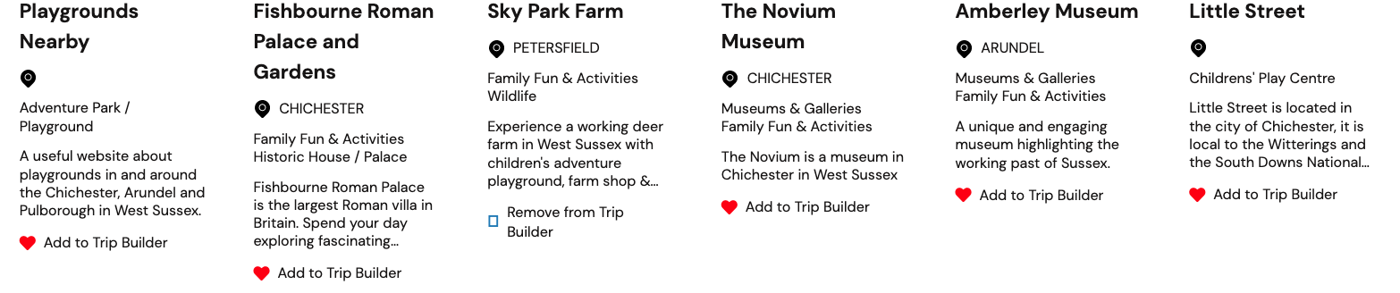

You can also add in Road & Public Transport directions:

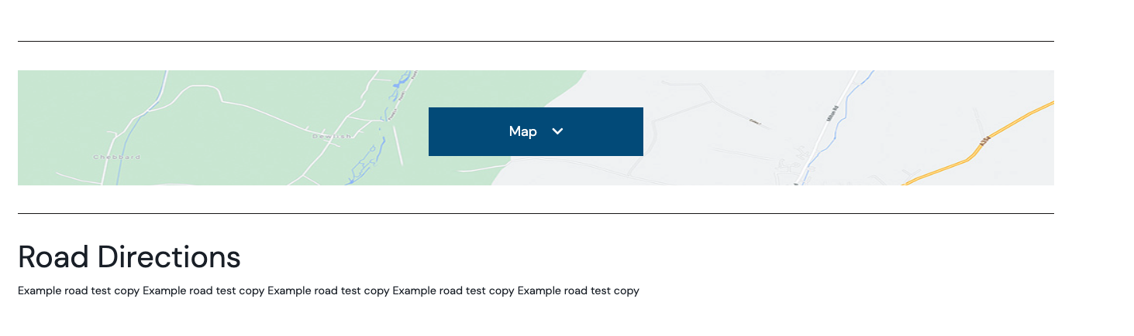

Once you have completed the changes, click ‘Save’.

Media/Images

On this tab you can upload images for you listing. Image dimensions are 1010x680px and smaller than 500kb please.

To add new images, click Actions > Upload New Media.
Alt Text is essential for images, this is a description of the image and is important for accessibility so please ensure all images have a description in this field. When you log in, if there are images with no alt text you will get a warning appear in the top right hand corner.

You can click and drag multiple file images into the file upload section at once. If you need to change the order that the images appear in, click on the image you would like to move and drag it across the carousel to the place you require.

Once you have completed the changes, click ‘Save’.

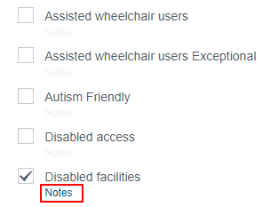
Facilities

Here you will find the list of facilities. You can go through and tick any that are relevant. Once a facility is ticked, a ‘Notes’ option will be available against the facility for you to add any relevant information.

Once you have completed the changes, click ‘Save’.

Openings

Here you can add opening times by clicking Actions > Add Opening. If the opening times are the same each year you can tick the option ‘Reoccur’ and they will automatically update each year. Once you have added in a date range, you can edit the days/times by clicking on the three dots at the end of the row and selecting: Edit Days

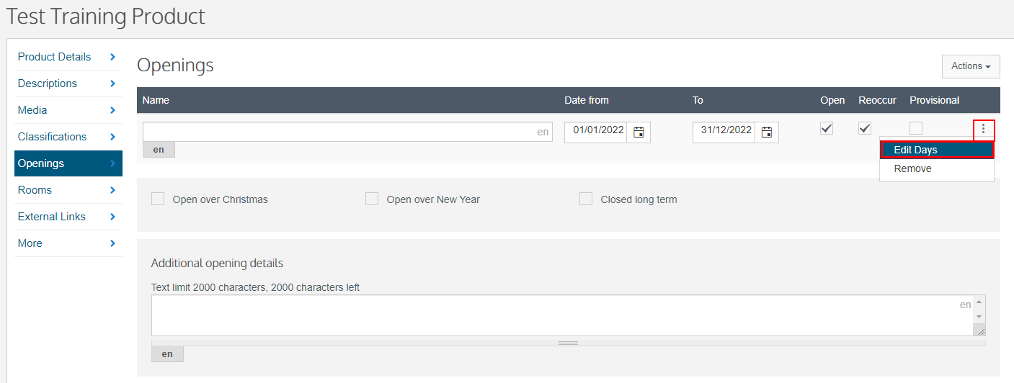

You can then go through the individual days and add in the relevant times:

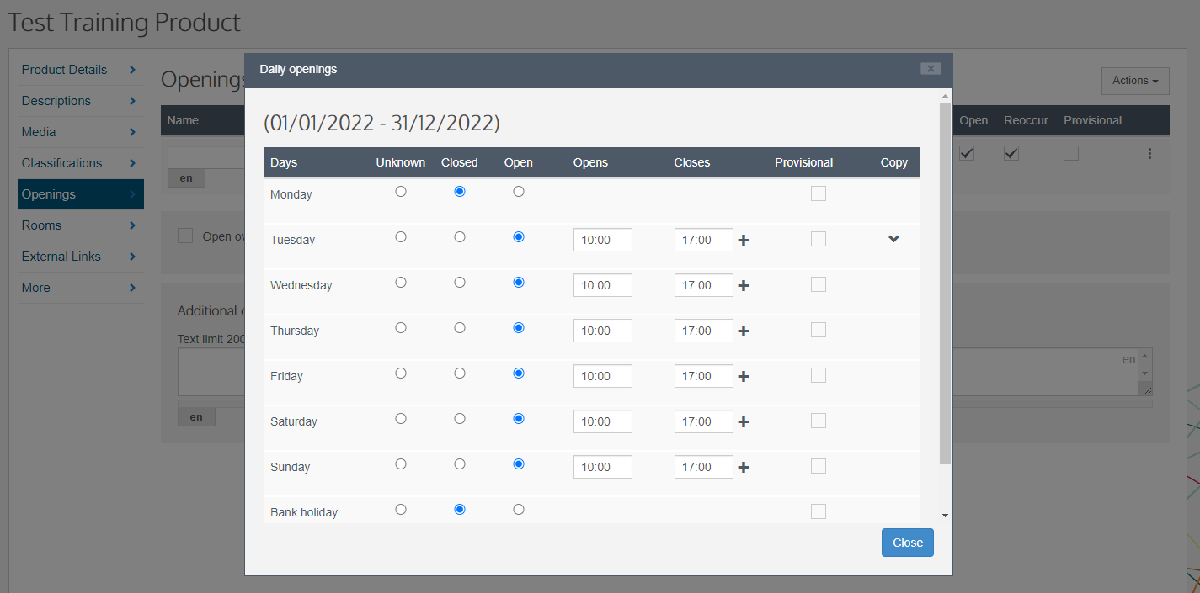

Once you have completed the changes, click ‘Save’.

Rooms

On this tab you can edit your room details as well as add rooms.

To add a new room, click Actions > Add Unit

In the pop up window, you can now select:
- The type of room (double/single/twin etc)
- Name the room (if applicable)
- Add in the quantity (number of this type of room)
- Add in the capacity (number this room/type of room sleeps)
- Add in a guide price
- Select pricing type
Once you have added a room you can then edit the prices and facilities for this individual room. To do this, at the end of the row select the three dots:

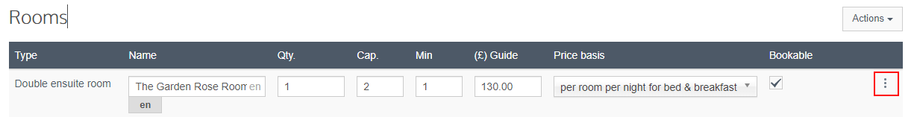

You can then select to edit prices and/or facilities:

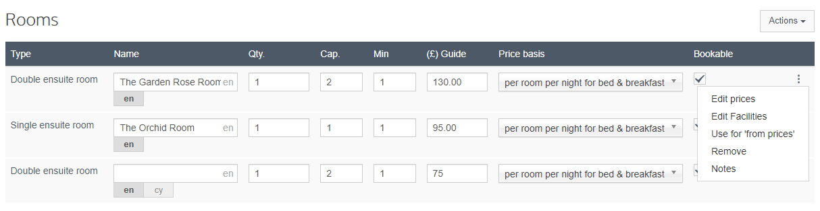

Prices:

Against the previously added opening times you can add in a minimum and maximum price range. This means, for example, that you can add in your low and high seasons as opening times, and against these add in the min/max prices.

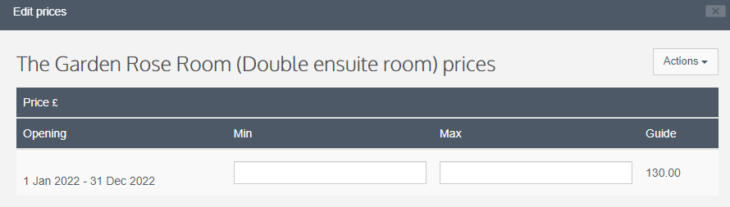

You can then go through and complete this for each unit added.

Facilities:
In the pop up window you can go through and tick all the facilities which are relevant for this unity.

Once you have completed the changes, click ‘Save’.

Links

On this tab you can add in various links including your social media accounts and any external links that are relevant.

Social Media

On this tab you will see all the various social media channels. To add your social media links, click on the three dots against the relevant one and select ‘Add’. You can then add in the URL to your social media account.
Please note only Facebook and Twitter feeds are pulled through to your business listing.
We are working on getting Trip Advisor reviews established. Please feel free to add this in, and it will become live when possible.

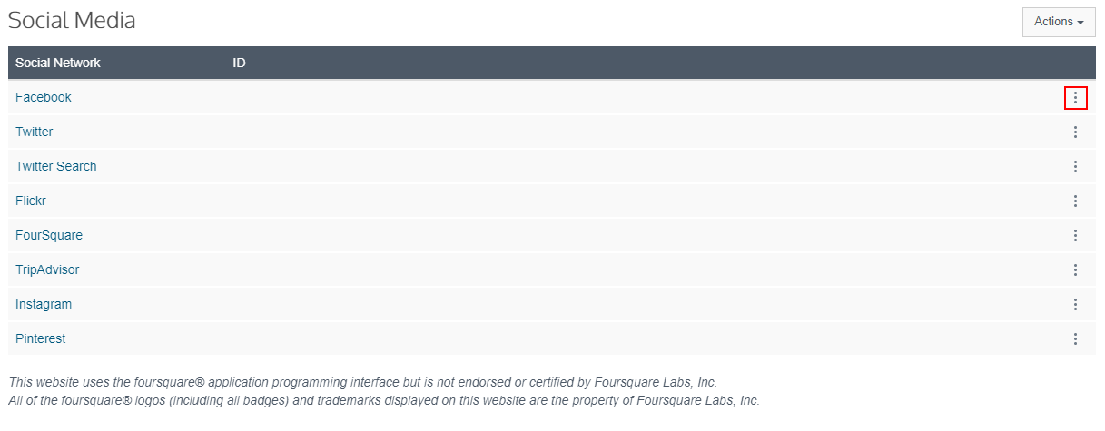
Once you have completed the changes, click ‘Save’.

External Links

Here you can add in a url to any relevant external website. To add a youtube video to your listing, click on Actions > Add External Link.
Add in a name, the URL to the video and from the ‘Type’ drop down menu, select YouTube Video.
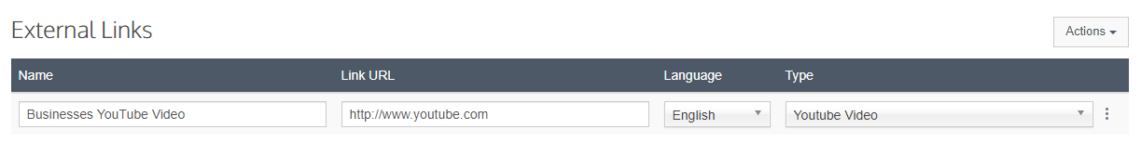
To remove a video, click on the three dots and select ‘Remove’.

Once you have completed the changes, click ‘Save’.

Special Offers
You can add any relevant Special Offers to your listing.

Click Actions > Add Special Offer

Description: here you can add in the details of your special offer.

Media: The 1st image of your product listing will display against your special offer on the offers page. If you would like to change this, click ‘Manage’ and select to upload a new image.

Add Offer Categories: Click this option and you can select the relevant categories from the options by clicking on the field. You can select more than one category for an individual offer.

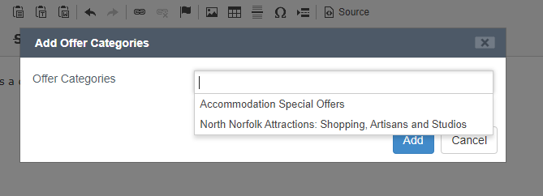

Once you have added a Special Offer category, you will then have the option to set your validity date for this special offer.

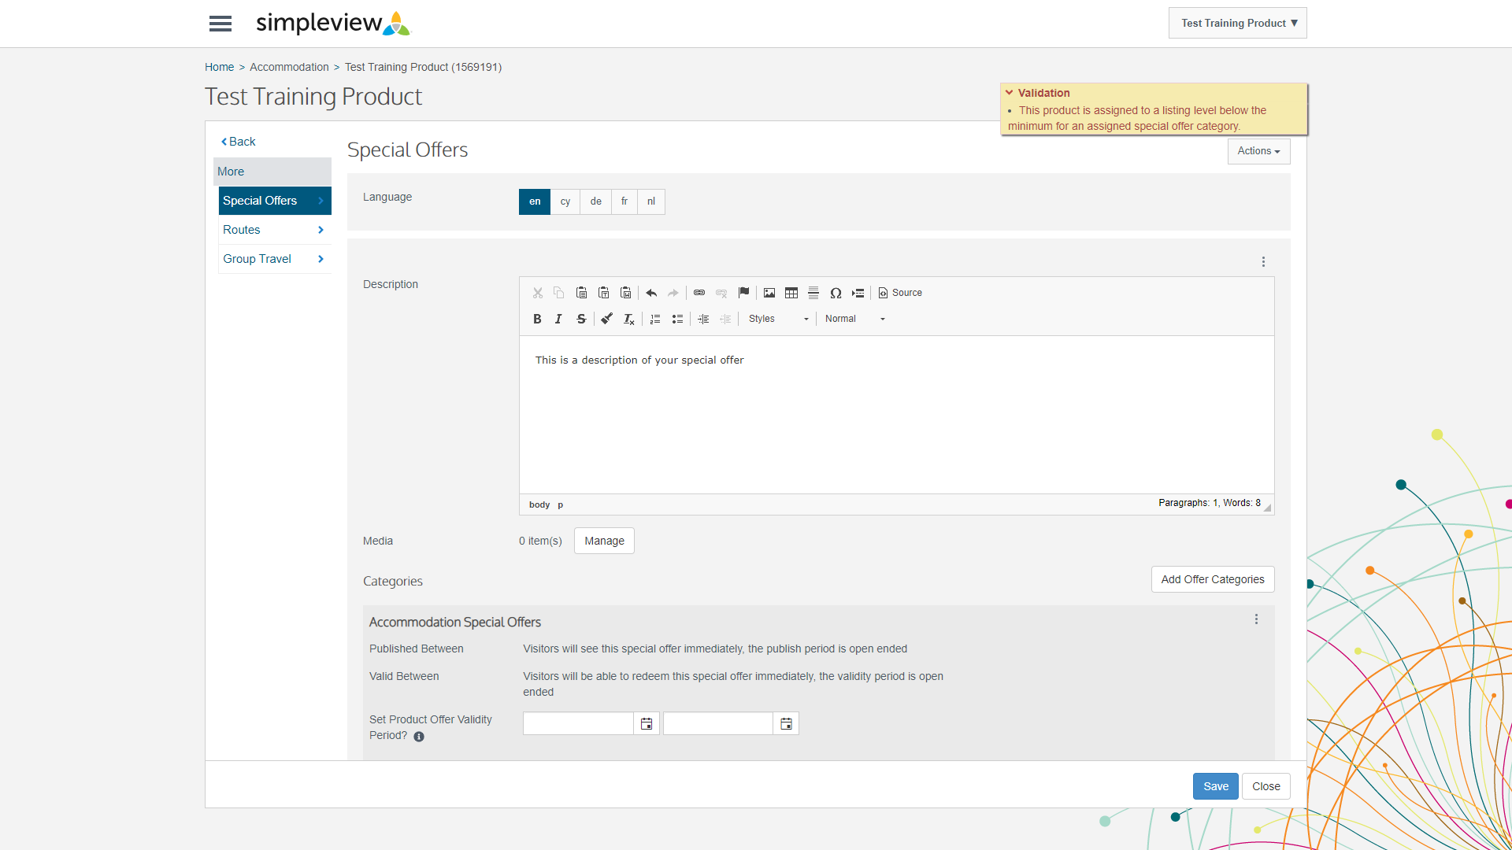

Once you have completed all the information, click save.

When you are happy with your updates, you can navigate to the homepage and if required update the next product record.

