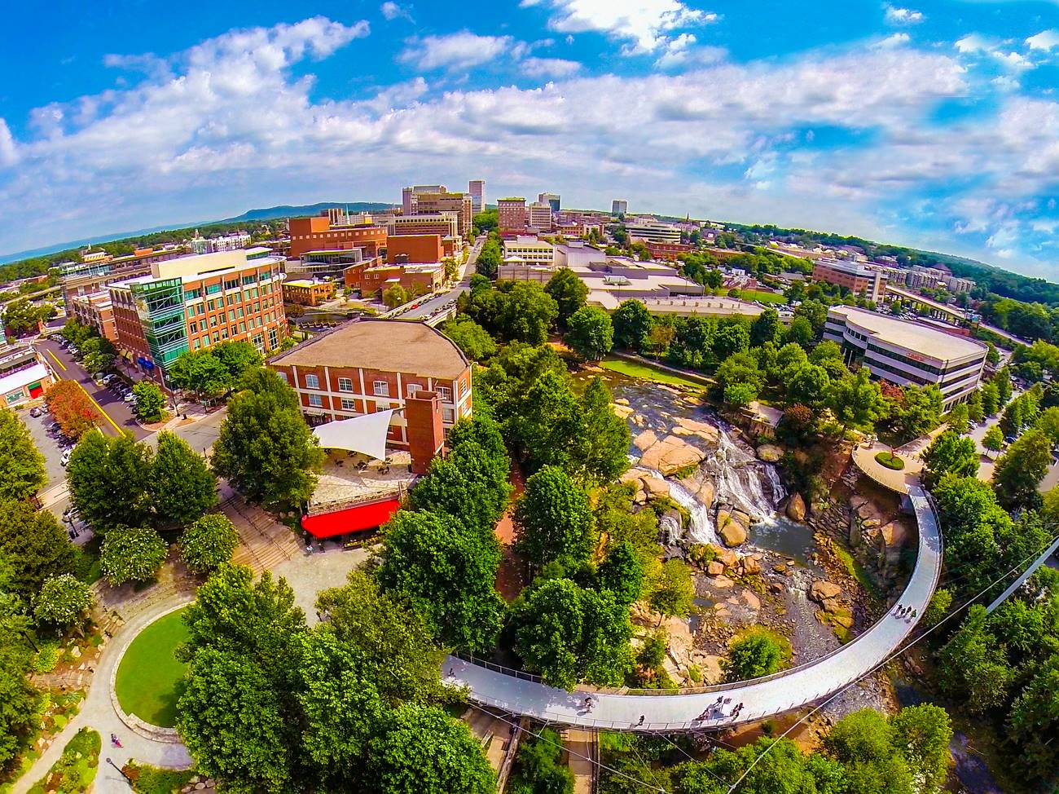
Greenville in 100 Words
Greenville, South Carolina has people talking ― and they’re saying a lot of nice things. Travel + Leisure called Greenville a “Top Place to Travel (in the World).” Southern Living listed Greenville among the “South’s Best Cities on the Rise.” Why the accolades?
Greenville offers visitors a unique blend of traditional Southern charm and contemporary cool you won’t find anywhere else. Its award-winning, tree-lined Main Street buzzes with people, locally owned boutiques, and 200+ inventive restaurants. Not to mention a ridiculously picturesque 32-acre park situated in the heart of downtown, with a breathtaking waterfall and a one-of-a-kind floating pedestrian bridge.

