

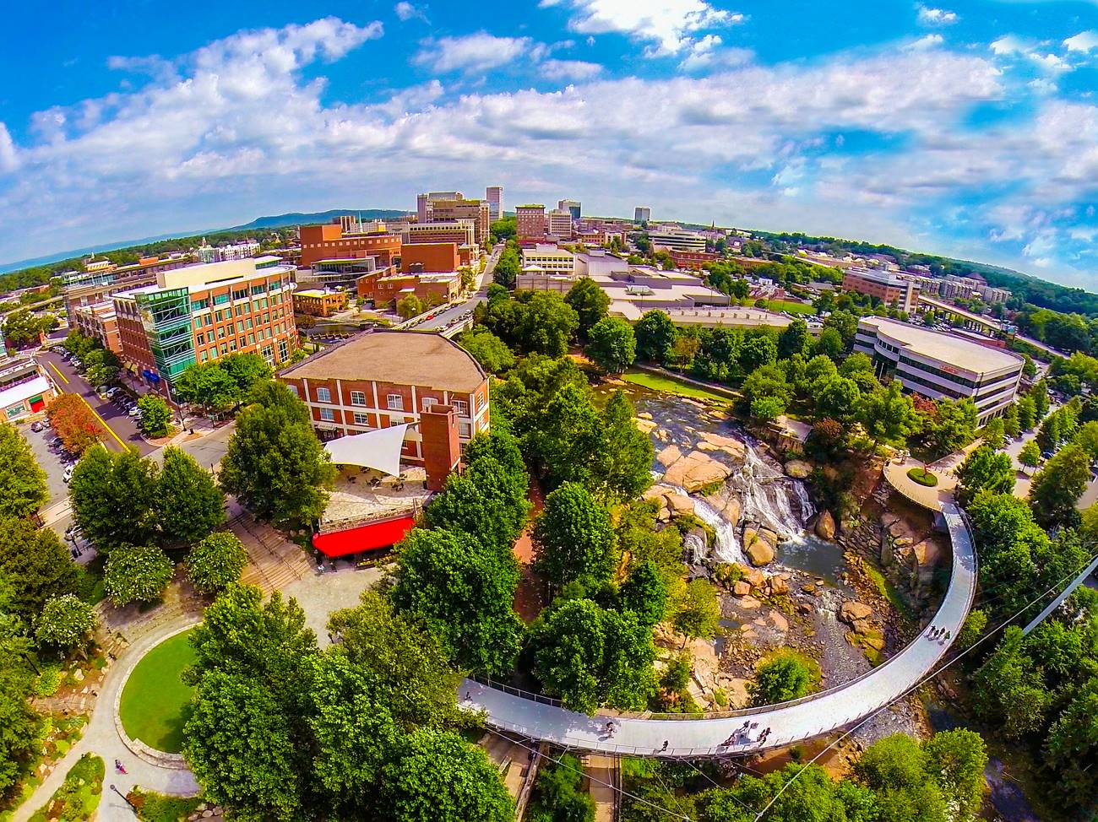

**Greenville in 200 Words**

Greenville, South Carolina has people talking ― and they’re saying a lot of nice things. Travel + Leisure called Greenville a “Top Place to Travel (in the World).” The praise doesn’t stop there, though. Southern Living listed Greenville among the “South’s Best Cities on the Rise.” So, why all the accolades?

Nestled in the foothills of the Blue Ridge Mountains, Greenville, SC offers visitors a unique blend of traditional Southern charm and contemporary cool you won’t find anywhere else. Its award-winning, walkable downtown is packed tight with cultural and culinary distractions. The nationally recognized, tree-lined Main Street buzzes with people, locally owned boutiques, and 200+ inventive restaurants. The bustling art scene is alive through theater productions, street musicians, galleries, and public displays of art.

Not to mention, a ridiculously picturesque 32-acre park situated in the heart of downtown, complete with a 40-foot waterfall and a one-of-a-kind floating pedestrian bridge. Bike or hike in the nearby mountains or through one of three state parks. Greenville will surprise you, engage you, delight you—and welcome you back again and again. There are a million reasons why people are saying “Yeah THAT Greenville.” It’s time you discovered a few of your own.