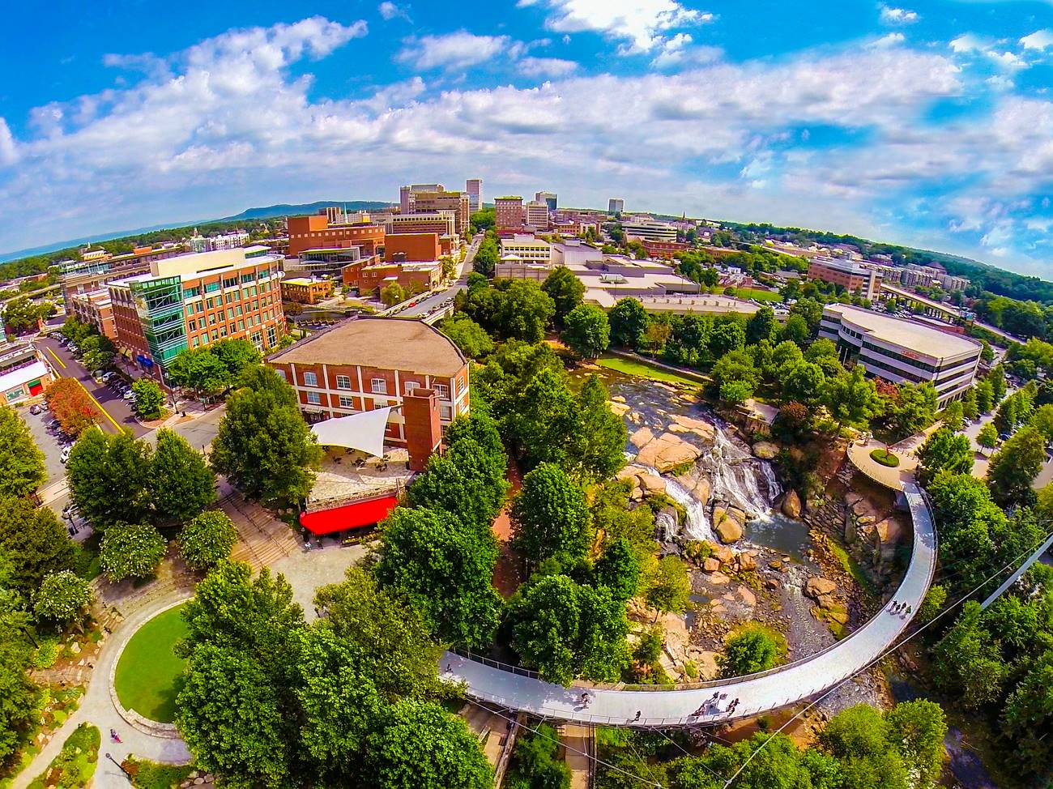
Greenville in 50 Words
Greenville, South Carolina offers visitors a unique blend of traditional Southern charm and contemporary cool. Its award-winning Main Street buzzes with people, locally owned boutiques, and 200+ restaurants. Not to mention a ridiculously picturesque 32-acre park in the heart of downtown, with a breathtaking waterfall and one-of-a-kind floating pedestrian bridge.

