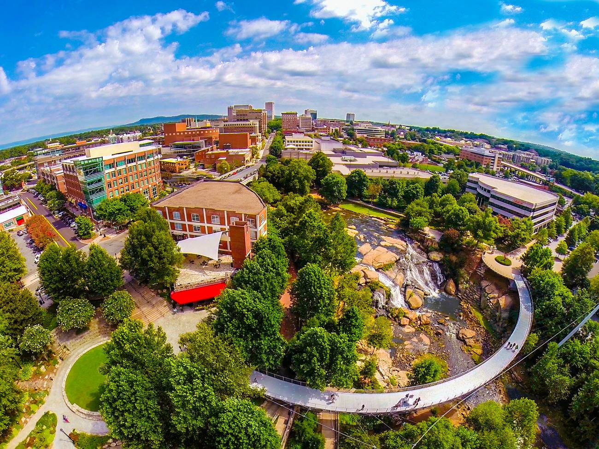
Greenville in 200 Words
Greenville, South Carolina has people talking — and they’re saying a lot of nice things. Travel + Leisure called Greenville a “Top Place to Travel in 2018 (in the World).” Men’s Journal listed Greenville among its “Top 18 Coolest Towns in America.” So why the accolades?
Nestled in the foothills of the Blue Ridge Mountains, Greenville, SC offers visitors a unique blend of traditional Southern charm and contemporary cool you won’t find anywhere else. Its award-winning, walkable downtown is packed tight with cultural and culinary distractions. An award-winning, tree-lined Main Street buzzes with people, locally owned boutiques and 110+ inventive restaurants. Art is alive through the theater, street musicians, galleries and public displays of art.
Not to mention a ridiculously picturesque 32-acre park situated in the heart of downtown, complete with a 40-foot waterfall and a one-of-a-kind floating pedestrian bridge. Bike or hike in the nearby mountains or through one of three state parks. There are a million reasons why people are saying “Yeah THAT Greenville.” It’s time you discovered a few of your own.

Greenville in 100 Words
Greenville, South Carolina has people talking ― and they’re saying a lot of nice things. Travel + Leisure called Greenville a “Top Place to Travel in 2018 (in the World).” Men’s Journal listed Greenville among its “Top 18 Coolest Towns in America.” Why the accolades?

Greenville offers visitors a unique blend of traditional Southern charm and contemporary cool you won’t find anywhere else. Its award-winning, tree-lined Main Street buzzes with people, locally owned boutiques and 110+ inventive restaurants. Not to mention a ridiculously picturesque 32-acre park situated in the heart of downtown, with a breathtaking waterfall and a one-of-a-kind floating pedestrian bridge.

Greenville in 50 Words
Greenville, South Carolina offers visitors a unique blend of traditional Southern charm and contemporary cool you won’t find anywhere else. Its award-winning, tree-lined Main Street buzzes with people, locally owned boutiques and 110+ inventive restaurants. Not to mention a ridiculously picturesque 32-acre park situated in the heart of downtown, with a breathtaking waterfall and a one-of-a-kind floating pedestrian bridge.

