Community members,

As we begin a new year, we wanted to take a moment to reflect on and share a few accomplishments from 2025 that we’re especially proud of. The Explore Gwinnett team is honored to have received four recognitions that celebrate the leadership, creativity, and impact of our organization and team members.

- Lisa Anders named to Georgia Trend’s Georgia 500 (Hospitality & Tourism) Georgia Trend’s Georgia 500 is an annual list recognizing the most influential leaders shaping Georgia’s business and civic landscape. Lisa was included in the 2025 issue under the Hospitality & Tourism category, with highlights on her leadership and achievements with Explore Gwinnett and the Gwinnett Sports Commission, and her contributions to tourism-driven economic growth across the state.

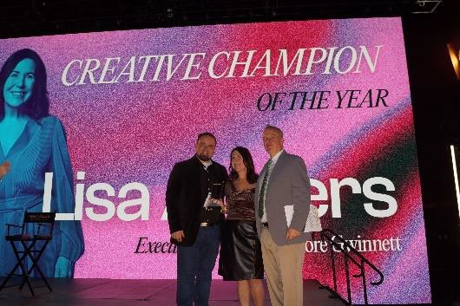
  - Lisa Anders named Georgia Entertainment’s Creative Champion of the Year Presented at Georgia Entertainment’s Signature 100 gala, an invitation-only event convening more than 800 top leaders across Georgia’s creative industries, this award honors individuals driving innovation at the intersection of entertainment, tourism, and economic development. Lisa was recognized for her leadership and strategic vision, advancing Gwinnett County as a destination for film, events, and creative investment.

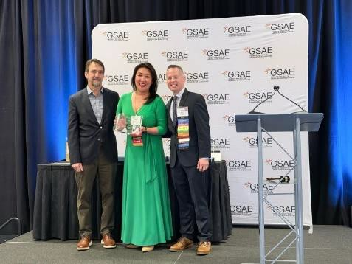
- Anne Chen honored with GSAE’s Peggy Siegler Corporate Member of the Year Award The Georgia Society of Association Executives (GSAE) presents this award to a corporate member who demonstrates outstanding service, leadership, and commitment to the association community. Anne was recognized for her dedication, professionalism, and continued contributions to the industry and GSAE’s mission.

- Two HSMAI Adrian Awards for the Seoul of the South™ Pass The HSMAI Adrian Awards are among the most prestigious honors in travel marketing, celebrating creativity and measurable impact. Explore Gwinnett received two Silver Adrian Awards for the Seoul of the South™ Pass, including Best of Category in Technology (Owned Media Only) and Silver in New Opening/Launch (Multi-Channel/Integrated Marketing). Selected from more than 800 entries, the campaign was recognized for its innovation, cultural storytelling, and meaningful community engagement.

We are incredibly proud of our team and grateful for the continued support of our partners and stakeholders. These recognitions reflect the collaborative efforts that help elevate Gwinnett County on a regional, national and global stage.

Warm regards,

For more information on Explore Gwinnett, visit ExploreGwinnett.org. Stay up-to-date on the latest news by following @ExploreGwinnett on Instagram or ExploreGwinnett on Facebook.

