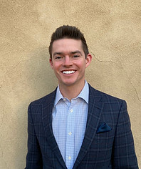

COLE MCKEEL

Vice President of Partnerships
Cole served as the manager of Olympic & Paralympic Training Center sport business development for the United States Olympic & Paralympic Committee from 2016-2020. In this position, McKeel was in charge of generating outside revenue for the Olympic & Paralympic Training Centers in Colorado Springs, Colo. and Lake Placid, N.Y. Prior to his role with the USOPC, McKeel worked as the marketing and media assistant and diversity and inclusion champion for USA Bobsled & Skeleton. In this role, McKeel was responsible for the company’s partnerships with BMW and Under Armour.

McKeel serves as the Vice President of GoEmpire Group, a professional basketball athlete representation firm in Chicago. In this role, McKeel is responsible for international operations, including client recruiting and relations, as well as ensuring the continued satisfaction of GoEmpire clients. In addition, McKeel is an adjunct professor for the sport and recreation management program at the University of Alaska Fairbanks. He serves on advisory committees for the Southeast Tourism Society and the Adapted Sport Leadership & Business Symposium.

McKeel was the head manager for the basketball team at the University of Louisville, where he graduated with honors with a bachelor degree in sport administration and minors in business administration, finance and marketing. Upon graduation, McKeel furthered his education at UofL, earning a MBA with a concentration in finance. He also has a MS in Olympic Studies, Olympic Education and Organization and Management of Olympic Events from the International Olympic Academy in Olympia, Greece.

