**Community members,**

The [Explore Gwinnett](https://www.exploregwinnett.org/) team is thrilled to announce that our chief operating officer Lisa Anders has been named one of *Atlanta Magazine*’s 2025 ‘Women Making a Mark.’ This prestigious recognition celebrates women across metro Atlanta who are making significant contributions in their fields and communities.

With 29 years dedicated to our organization, Lisa has played a pivotal role in guiding our growth and shaping Gwinnett County into one of Georgia’s top tourism and film destinations. Under her leadership, Gwinnett’s Film Office earned official film commission status in 2024—a milestone that reflects the county’s rising influence in the film industry. By attracting high-profile productions and supporting local crews and businesses, Lisa has solidified her impact as a visionary leader in both tourism and economic development.

“We are proud to see Lisa recognized by *Atlanta Magazine*—an honor that reflects our GCVB values and industry commitment,” said Stan L. Hall, president and chief executive officer of Explore Gwinnett. “Strong leadership drives our vision and impact. Lisa truly exemplifies these values, and is a celebration of our commitment to excellence.”

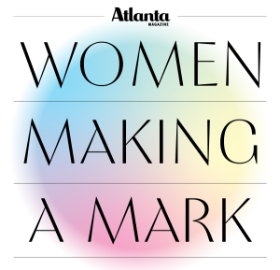

The Women Making a Mark program honors influential women whose leadership, service and dedication have made a lasting impact on their communities. Honorees are selected for their unwavering commitment to their professions and Atlanta citizens through innovation, collaboration and purpose-driven work. Past recipients include philanthropists, nonprofit leaders, Supreme Court judges and public servants. Lisa’s recognition proudly highlights the essential role of tourism and film development in driving economic and cultural progress throughout the region.

“Each year, this recognition reminds us of the incredible talent, leadership and heart that drives Atlanta forward,” said Al McRae, president of Bank of America. “The women we recognize today are trailblazers. They’re shaping the future of our communities and inspiring the next generation of leaders.”

The digital edition of *Atlanta Magazine* is available [HERE](https://atlantamagazine.mydigitalpublication.com/publication/frame.php?i=846370&p=&pn=&ver=html5&view=articleBrowser&article_id=4981347), and Lisa’s full feature can be read [HERE](https://atlantamagazine.mydigitalpublication.com/publication/frame.php?i=846370&p=&pn=&ver=html5&view=articleBrowser&article_id=4981347).