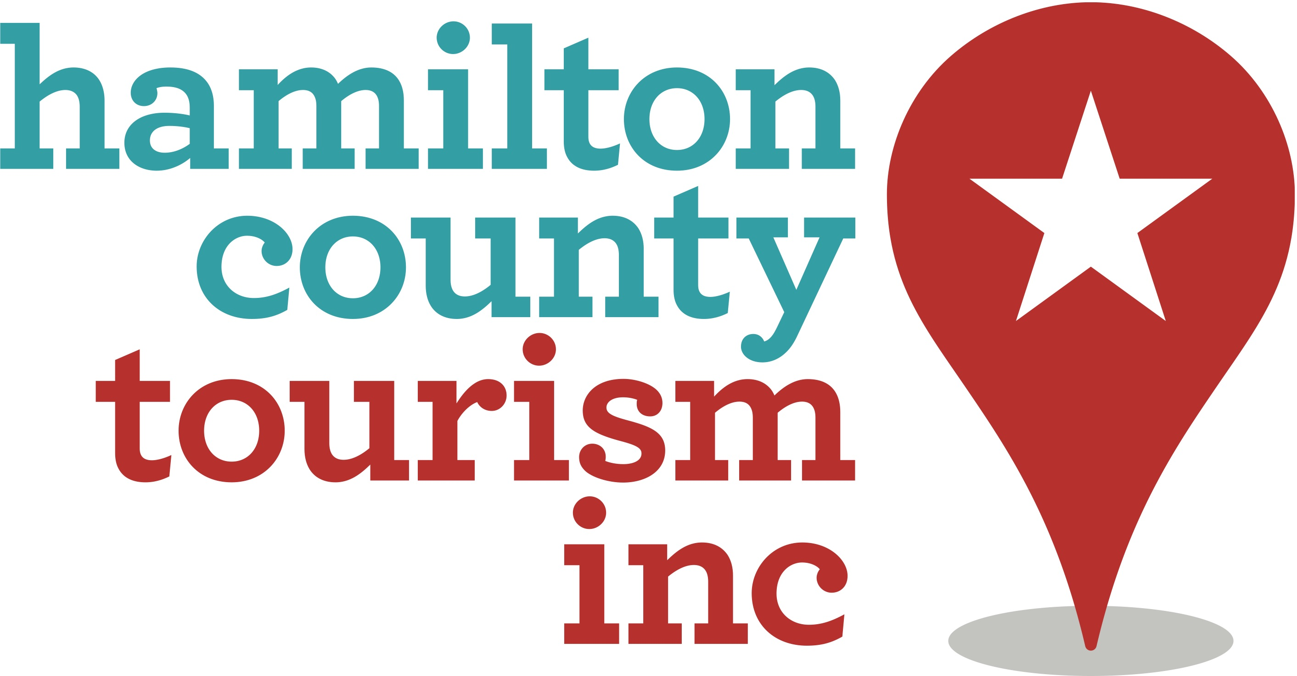

The Board of Directors Will Meet:
Friday, August 5, 2022
8:30-1130 a.m.

The Renaissance Hotel Indianapolis North
11925 N. Meridian St., Carmel, IN 46032

Contact Brenda Myers at bmyers@hamiltoncountytourism.com to receive a virtual link for observation.

- Welcome Bob DuBois

- Minutes of the June 2022 Meeting Bob DuBois

- HCT & Community Metrics
- 2022 Visitor Report Brenda Myers
- 2022 Tax Report Brenda Myers
- 2022 Budget Report Brad Lynn

- Old Business
- BEST Study Contract Approval Karen Radcliff
- Audit Updates Brad Lynn

- New Business
- Action Needed: Nominating & Budget Committees Bob DuBois

Confirming Current Budget Committee: Jeffrey Brown, Andrew Newport, Norman Burns from HCT Board; Connor Sullivan, Chris Renner, and Tiffany Pasco from Tourism Commission
Nominating Committee Volunteers Needed (2)

- Destination NEXT Report & Workshop Deb Travis Archer, MMGY
NextFactor

- Adjourn until 8:30-10 a.m. October 7, 2022 (2023 Plans Meeting) Bob DuBois
Final Board meeting of the year will be November 4, 2022 (2023 Budget Adoption)

Dates & Things to Watch For:
Colts Camp – through August 25
2023 Hotel Forecast White Paper – Late September/Early October

