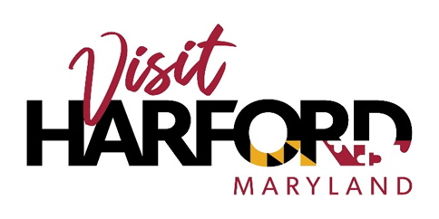

Contact: Tyler Zeisloft

Tyler@VisitHarford.com

410-838-7777

**Harford Community College to Hold Celebration of 60th Anniversary of Civil Rights Act with Visit Harford**

The Harford Civil Rights Project, in partnership with the NAACP's Harford County Branch, is proud to announce an event on Tuesday, July 2, from 5:30 to 7:30 PM in the Globe Cafe in the Student Center on Harford Community College’s campus. The event is being held to celebrate and reflect upon the 60th anniversary of the Civil Rights Act of 1964. This free event is open to the community and will feature speakers and a panel discussion about the significance and legacy of the Civil Rights Act in both historical and contemporary contexts.

In addition to the discussion, Visit Harford will be showcasing their Gateway to Freedom Ride Pathway. This experience takes you on a journey to Harford County, Maryland during the Civil Rights Era through augmented and virtual reality. More stops along the Gateway to Freedom Ride will be added to the app in the coming years, each playing a pivotal role in the Civil Rights Movement. The app user will gain knowledge of Harford County’s role in this monumental moment in American history through interactive storytelling and images of the mid 1900’s. Download this app and go back in time to Harford’s Civil Rights sites and learn more on Harford County’s incredible role in the Civil Rights Movement. This app would not be possible without $80,000 of grand funding awarded by The Maryland Department of Commerce, Office of Tourism.

###

About Visit Harford

We are a non-profit organization dedicated to the promotion of Harford County and its tourism attractions to visitors in order to stimulate economic activity for the enhanced quality of life of all Harford County citizens.