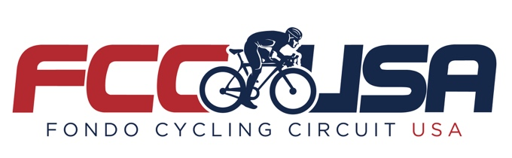

FONDO CYCLING CIRCUIT USA launches six events in 2018

Tampa, Fla. (April 10, 2018) – ASD announced today the creation of FONDO CYCLING CIRCUIT USA, a collection of six Gran Fondo-style cycling events offering 30, 50 and 75 mile ride options. While more recreational in nature, several timed sections along each route offer a competitive element for cyclists looking for a challenge. Each FCCUSA event culminates with live music and a food truck and craft beer festival.

In 2018 the FONDO CYCLING CIRCUIT USA will visit the following cities:
• Aug. 5 – Davidson NC • Oct. 14 – Akron OH
• Aug. 26 – Harrisburg PA • Oct. 21 – Fredericksburg VA
• Sept. 30 – Clermont FL • Oct. 28 – Ridgeland MS

“Our host cities are all highly regarded cycling destinations within their respective geographical regions,” said Steve Meckfessel, National Series Director for FCCUSA. “Each location is also a draw for entertainment, historical, cultural and recreational reasons and within a 2-3 hour drive of major metropolitan areas. We’re excited to partner with each of these communities!”

Online registration is now open at FondoCyclingCircuitUSA.com. The first 100 cyclists to register for any of the FCCUSA events (50 and 75-mile routes only) receives a free Pearl Izumi SELECT Escape LTD cycling jersey. Each registered cyclist receives a t-shirt, sling bag, finisher medal, water bottle, tickets to the food trucks and craft beer, plus other amenities.

ASD is a subsidiary of Asdeporte, producers of L’Etape by Tour de France, IRONMAN, Spartan Race and Rock ‘n’ Roll Marathon Series events in Mexico. Meckfessel, a former event director and senior executive for IRONMAN, manages ASD’s Tampa office and will oversee FCCUSA.

For further information on FCCUSA, please contact:

Steve Meckfessel
National Series Director
Steve@fondocyclingcircuitusa.com

