IGLTA FEATURED DESTINATION/BUSINESS PACKAGE
INCLUDES THE FOLLOWING MARKETING BENEFITS

- 1 annual IGLTA membership with a dynamic profile on the website including:
  - Enhanced listing upgrade (moves listing to the top of search results)
  - Featured Destination or Featured Business banner on profile
- 2 eBlasts (business or consumer)
- 2 IGLTA eNewsletter sponsorships (business or consumer)
- TravelOutNewsWire® press release distribution or Press FAM consulting package
- Destination/Business specific cover photo postings on IGLTA Facebook page
  - Up to three per year
- Social media integration using dedicated posts
  - 6x posts: Facebook, Twitter or LinkedIn

ANNUAL IGLTA MEMBERSHIP WITH DYNAMIC PROFILE ON IGLTA WEBSITE
Contact: membership@iglta.org

IMAGE FORMAT: JPG, QTY: 30, MAX FILE SIZE: 800 px wide x 600 px tall
- Business Name (30 characters maximum)
- Address on listing
- Short description (300 characters maximum)
- Long description (2,000 characters maximum)
- Website link
- Social Media links
- Ability to activate TripAdvisor rating on listing
- Ability to feature up to 30 photos on membership profile
- Ability to create Events, Tours & Specials linked to profile

HOW TO NAVIGATE MEMBERSHIP – CLICK BELOW TO VIEW OUR HOW-TO GUIDES
- Membership Profile Activation
- Membership Renewal/Rejoin
- New Individual - Existing Company
- New Membership - Company and Listing
- Update Listing
- How to Add Events, Tours, & Specials

DEDICATED E-BLAST TO IGLTA B2B OR B2C DATABASE
Contact (B2B): toni.reckley@iglta.org
Contact (B2C): auston.matta@iglta.org

This email blast is distributed to our entire database of either travel professionals (7,000 opt-in contacts) or LGBTQ+ consumers (35,000 opt-ins) worldwide. A previous example of an eBlast can be found here (B2B) and here (B2C).

QTY AVAILABLE: 2, your choice of either B2B or B2C

DEADLINE: Due two weeks prior to the distribution date.

SPECIFICATIONS:
Please provide content in the form of an HTML file that has all necessary coding within the <body> tag, MAX 600 pixels wide or less and houses all images on a set -public server (so all <img> tags must use the http:// part of the address - IGLTA cannot host images on our server).

ALTERNATE SPECIFICATIONS: .jpeg image, 800 x 800 pixels
Please provide a redirect URL. (Please note: this option is less dynamic than the html option.)

IGLTA E-NEWSLETTER BANNER AD (OR) FEATURED ARTICLE IN B2B OR B2C E-NEWSLETTER
Contact (B2B): loann.halden@iglta.org
Contact (B2C): auston.matta@iglta.org

QTY AVAILABLE: 2

This is in the IGLTA business or consumer newsletter emailed to more than 7,000+ tourism business contacts or 35,000 consumers worldwide. You have the option of providing a banner ad sponsorship (A) OR doing a featured article (B). A previous example of the newsletter can be found here (B2B) and here (B2C).

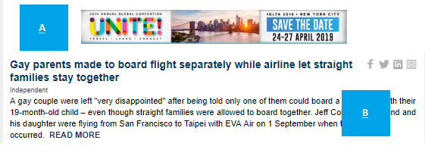
DEADLINE: Newsletters are sent each Wednesday (B2B) or every other Friday (B2C); content is due no later than the Friday prior to each distribution.
SPECIFICATIONS:
(A) BANNER DIMENSIONS: 468 PIXELS x 60 PIXELS + URL
(A) FILE FORMAT: JPG or GIF
(A) MAX FILE SIZE: 40kb
(B) TEXT: Up to 100 words + URL
(B) IMAGE: Landscape image or
logo file max 600 pixels wide

TRAVELOUTNEWSWIRE PRESS RELEASE DISTRIBUTION OR PRESS FAM CONSULTING
Contact: loann.halden@iglta.org

Take advantage of IGLTA’s connections with LGBTQ+ travel media worldwide. Distribute your press release via our database of 375+ opt-in media outlets or request consulting to host your own LGBTQ+ media press FAM.

QTY AVAILABLE: 1
IGLTA Press FAM consulting package Click HERE
TravelOutNewsWire Click HERE

IGLTA B2B OR B2C FACEBOOK COVER PHOTO FOR 1 WEEK
Contact: toni.reckley@iglta.org

QTY AVAILABLE: 3
FILE FORMAT: JPG, GIF, and SW
MAX FILE SIZE: 851 pixels wide & 315 pixels tall – Desktop applicable
- Optional text for photo
- Destination/Business-specific cover photo postings on IGLTA Facebook page (up to three per year)
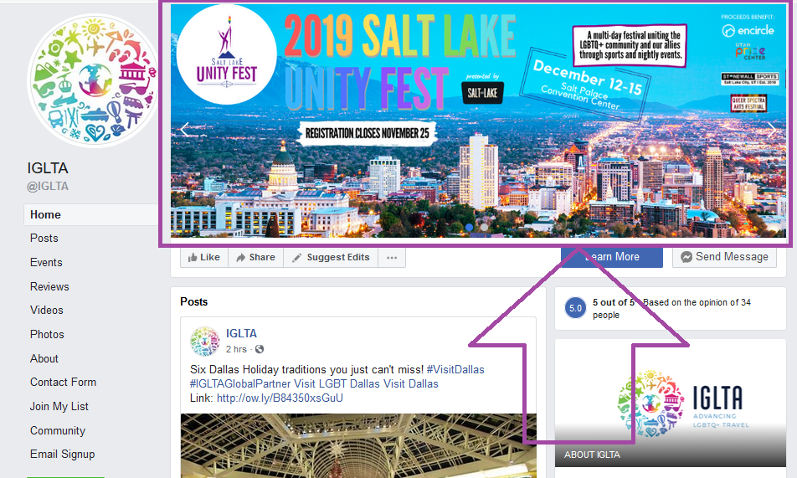

SOCIAL MEDIA B2B OR B2C CHANNELS
Contact: toni.reckley@iglta.org

QTY AVAILABLE: 6

FILE FORMAT: jpg or png
- Image ratio: 9:16 to 16:9
- Recommended resolution: Upload the highest resolution image available.
- Images that consist of more than 20% text may experience reduced delivery. Learn more about text in images.
- Text in post: 125 characters
- Images cropped to 1.91:1
- Recommended resolution: at least 1,200 x 628px
- Headline: 25 characters
- Link Description: 30 characters
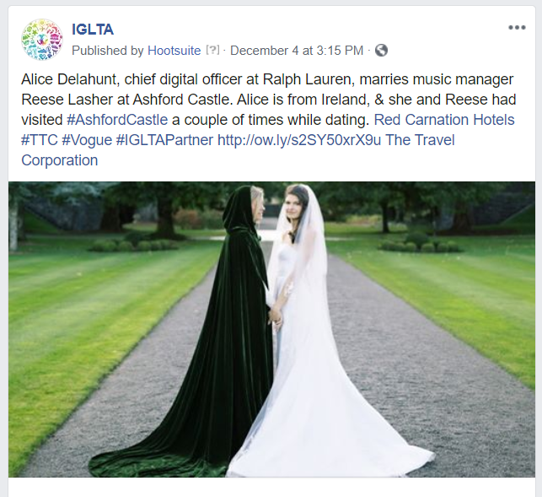

END OF SPEC LIST

