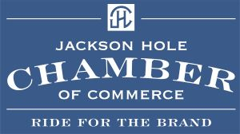

The Jackson Hole Chamber of Commerce, Teton County Elected Officials, and representatives of member businesses met with representatives of the State Lands Investment Board to discuss options for the 640-acre Kelly Parcel bordering Grand Teton National Park. When surveying our membership, 96% of our members wished for the parcel to be sold to Grand Teton National Park. In line with this wish was the desire for a cash value option as opposed to a "land trade." The cash value option provides the benefits of a more realistic price point and a shorter time frame to a potential sale, as opposed to a land trade, which tends to inflate values and takes place over a longer time frame due to the complex nature of such negotiations. State Land Investment Board members were receptive to Teton County's desire for the land to be sold to the park.

