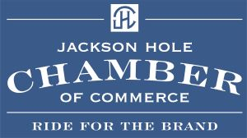

To the Wyoming Legislature,
Tourism is the one industry in Wyoming and Teton County that has consistently provided us Economic Viability through some of the toughest and most challenging years in our history. This is an important lifeline to all businesses and workforce throughout the state. The Tourism Industry requires your support to remain healthy. Our state already has one of the lowest Tourism budgets throughout the Rocky Mountains and keeping that support should remain a priority as the return on that investment is paramount to our state.
Please do not cut the tourism budget.
Sincerely,

Rick Howe, IOM
President / CEO
Jackson Hole Chamber of Commerce

