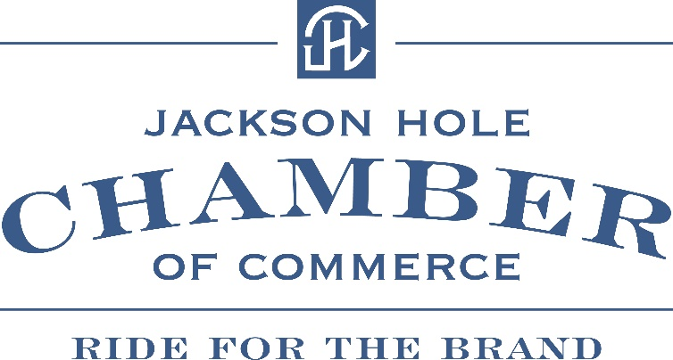

TBA / Artificial Intelligence Training for Your Business
The Jackson Hole Chamber of Commerce is excited to announce an upcoming Artificial Intelligence Training designed specifically to empower local businesses. This hands-on session will be an eye-opener, revealing how AI can streamline operations, save valuable time, reduce stress, and enhance employee performance. Whether you're new to AI or already exploring its potential, this training will focus on smart, practical applications that you can implement immediately—no technical background required. Learn how to harness this powerful tool to take your productivity to the next level and stay competitive in today’s fast-paced business landscape.
Stay tuned for the official date and registration details!

