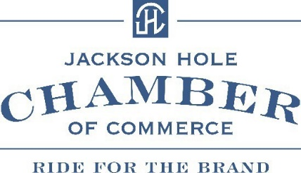
September 6th, 2024
Happy 40th Anniversary of the Falls Arts Festival,
This event put on by your Chamber of Commerce has now become one of the top art events in the nation. We hope you enjoy one of the 11 days of events that celebrate art, inspiration & creativity in our community and the amazing artists who make at all come to life.
Here are highlights of the Chamber of Commerce advocacy efforts this past year.
- Northern South Park / Approved – the Chamber attended over twenty-seven meetings, hosting six of our own to get the single largest approved housing project approved in the boundaries of Teton County in over 30 years. This has been the number one priority of our members for the past four surveys.
- Housing Mitigation for existing businesses – The Jackson Town Council is reconsidering the fees for existing businesses at a meeting on September 9th. This has been a focus of the Government Community Affairs committee to save small businesses over one hundred thousand dollars if they wish to keep this in the family or keep the same space but change the use.
- Prevention of Tax increases – Locally and nationally the Chamber of Commerce has lobbied and submitted letters to local, state, and national officials to prevent harmful increases that negatively affect families and businesses in Teton County.
- Prevention of Harmful Federal & State Regulations & Initiatives – H.R.7198 The Prove it Act closes loopholes and requires federal & state agencies to take small business input to understand true costs of regulatory burdens that only hurt businesses.
- Support of North Highway 89 Wildlife Crossing – The Chamber of Commerce sent a support letter to the Federal Highway Administration to build a highway crossing Pilot Program for protection of wildlife and highway safety.
- Kelly Land Parcel – Through meetings with the State Land Investment Board and solid support from our membership survey the next steps are taking place to get this parcel into ownership by Grand Teton National Park for use by future generations in perpetuity.
We at the Chamber of Commerce encourage you to stay involved and help keep Economic Viability our top priority. We are certainly a more complex place than it was over 40 years ago when I first moved here, but there is still no place like it on earth. Contact me anytime.
Sincerely,
Rick Howe
President / CEO
Jackson Hole Chamber of Commerce

