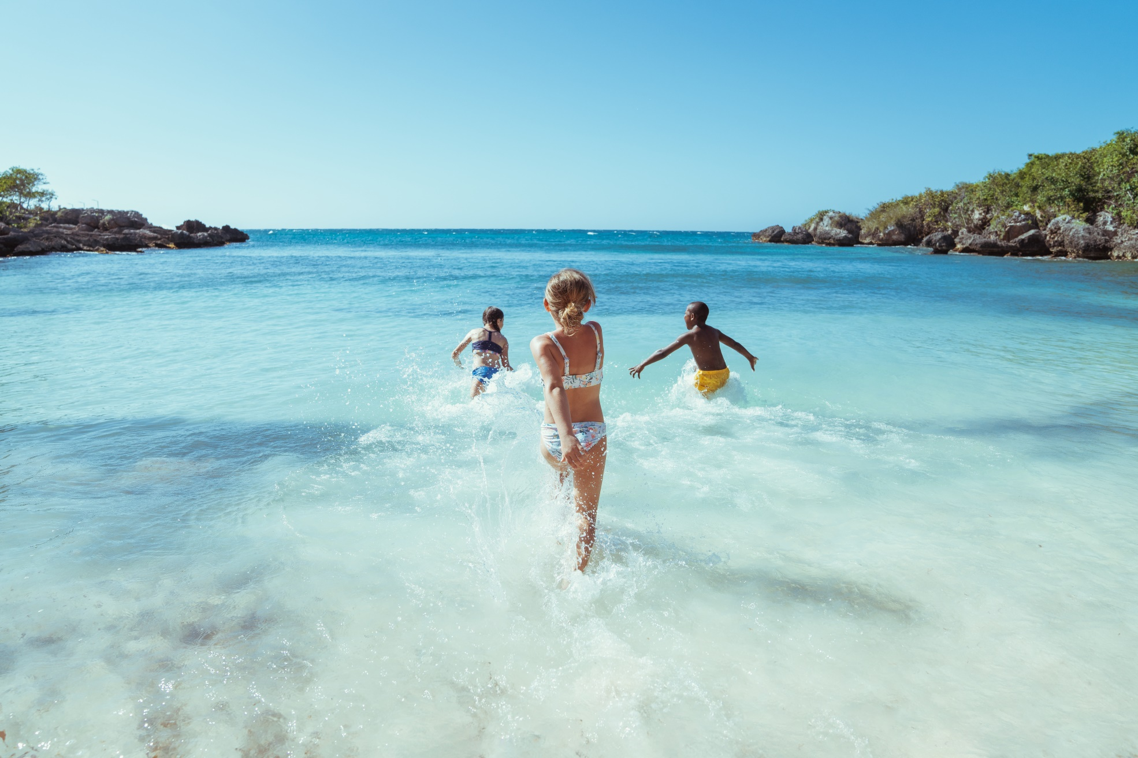

**WESTERN CANADA**

**MEET - ME - IN -MOBAY**

**JULY 14 – 20, 2025**

**DRAFT ITINERARY**

|  |
| --- |
| **MONDAY, JULY 14, 2025** |

Various Arrival Times

Arrive at Sangster Int’l Airport, Montego Bay

Meet JTB Staff in airport arrival terminal

Clear Jamaica Immigration and Customs

Depart for host resort

03:00pm Check into host hotel - **Royalton Blue Waters**

At leisure until group meeting time

06:00pm Meet JTB Representative in the hotel lobby

06:30pm Hosted welcome dinner

Breakfast at leisure

|  |
| --- |
| **TUESDAY, JULY 15, 2025** |

Site inspections

Day spent on property to experience the hotel’s offerings

Special arranged, lunch/cooking demonstration

Dinner and evening at leisure

|  |
| --- |
| **WEDNESDAY, JULY 16, 2025** |

Breakfast at leisure

10:00am Depart for days activities

Visit **Falmouth Artisans Village**

Enjoy Jamaican Patties on the go

Arrive at **Chukka Goodhope** for Rafting, E-bike, Rum Tasting Experience and lunch on property

Return to the hotel

Group dinner at assigned restaurants at the hotel

|  |
| --- |
| **THURSDAY, JULY 17, 2025** |

Breakfast at leisure

9:00 a.m. Check out and depart for day’s activities

Experience **Dunn’s River Falls**

Site Inspections and Lunch of Couples Ocho Rios

**First Dance Studio**, dance class, to learn the art and techniques of Jamaica’s popular dance genres

Continue and check into host hotel – **Couples Negril Resorts**

Dinner an evening at leisure

|  |
| --- |
| **FRIDAY, JULY 18, 2025** |

Breakfast at leisure

10:00 – 4:00 p.m. **Hotel assigned day to plan activities for the advisors**

6:30 p.m**.** Hosted dinner at property

**REGGAE SUMFEST NIGHT 1**

9:00 p.m. Depart for events venue (Catherine Hall)

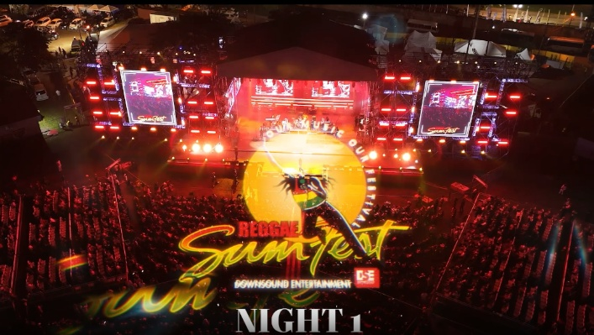

|  |
| --- |
| **SATURDAY, JULY 19, 2025** |

Breakfast at leisure

2:00 – 4:00 p.m. **Hotel assigned day to plan activities for the advisors**

Spa treatments

Dinner on property

**REGGAE SUMFEST NIGHT 2**

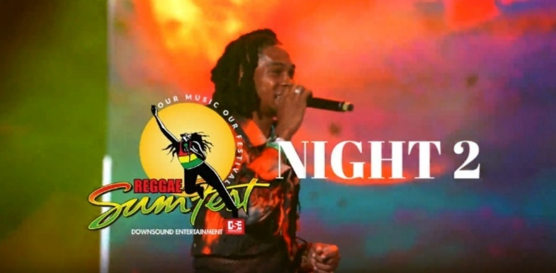9:00 p.m. Depart for events venue (Catherine Hall)

|  |
| --- |
| **SUNDAY, JULY 20, 2025** |

Morning at leisure until departure

Transfer to airport

Check in at airline counter MBJ

Club MoBay Loung check-in

Depart on flight