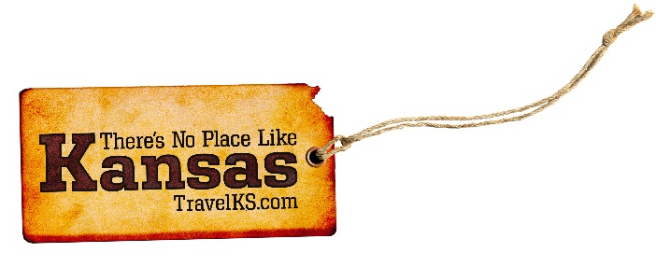
Contact: Kelli Hilliard
Phone: (785) 296-4922
Email: Kelli.Hilliard@ks.gov
Date: February 6, 2019
Photos: TravelKS.com/media/photo-gallery/

Awards Given to the Most-Visited Places in Kansas

Recipients Announced at “Destination Statehouse” Event

Topeka, Kan. – This year, Arrivalist and Kansas Department of Wildlife Parks and Tourism (KDWPT) handed out ArrivaLIST most-visited places awards to top visited destinations in Kansas. Arrivalist is a visitation-intelligence company that empowers marketers with a suite of measurements to evaluate the lifetime value of a visitor. In 2014, KDWPT was the first state agency to partner with Arrivalist to track visitors entering Kansas after visiting KDWPT’s websites online or seeing one of their digital ads. Attractions with the most tourist visits tracked through Arrivalist in 2018 were awarded at a lunch ceremony on February 6, 2019 during the Destination Statehouse event.

Historically, out-of-state visitor information relied on self-reporting, and marketers were only getting a fraction of data they needed to accurately understand visitation behavior. Arrivalist uses concrete data to report actual foot-traffic captured in real time. The company unveiled ArrivaLIST, Kansas’ most-visited sites, to provide consumers, travelers and businesses with accurate, unbiased travel advice. Arrivalist only captures unique visitors at each attraction once per trip, allowing the company to offer clients the most precise visitation behavior.

The ArrivaLIST winners include a variety of categories. Following are the top winners in each category:
- Attractions winner: Massachusetts Street, Lawrence
- Zoos, Parks and Natural Attractions winner: Sedgwick County Zoo, Wichita
- Farms and Ranch Experiences winner: Ringneck Ranch, Tipton
- Breweries, Distilleries and Wineries winner: Gella’s Diner and Lb. Brewing Company, Hays
- Large & Luxury Hotels winner: Great Wolf Lodge, Kansas City, Kansas
- Casinos winner: Kansas Star Casino, Mulvane

The full list of winners can be found at
https://www.travelks.com/industry/arrivalist/2019-kansas-arrivalist-winners/

Kansas Department of Wildlife, Parks and Tourism is charged with encouraging the public to visit and travel in Kansas by promoting recreational, historic and natural advantages of the state and its facilities. The Tourism Division focuses on measurable goals in its marketing and promotional efforts, which include increasing domestic and international inquiries through advertising and public relations efforts and converting those inquiries into visits to Kansas, increasing group tour visits, and generating positive public perceptions about the state as a travel destination.

###

