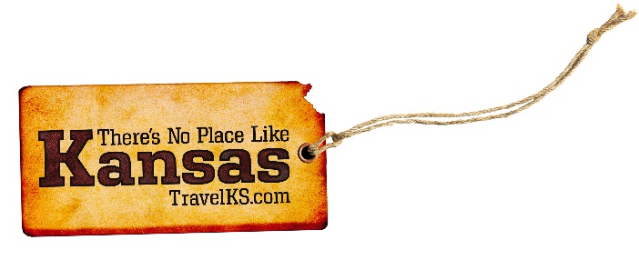
Contact: Kelli Hilliard
Phone: (785) 296-4922
Email: Kelli.Hilliard@TravelKS.com
Date: March 2, 2016
Photos: www.travelks.com/media-gallery/photos/whatsnew/

Check Out What’s New in Kansas This Year
Get set to day-trip across Kansas this year, discovering all the brand-new attractions and events in store. Plan a stop at the dare-devilish Evel Knievel Museum, the trumpeted Elephants of the Zambezi River Valley zoo exhibit and other anticipated attractions, and say “cheers” to first-ever festivals that celebrate local brews, chocolate, the Chisholm Trail and more.
Among the must-sees this fall is Topeka’s new Evel Knievel Museum, featuring the world’s largest collection of the fearless cyclist’s authentic performance leathers, helmets, jump bikes and memorabilia. The permanent museum, housed at Historic Harley-Davidson of Topeka, also showcases Knievel’s first Harley-Davidson, a larger-than-life bronze and copper statue, fan letters, X-rays (the late motorcycle jumper holds the Guinness World Record for surviving the most broken bones—433) and other never-before-seen memorabilia. It’s set to open in early fall (www.visittopeka.com).
Wichita’s Sedgwick County Zoo will boast the third largest elephant exhibit in the country when the Elephants of the Zambezi River Valley opens Memorial Day weekend. Seven elephants will splash in the nation’s largest elephant water pool and roam the sprawling five acres, resembling Africa’s lush river valley. The immersive experience takes visitors on boat rides in the same water as the elephants and on walking paths to a viewing pavilion surrounded by elephants on all sides (www.scz.org).
At the new Lowell Milken Center for Unsung Heroes exhibition hall, opening in downtown Fort Scott on May 24, learn the touching stories of compassionate, everyday people who took extraordinary action to make a difference. The 6,000-square-foot museum, with high-tech, interactive exhibits and a theater, chronicles the heroics of Irena Sendler, a Polish Catholic social worker who saved over 2,500 Jewish children from the Warsaw Ghetto during World War II, Little Rock Central High School senior Kendall Reinhardt who faced bullying and beatings for simple kindnesses to the nine African Americans who integrated his school at the height of the Civil Rights Movement, brave stray Sgt. Stubby, the most decorated war dog in history, and many other unheralded heroes (www.lowellmilkencenter.org).
Take the plunge this summer at Dodge City’s new $12-million western-themed water park, named Long Branch Lagoon! One of the state’s biggest aquatic parks makes waves with its Cowboy Creek lazy river, Wrangler Rapids wave pool, Doc’s Plunge Boomerango slide, Fort Splash play area, Olympic-sized lap pool, climbing wall and Chuck Wagon concessions. Situated in Wright Park, the Lagoon gets its western look from wagon wheels, covered wagon, saddles, hitching posts, tombstones, cowboy silhouettes and other rustic relics worked into the landscape (www.lblagoon.com).
Coming soon to downtown Manhattan: a 13-screen movie complex, including an immersive 575-seat IMAX theater and five auditoriums offering full dining and beverage options. Set to premiere in fall 2016, the Carmike Cinemas complex adjoins the south end of the Manhattan Town Center shopping mall, replacing the former Sears building (www.manhattantowncenter.com).
Already flying high, Overland Park’s newest attraction iFLY gives visitors the thrill and adrenaline rush of skydiving without plunging from an airplane. Opened earlier this year, the indoor skydiving complex outfits customers in equipment they need to fly comfortably, including flight suits, goggles and helmets. After a brief training session, flyers then get a chance to apply that knowledge to experience the sensation of skydiving in the safety of a three story wind tunnel (www.iflyworld.com/kansas-city).
Also in 2016, mark your calendars for first-ever events scheduled across the state, including the yummy Kansas Chocolate Festival September 24 in downtown Topeka. Presented by Visit Topeka Inc. and Mars Chocolate North America, which makes Snickers and Peanut M&Ms at its Topeka plant, the celebration will include cooking demonstrations by chocolatiers, 20 food trucks (each selling at least one Mars chocolate dish), an art show with chocolate sculptures, chocolate cooking contest, M&M characters and other sweet treats. Also showing: a chocolate-themed movie on the lawn of the capitol (www.visittopeka.com/events/-events-chocolatefestival).
Another inaugural event, the Cyclovia Topeka bicycling festival, pedals through Topeka July 29-30. Gear up for a glow ride, Friday night concert, rides to parks and trails across the city, obstacle courses, food trucks, yoga, aerobics and other healthy fun. The fest was created in response to Visit Topeka’s My Top Festival competition, allowing the pubic to vote on a new event for the city (www.visittopeka.com/events/mytopfestival).
Watch for other first-time happenings on the horizon in 2016. Among them:
--“Lift Every Voice: The Black Experience in the Heartland,” a traveling theater production, stops at four sites in Kansas in celebration of the National Park Service’s centennial. Scripted and performed by North Carolina’s Bright Star Touring Theatre, the original play celebrates African American history in Kansas and the Midwest. Watch for it March 5 at Emporia Arts Center (hosted by Tallgrass Prairie National Preserve), March 7 at State Street Elementary School in Topeka (in partnership with Brown v. Board of Education National Historic Site), March 8 at Fort Scott National Historic Site and July 30 at Nicodemus National Historic Site. (The sites are scheduling both public and school group performances, so check ahead).
--Brews on the Bricks Craft Beer Festival, on tap April 2 in historic downtown Hays. This afternoon affair draws 15 regional breweries, food trucks, brewery tours, live music and merchandise and food vendors (tickets already sold out for the beer tasting, but there’s plenty more fun brewing) (brewsonthebricks).
--Scoot your boots to Trail, Rails & Tales on Labor Day weekend (September 3-4) in Abilene. The Chisholm Trail celebrates its sesquicentennial in 2017, but the partying starts early in Abilene, the once-rowdy railhead at the end of the famous trail. Trot into town for historic re-enactments, can-can girls, cowboy poets and a chuck wagon cook-off, and see longhorn cattle loaded into a cattle car and hauled away by a steam locomotive. Watch for a whole herd of happenings in Abilene and along the Chisholm Trail in 2017.
##

