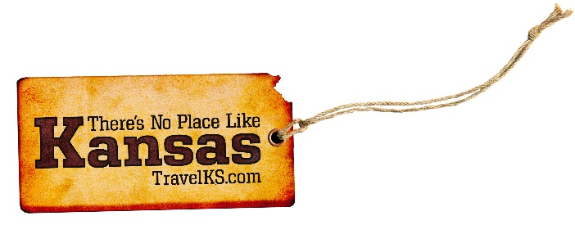
Contact: Kelli Hilliard
Phone: (785) 296-4922
Email: Kelli.Hilliard@KS.Gov
Date: April 11, 2018
Photos: travelks.com/media/photo-gallery/

Celebrate Spring in Kansas

Spend a Family Weekend in Bonner Springs. Barnyard Babies, April 21 10:00 am- 4:00 pm at National Agricultural Center & Hall of Fame, 630 North 126th Street, Bonner Springs, KS 66012. Come out to this fun family festival and experience life on a farm – from barnyard babies to a tractor petting zoo, and fresh produce to kiddie pedal pull contests, giant balloon animals, games and much more! Spring Family Timber Challenge, April 22 9:00 am- 1:00 pm, KC Timber Challenge, 12829 Loring Road, Bonner Springs, KS 66012. Get your play on with the whole family! This Spring Family Timber Challenge is 2 miles long and is packed with fun and challenging obstacles for the whole family (ages 5+). (BonnerSprings.org )

Get the Heck into Dodge City Raceway Park and Final Friday Events this Spring. Dodge City Raceway Park opened its’ 2018 racing season Saturday, March 31. This race features DCRP Sprint Cars, IMCA Modifieds, IMCA Sport Modifieds, IMCA Stock Cars, IMCA Hobby Stocks. Tickets are $15 at the door. Children 11 & under are admitted free when accompanied by adult. Pit passes are $30 every night. Final Fridays in Dodge City are the hottest events in town. Enjoy socializing while viewing art on the last Friday night of every month starting at 4 PM. View unique pieces by local artists, visit several downtown businesses involved such as the Boot Hill Distillery, Dodge City Brewing, and the new Red Beard Coffee. Check out Final Fridays in Dodge City on Facebook to see the most up-to-date information. (VisitDodgeCity.org)

Emporia will welcome 1,600 players to the world’s largest disc golf tournament, the Glass Blown Open (GBO) April 21-29. GBO is a PDGA sanctioned tournament hosted by Emporia-based Dynamic Discs. On June 1-3, the Dirty Kanza bicycle race is expecting 61 riders from 16 foreign countries and Puerto Rico amongst it’s 2,500 registered riders. A 200-mile gravel race is the signature event. Other categories include the DK half-pint (100-miles), the DK lite (50-miles) and the 25-mile fun ride. New events for 2018 include the DKXL, a 350-mile, rider-self-supported gravel cycling adventure through the Flint Hills region, and the High School Gravel Championship. Emporia will also host the inaugural PDGA Junior Worlds July 10-14. (VisitEmporia.com)

In Lawrence, art galleries, shops and boutiques host events, specials, and live music for Final Fridays - the last Friday of every month. The Fifth Annual Kansas Food Truck Festival will be held May 5th from 4pm-10pm. There will be more than 25 food trucks, live entertainment, and a beer garden. The always quirky, crowd-pleasing Busker Festival is back for its 11th year, May 25-27. This once-a-year-get-weird-weekend features more than 15 jaw-dropping acts on five stages throughout Downtown Lawrence. The National African American Quilt Conference takes place July 11–14. The city-wide event celebrates the history and legacy of African Americans in Lawrence, the African American quilting tradition, and contemporary art by African American artists. See the biggest talent in youth basketball during The Hardwood Classic, July 19-22 and July 26-29, at Sports Pavilion Lawrence. College coaches flock to Lawrence for this NCAA Certified recruiting event. (UnmistakablyLawrence.com)

Roll those windows down and cruise to Manhattan for Kicker Country Stampede with Florida Georgia Line. You’ll be walkin’ in high cotton with Alabama and more great artists, June 21-23, Tuttle Creek Park. Kick it into gear to reach the finish line at Bill Snyder Family Stadium during MHK’s half-marathon race on May 19. Be the man! Be the woman! Be The Dinosaur, when this new exhibit at Flint Hills Discovery Center opens May 12 and brings a fusion of high-tech video games mixed with T-Rex and pterodactyl truths. Tremendous! As are summer visits to the Gateway to the Flint Hills with amazing sunset views prevalent. Soar high on Wildwood ziplines, and sip wines just yards from their vineyard harvest spot. Visit the state’s top-ranked zoo and its newborn maned wolves. Widgets provides another spectacular family entertainment spot with laser tag and more. Visit Manhattan! Gateway to the Flint Hills! (VisitManhattanKS.org)

Join us for the Big Kansas Road Trip May 3-6, 2018 in the South Central Kansas counties of Barber, Comanche and Kiowa. This weekend will all about seeing, doing, exploring, eating and finding out what makes all of the communities in the 3 counties unique. Visitors will be able to attend many special events throughout the area, visit area attractions and explore all the nooks and crannies and quirkiness that makes us who we are! Imagine exploring an area of Kansas with hundreds of other people at the same time! BKRT 2018 is a chance to really see what makes these rural communities tick and appreciate them for who they are. This event is a partnership between the Kansas Sampler Foundation and the local communities. (BigKansasRoadTrip.com)

Wichita is known as the Air Capital of the World for its innovation and manufacturing aptitude in the aviation industry, and is home to Design Build Fly, the only exhibit in the country to provide a closeup look at how airplanes are made and piloted. The city has more than 33 museums, 22 attractions, 22 live theatres, 17 festivals, eight shopping districts and more than 1,000 restaurants. In recent years, Wichita has evolved into a vibrant, multicultural city, with many new eateries, shops, breweries and outdoor spaces like the ICT Pop-Up Urban Park and Gallery Alley, a once under-utilized alley turned lively public space. Final Fridays are a way to experience the local art scene, which earned Wichita a spot in Expedia’s list of Most Artistic Towns in the United States. Additionally, expansion of the city’s free Q-Line Trolley and Bike Share ICT have ignited vibrancy into the city’s core. (VisitWichita.com)

