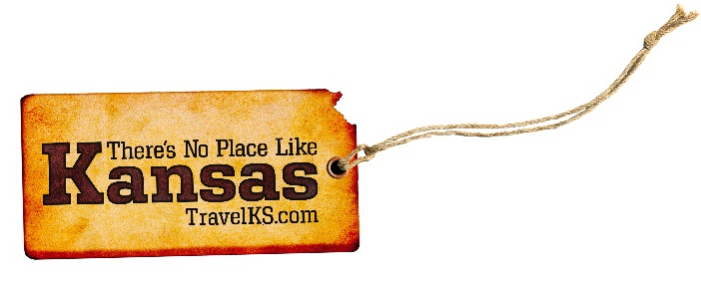
Contact: Kelli Hilliard
Phone: (785) 296-4922
Email: Kelli.Hilliard@KS.Gov
Date: January 18, 2017
Photos: travelks.com/media/photo-gallery/

Events and Attractions Beckon Travelers to Kansas
The party never stops in Kansas, with attractions and events filling travelers’ cravings for good food, great entertainment and the best local hospitality. A special addition to the calendar this year: the 150th anniversary of the iconic Chisholm Trail, with celebrations planned across the state.
Hillary Clinton may not get the big party in Washington, D.C. that she'd hoped, but she will have her own inauguration on January 20. At 10:30 am, one half hour before the next president, Donald Trump, takes the oath of office in D.C., Clinton will be officially inducted into the "They Also Ran Gallery" in Norton, Kansas. Local politicians and guests will take a few moments to recognize Clinton as the first woman and 61st entry into the fraternity of those who have been challengers for, but lost the presidency of the United States. The gallery was conceived in 1965 after First State Bank owner and president William Walter Rouse read a book called They Also Ran by Irving Stone. He was so inspired by the stories of the people who had the vision, but lost the election, that he decided to create a permanent place to recognize their efforts inside the lobby of the bank. (theyalsoran.com)
Listen to history in a room that made national political news 160 years ago, Constitution Hall. For 21 years, Constitution Hall State Historic Site in Lecompton, Kansas, has hosted a series of talks and dramatic interpretations on the violent territorial and civil war history of Kansas, 1854-1865. Come experience history by listening to the programs on Sundays at 2pm, from January 29-March 5, with a suggested donation of $3 each. Several of the programs feature feisty reenactors. The Lecompton Constitution was written in the building, the oldest wood frame building in Kansas still in its original location, 160 years ago. Lecompton, Kansas, voted a “best small town in Kansas” by the readers of KANSAS! Magazine, is home to two amazing museums, two eateries, quaint shops, and no stoplights. (lecomptonkansas.com)
Many people are familiar with Mardi Gras celebrations on the day before Lent, but in Liberal, Kansas, the day before Lent means just one thing – it’s Pancake Day. On Shrove Tuesday, February 28, 2017, at 11:55 a.m., the International Pancake Race goes on again between Liberal and Olney, England, with women running down the streets of each town with pancakes. The International Race started in 1950 from a magazine picture of the Olney women racing each other to the church. Liberal Jaycee President R.J. Leete contacted Rev. Ronald Collins, Vicar of St. Peter and St. Paul's Church in Olney, challenging their women to race against women of Liberal. The traditional prize of the race is still the "Kiss of Peace" from the verger (bellringer). This friendly little race is still the only race of its kind on the planet. (pancakeday.net)
On May 4th, 2007, 95% of Greensburg, Kansas was destroyed by an EF5 tornado. But this is not what defines them. Greensburg has rebuilt as one of the greenest cities in the United States, has been featured as one of Budget Travel’s 2011 Coolest Small Towns in America, seen in 2013 USA Today’s Sustainability magazine, and appeared in the Planet Green’s series, Greensburg. In 2017, Greensburg will be celebrating 10 years of pioneering and innovation of rebuilding their community with sustainability in mind. Over the May 4-7th weekend, they will memorialize those who perished and will commemorate their successes and look forward to what the future has in store for the community. (greensburgks.org)
There’s a new restaurant in town! The Guymon Petro Bar and Grill opened for business on December 9, 2016 in Dodge City Kansas. This historic mercantile building was built in early 1900’s and was used as a distribution warehouse until the late 1940’s. The building was renovated to an upscale restaurant with room on the second floor for private event space rental. With menu items that include Quail and Pheasant, your taste buds are sure to be tantalized by this unique dining experience in this historic building transformation. The restaurant is part of several renovations happing in Dodge City, with other new projects being completed in this historic area, Long Branch Lagoon- a new Family friendly water park, a brand new hotel and RV Resort are all within walking distance, located directly in front of World Famous Boot Hill Museum. (visitdodgecity.org)
No other city in the world can boast the basketball heritage of Lawrence, Kansas. Although James Naismith, the Father of Basketball, invented the game in Massachusetts, the game “grew up” in Lawrence after Naismith brought the game to the University of Kansas in 1898. That’s why we’re called the Cradle of Basketball. Forrest C. “Phog” Allen, the Father of Basketball Coaching, was a player on Naismith’s 1905 team and became one of the greatest coaches. He established the National Association of Basketball Coaches, propelled basketball into an Olympic sport and launched the NCAA basketball tournament. The Cradle of Basketball is a place two “parents” of basketball called home, and where they spent their careers advancing the game. Today you can view the original rules of basketball in their permanent home, The DeBruce Center, next to the renowned Allen Fieldhouse. Follow the Cradle of Basketball itinerary to get the full experience. (unmistakablylawrence.com)
Near Dodge City’s historical Front Street, the inscription below a cowboy statue reads, “On the ashes of my campground, this city is built.” The same could be said of Wichita, Abilene, Ellsworth, Wellington, Newton and Caldwell—all raucous Kansas cow towns that took their turn as the final stop of the legendary Chisholm Trail. In 2017, those communities and others celebrate the 150th anniversary of the route along which 5 million longhorns lumbered from Texas to Kansas between 1867 and 1885. Towns all along the trail have a roundup of special sesquicentennial events planned. (chisholmtrail150.org)
For more information on these, or any attractions or events happening in Kansas, visit TravelKS.com.
###

