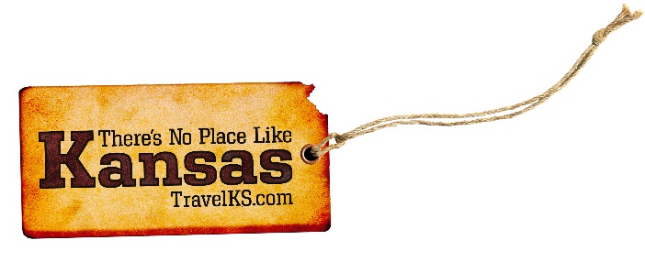
Contact: Kelli Hilliard
Phone: (785) 296-4922
Email: Kelli.Hilliard@KS.Gov
Date: July 23, 2018
Photos: travelks.com/media/photo-gallery/

Fun in the Late Summer Sun in Kansas

Find the Wild Side of the state for Dodge City Days July 27- August 5, 2018. With the Boot Hill Bull Fry & Bash, the Dodge City Revival (July 27), the Dodge City Days Parade and BBQ contest, or kicking it up at the Justin Moore Concert at United Wireless Arena on the July 28. (Tickets are available now at and are selling fast, so act quickly for best selection!) On Sunday, July 30, test your endurance with the 2-mile course at the Gauntlet Challenge. Put your boots on and stomp down to Dodge City Roundup Arena for the Wrangler Million Dollar Tour Gold Rodeo to watch the top cowboys and cowgirls compete August 1- 5. Everyone relives history as the longhorns are driven down Wyatt Earp Boulevard (August 4). Come on- “Get The Heck INTO Dodge!” (VisitDodgeCity.org)

A re-dedication ceremony occurred at the Memorial to Fallen Educators during National Teachers Hall of Fame Induction week in Emporia, Kansas. Seven names will be added to the memorial this year including three educators from Parkland, Florida. The Memorial to Fallen Educators became the first national memorial in Kansas when the National Memorial to Fallen Educators Act was signed into law April 30. The National Teachers Hall of Fame partnered with Emporia State University to create a permanent tribute to educators who lost their lives while on duty in their PreK-12 schools. A dedication ceremony was held June 12, 2014. The memorial includes the names of 119 educators including teachers, administrators and education support professionals who were killed “in the line of duty,” dating back to 1764. (VisitEmporia.com)

Lawrence was founded in the 1850’s as the state’s center of resistance to the expansion of slavery. And it paid the price. Targeted, pillaged and burned to the ground during the Civil War, the community rebuilt with a commitment to education, civility, and the future. Historical agencies throughout Douglas County will present programs that explore Quantrill’s Raid and highlight the area’s territorial and Civil War History during the Civil War on the Western Frontier, August 12-19. On September 21-22, a national gathering called Keeping Legends Alive at Haskell Indian Nations University will honor the legacy of those who served our country and recreate the largest gathering of tribal people in Lawrence, Kansas in 1926 when the first tribal World War I Memorial – the Haskell Stadium and Arch – was dedicated. (UnmistakablyLawrence.com)

Music is in the air at numerous Manhattan venues, with the Liquid Art Summer Music Series at Manhattan’s west-side located winery in the Flint Hills, and Landshark Music Series at Coco Bolos, each with two July entertainment dates. Bluemont Lounge is another hot spot with musicians each Wednesday and Thursday. On July 25, National Wine and Cheese Day won’t go unnoticed at Harry’s on Poyntz Avenue, where the classic restaurant celebrates a classical drink and food pairing. Another tradition, Kaw Valley Rodeo bucks into Manhattan at CiCo Park (July 26-28) during the Riley County Fair. Observe gentler animals during Aug. 18 Brew at the Zoo at the state’s top zoological location, Sunset Zoo. Perennial power Kansas State Wildcats kick off another college football season Sept. 1 with the annual Family Reunion game. Mississippi State Bulldogs and Texas Longhorns top the schedule during September’s opening month. (VisitManhattanKS.org)

In a natural amphitheater set against the Red Hills, Medicine Lodge re-enacts 300 years of history at its Peace Treaty Pageant September 28-30 (staged every 3-5 years). This historical pageant reenacts the events surrounding the Medicine Lodge Treaty of 1867 and commemorating the 150 years since the signing. Also part of the town’s frontier festivities: the Kansas Championship Ranch Rodeo (September 28-29) and the Peace Treaty Powwow (September 28-30). (PeaceTreaty.org)

