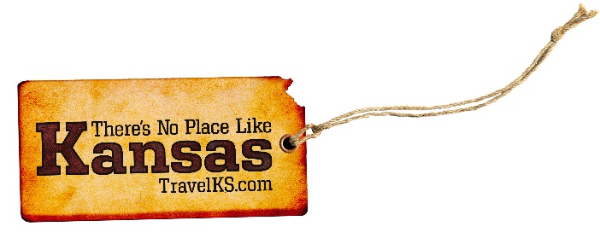
Contact: Kelli Hilliard
Phone: (785) 296-4922
Email: Kelli.Hilliard@KS.Gov
Date: July 9, 2019
Photos: travelks.com/media/photo-gallery/

Endless Summer in Kansas

The all-new 25,000 square feet of museum exhibits at the Eisenhower Presidential Library and Museum in Abilene will open the end of July! The most recent innovations in technological components and interactives are guaranteed to engage audiences of all ages and learning styles. One new interactive feature tells the story of “Becoming Ike and Mamie.” The hands-on table allows visitors to explore Eisenhower’s pre-WWII career assignments. In addition to seeing rare artifacts and hearing new stories from the archives, visitors will come away with an understanding of how those experiences made Ike the perfect General to lead the Allies to victory in Europe in WWII. New mini-theaters offer visitors the opportunity to hear Ike’s words firsthand on a variety of events and issues from D-Day to world peace. Visitors will come to understand why the Eisenhower Administration was known for eight years of peace and prosperity. The layered-learning approach throughout the exhibits gives all visitors the opportunity to make a personal connection during their visit. Come see Ike again for the first time. (eisenhowerlibrary.gov)

Chanute Blues Blast presents Joanna Connor Band out of Chicago and Donnie Miller & Rude Awakening out of Nashville in concert on Saturday, Aug 10, in Chanute, KS. Tickets are $10 prior to event and $15 at the gate. Venue is outdoors at the historic Martin Johnson Airport with seating on the concrete tarmac. Gates open at 6:30pm with music at 7:30pm. No outside food or beverages. Vendors on site. Bring your own seating. For more information or tickets, 620-431-3350. Tickets also on eventbrite.com. (ChanuteChamber.com)

Get the Heck into Dodge City – Celebrate the 140th Anniversary of the Cowboy Band during Dodge City Days July 26- August 4, 2019. With the Boot Hill Bull Fry & Bash, the Dodge City Days Parade and BBQ contest, or dancing out the night with the Trace Adkins concert at United Wireless Arena on the July 27. On Sunday, July 28, test your ninja skills with the 2-mile course, United Wireless Ninja Warrior Challenge at the Western State Bank Expo. Put your boots on and stomp down to Dodge City Roundup Arena for PRCA Rodeo to watch the top cowboys and cowgirls compete July 31- August 4. Everyone relives history as the longhorn cattle are driven down Wyatt Earp Boulevard on August 3rd. (VisitDodgeCity.org)

Get ready for another fun packed summer in Salina! Rolling Hills Zoo is celebrating their 20th Anniversary with celebrations commencing all year long. Journey back in time to when it all began with a special Gallery Show. The historic Stiefel Theatre has a full schedule with acts such as Ronnie Milsap and 38 Special. The 39th annual KKOA Leadsled Spectacular Car Show event in beautiful Oakdale Park brings everything from drag races, vintage markets, pin-up girls, food trucks, and music for a July weekend you won’t want to miss! Pack up the kids and head to Tony’s Pizza Events Center for Paw Patrol Live. Make it a weekend - Friday Night Live presents live performances downtown every week! Pack your sunscreen and soak up some sun at Kenwood Cove Aquatics Park! (VisitSalina.org)

For more information on these, or any attractions or events happening in Kansas, visit TravelKS.com.

