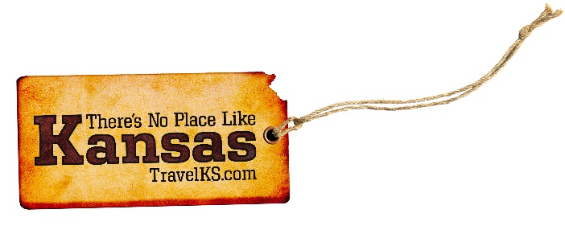
Contact: Kelli Hilliard
Phone: (785) 296-4922
Email: Kelli.Hilliard@KS.Gov
Date: October 9, 2018
Photos: travelks.com/media/photo-gallery/

Fall into Winter in Kansas

The 2018-2019 pheasant hunting season in Ford County boasts an additional incentive to hunters as the Dodge City Convention and Visitors Bureau once again hosts their two annual pheasant contests, “Bounty Bird” and “Rooster Roundup”. 150 banded pheasants will be released near Ford County walk-in hunting areas adjacent to Dodge City. 100 gold numbered, banded birds will be released for the “Bounty Bird” and 50 red numbered, banded birds will be released for the “Rooster Roundup”. If you are lucky enough to bag one of the Ford County leg banded pheasants, hunters will need to return the band to the Dodge City Visitors Center to receive a gift and officially register the band for the appropriate contest. (VisitDodgeCity.org)

eXplore Lawrence is pleased to announce the addition of two new employees in the Sales Department. Kendra Schultz joined the team in July as the Director of Sales. Lauren Driessel joined in August as the Higher Education Sales Manager. Lauren and Kendra work together to prospect and service meetings, conferences, and athletics events with the primary focus of increasing Sunday – Thursday overnight visits. Two new hotels are opening this quarter in Lawrence. Tru by Hilton and Best Western Plus are bringing nearly 200 new rooms to Lawrence’s inventory. Blade and Timber Axe Throwing recently opened in Downtown Lawrence, and offers remarkable entertainment for friends, family, corporate groups, and team building. A new dessert, coffee, and cocktail lounge has opened in Downtown Lawrence as well. Crystal’s Spot, “where friends become family”, is open 6:00 PM – 11:00 PM Thursday – Saturday, and is bookable for special events. (UnmistakablyLawrence.com)

Autumn around Manhattan -- Gateway to the Flint Hills -- brings every color of the season into focus. Biking, hiking and hunting/fishing are prevalent activities around the marvel of the Midwest plains. Getaways don’t come much more pleasing than roaming the rolling hills around MHK. Hike the Konza Prairie or take jaunts up Bluemont Hill where you see the hillside “Manhattan” letters from faraway. The leaves begin to turn at Tuttle Creek State Park, which Nov. 3 hosts the inaugural Little Apple Marathon. Runners rejoice for perfect, early-morning conditions offered lakeside. Later in November, kids climb atop parents’ shoulders and Santa’s lap during Festival of Lights opening ceremonies. Nov. 23 events include lighting of the state’s tallest tree in Blue Earth Plaza. As for nature, the state animal is featured through January in Flint Hills Discovery Center’s newest exhibition, “Bison: The American Icon.” Get your fill of fall around MHK! (VisitManhattanKS.org)

The season of glowing jack-o-lanterns and things that make you go “Boo!” is among us! Russell County is bursting with Fall bounty, so grab your sweatshirt and pumpkin spice, and drive the post rock scenic byway at Wilson Lake to Lucas and find a day full of grassroots art and attractions for the whole family. See the leaves changing color in rural Kansas and don’t miss your chance to experience Granny Mae’s Pumpkin Patch by Dorrance, just a few miles South of I-70. The ROAR Art show in Russell celebrates 50 years of Kansas art and the Russell Masonic Lodge is waiting for you at their haunted house, one you don’t want to visit alone! (RussellCoKS.org)

"Get Lit" in WaKeeney! New LED Color-Changing perimeter lights are currently being installed in Downtown WaKeeney. They will take "the Christmas City of the High Plains" into the 21st Century. The LED Color-Changing perimeter lights will remain lit year-round. The traditional Christmas Tree Lighting Ceremony is scheduled for Saturday, November 24, 2018. The day begins with the 18th Annual Christmas Bazaar by the Trego County Home-Based Business Association from 10:00 AM - 5:00 PM at the Trego County Fairgrounds. The festivities begin downtown at 4:30 PM. Enjoy the benefit Soup Supper, live Christmas music, and a ride in Santa's Sleigh by Virtual Reality In Motion. Join us at 6:00 PM in Downtown WaKeeney when Santa lights the 35 ft. tree. Then the children can visit with Santa and receive special treats. This holiday tradition dates back to 1950. (WaKeeney.org)

For more information on these, or any attractions or events happening in Kansas, visit TravelKS.com.
###

