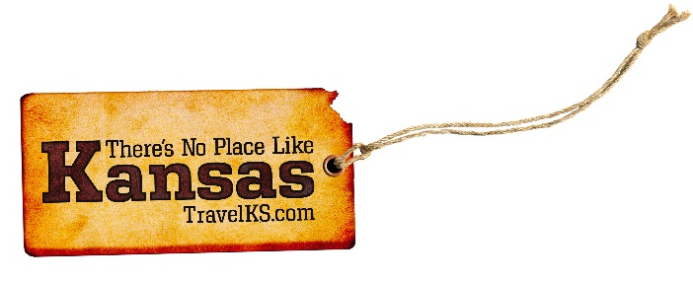
Contact: Kelli Hilliard
Phone: (785) 296-4922
Email: Kelli.Hilliard@KS.Gov
Date: October 3, 2019
Photos: travelks.com/media/photo-gallery/

There’s No Place Like Kansas for Sweater Weather

Join us on Saturday, October 12, for the Museum Rededication and Ribbon Cutting Ceremony at the Eisenhower Presidential Library and Museum in Abilene, Kansas. The ceremony is part of the weekend activities in honor of Dwight Eisenhower's birthday. The ceremony begins at 11 a.m. with a keynote address delivered by Mary Jean Eisenhower, Dwight and Mamie’s granddaughter. Following the ribbon cutting at noon, the museum doors will open to the public with free admission. Tickets for scheduled guided tours of the Boyhood Home are $7. With all-new exhibits, this is your opportunity to meet Ike and Mamie again...for the first time! (eisenhowerlibrary.gov)

Dodge City Convention and Visitors Bureau boost Ford County hunters incentive in 2019 -2020 as they prepare to host their two annual pheasant hunting contest, “Bounty Bird” and “Rooster Roundup.” The contests will release 150 banded pheasants near the Ford County walk-in hunting areas adjacent to Dodge City. 100 gold numbered leg banded birds will be released for the “Bounty Bird,” and 50 red numbered leg banded birds will be released for the “Rooster Roundup.” If you are lucky enough to bag one of the Ford County leg banded pheasants, hunters will need to return the leg band to the Dodge City Visitors Center to receive a gift and officially register the band for the appropriate contest. (VisitDodgeCity.org)

The season of glowing jack-o-lanterns and things that make you go “Boo!” is among us! Russell County is bursting with Fall bounty, so grab your sweatshirt and pumpkin spice, and drive the post rock scenic byway at Wilson Lake to Lucas and find a day full of grassroots art and attractions for the whole family. See the leaves changing color in rural Kansas and don’t miss your chance to experience Granny Mae’s Pumpkin Patch by Dorrance, just a few miles South of I-70. The ROAR Art show in Russell celebrates Kansas art and the Russell Masonic Lodge is waiting for you at their haunted house, one you don’t want to visit alone! (RussellCountyKS.org)

The Tallgrass Prairie National Preserve invites you to discover the meaning of national parks, how your park inspires you - both in personal connections and memorable experiences. On Saturday, November 9, 2019, come experience the 4th annual free Candlelight Tour. Costumed characters will present historic first-person vignettes in and around the historic buildings as visitors are transported back in time through a series of scenes portraying documented activities and events that took place at the ranch over 130 years ago. Visitors will learn about the ranch’s rich heritage of cattle, happy and tough times, and everyday people on the prairie. (nps.gov/tapr)

A cherished tradition continues in WaKeeney, known as “the Christmas City of the High Plains.” WaKeeney lights up the prairie skies with twinkling lights and fresh greenery during the holidays. This annual tradition began in 1950 and is considered one of the largest displays between Kansas City and Denver. Each November WaKeeney is magically transformed into a holiday wonderland. A magnificent 35-foot tree rests under a canopy of heavenly blue lights in the middle of the downtown intersection. A four-square block area around the tree is draped with garlands, handcrafted decorations, and more lights. The lighting takes place on November 30, 2019, with many activities beginning at 3:00 pm and continuing through the evening. Santa arrives at 6:00 pm to flip the switch and visit with the children. The holiday display remains lit through New Years and is free to the public. (WaKeeney.org)

For more information on these, or any attractions or events happening in Kansas, visit TravelKS.com.
###

