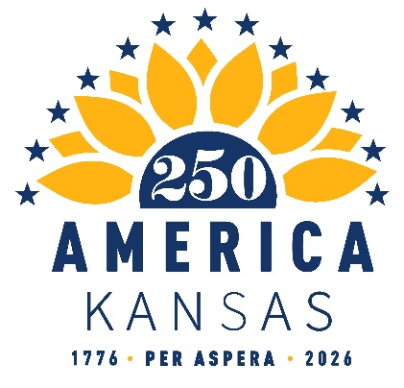

2025 Quarter 3 Finance Report
July 2025 – September 2025

Beginning Balance: $10,473.05

Deposits: $2,322.41
7/14/2025 – $48.25 SemiQuinn Contribution from Jordan Chambers (ACH)
7/14/2025 - $48.25 SemiQuinn Contribution from Bridgette Jobe (ACH)
7/21/2025 - $48.25 SemiQuinn Contribution from Lindsborg CVB (ACH)
8/11/2025 - $48.25 SemiQuinn Contribution from Alexis Radil (ACH)
8/11/2025 - $48.25 SemiQuinn Contribution from Valarie Lamoreaux (ACH)
8/13/2025 - $50.00 SemiQuinn Contribution from Jay Price (Cash)
8/18/2025 - $48.25 SemiQuinn Contribution from Susan Estes (ACH)
8/22/2025 - $750.00 from America 250 for America 250 Convening in DC (ACH)
8/22/2025 - $750.00 from America 250 for America 250 Convening in DC (ACH)
9/02/2025 - $48.25 SemiQuinn Contribution from John More (ACH)
9/15/2025 - $48.25 SemiQuinn Contribution from Brenda Dietrich (ACH)
9/15/2025 - $48.25 SemiQuinn Contribution from Leonard Roberts (ACH)
9/15/2025 - $48.25 SemiQuinn Contribution from Kit Rogers (ACH)
9/15/2025 - $48.25 SemiQuinn Contribution from Ryan J. Beehler (ACH)
9/15/2025 - $48.25 SemiQuinn Contribution from Pamela Curtis (ACH)
9/22/2025 - $48.25 SemiQuinn Contribution from Casey Meir (ACH)
9/22/2025 - $96.50 SemiQuinn Contribution from Bryan Wampler (ACH)
9/23/2025 - $0.41 Deposits Refund
9/29/2025 - $48.25 SemiQuinn Contribution from Nancy Rankin (ACH)
Expenditure: $2,657.92
8/13/2025 - $434.78 Holly Lofton for KS 250 Banner & Tablecloth (Check)
9/02/2025 - $1,015.10 Hillhouse W. LTD for stuffed bison & neckerchief (Check)
9/10/2025- $30.82 Dept of Commerce (reimbursement for postage supplies) (Check)
9/10/2025 - $568.85 Dept of Commerce (reimbursement for airfare, mileage, food, parking, and uber for America 250 Convening in Washington D.C.) (Check)
9/11/2025 - $607.96 Jay Price (reimbursement for airfare for America 250 Convening in 2024 Washington, D.C.) (Check)
9/22/2025 - $0.41 Account Analysis Charge

Ending Balance: $10,137.54
(NOTE: $0.30 off in our favor)

