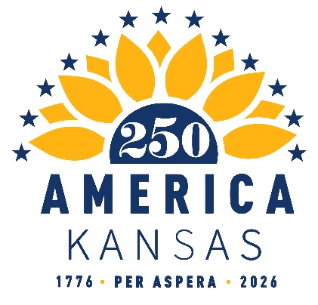

2025 Quarter 4 Finance Report
October 2025 – December 2025

Beginning Balance - - $10,137.54

Deposits: $675.65
10/06/2025 – $48.25 SemiQuinn Contribution from Mary McMurray (ACH)
10/27/2025 - $48.25 SemiQuinn Contribution from Marcia Rozell (ACH)
11/17/2025 - $48.25 SemiQuinn Contribution from Kara Heitz (ACH)
11/17/2025 - $48.25 SemiQuinn Contribution from Patricia Thomblison (ACH)
11/17/2025 - $48.25 SemiQuinn Contribution from Patricia Thomblison (ACH)
11/17/2025 - $48.25 SemiQuinn Contribution from Lisa Satterhwaite (ACH)
11/17/2025 - $48.25 SemiQuinn Contribution from Devin Cooper Lamoreaux (ACH)
11/17/2025 - $48.25 SemiQuinn Contribution from Susan Estes (ACH)
11/24/2025 - $48.25 SemiQuinn Contribution from Will Haynes (ACH)
11/24/2025 - $48.25 SemiQuinn Contribution from Will Haynes (ACH)
11/24/2025 - -$48.25 SemiQuinn Contribution from Andrew Olker(ACH)
11/24/2025 - $48.25 SemiQuinn Contribution from Tiffany Robbins (ACH)
12/15/2025 - $48.25 SemiQuinn Contribution from Melanie Highsmith (ACH)
12/22/2025 - $48.40 SemiQuinn Contribution from Seth Bate (ACH)

Expenditure: $746.25
11/24/2025 - $746.25 Holly Lofton Price (reimbursement for airfare for America 250 Convening in 2025 Washington, D.C.) (Check)

Ending Balance: $10,067.54
(NOTE: $.30 off in our favor again)

