Sports KS Microsite Tutorial

- Make sure you have access to the Extranet Portal

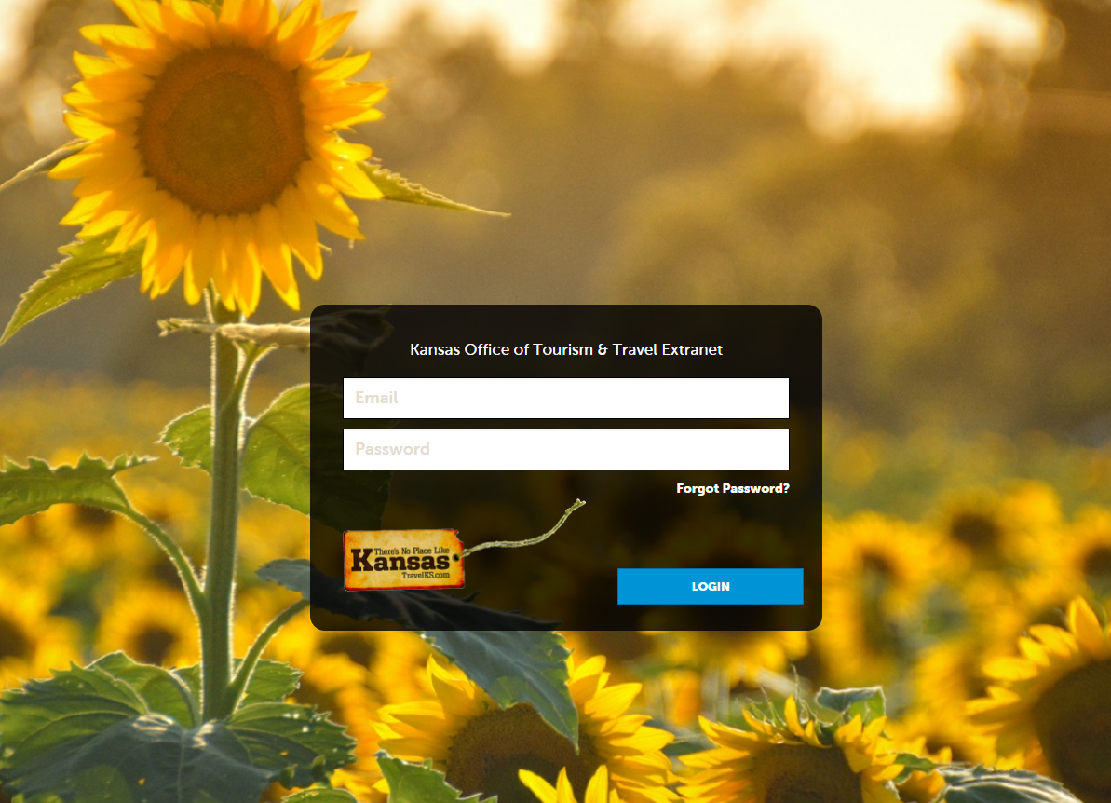

- If you do not have access, please contact Kelli Hilliard at Kelli.Hilliard@ks.gov.

- Once you have access, log in and check to make sure the facilities in your area have an account. Click “Profile” in the left navigation column and then click “Accounts.”
Video Tutorial: https://www.screencast.com/t/E1YnbLJop

- If a facility is not listed, you can either upload all facilities via this form OR email Kelli a list of everything that needs added. She will need the name of the facility, address, phone, general email, website, and contact information (name, title, phone and email).

- She will create the account and once that is complete you will have access to the account(s) and will be able add them to TravelKS.com.

- For more details on adding a new website listing, adding contacts, etc. please refer to the TravelKS.com Training Center tutorials - https://www.travelks.com/industry/education/travelks-training-center/

- After your listing is made, you will need to go into Collateral and tag the listing with "Sports KS - Sports Facilities" as a subcategory (you can pick multiple categories from this list). This will allow the website listing to show up on www.SportsKS.com.
Video Tutorial: https://www.screencast.com/t/oRTCJKaaH

- Then you will need to go into Profile and the account and click on the green drop down arrow and select "manage amenities". From there you will select the sport types that are available.
Video Tutorial: https://www.screencast.com/t/9JRLTQxj

