Lake Norman Lighted Christmas Boat Parade

Captain’s Package/Registration

December 16, 2022

5:00pm – Blythe Landing

1. Thank you to all participants! We are so excited to be part of this annual event!
2. Recognize Organizers and Lake Authorities:
   * Cornelius Police Department
   * Cornelius Lake Patrol
   * NC Wildlife
   * Cornelius Fire Department
   * Mecklenburg Parks and Rec
   * Colin Furcht – Event Founder/Organizer 704-661-2193
3. Safety is priority

* All children under the age of 13 aboard a vessel that is underway, MUST wear an approved PFD, unless below deck or in an enclosed cabin.
* Have **PFD’s** in convenient location and enough for all crew on board.
* Have Fire Extinguishers readily available
* Have a plan if something does happen
* Keep **4 boat lengths** between you and boat in front
* At the rounding mark at Ramsey Creek Park give plenty of space for boats to turn
* Be aware that boats will be slowing down and possibly stopping in some cases
* Keep a clear view at all times for the Captain
* Monitor VHF channels:
  + - 16 (Safety/Distress & TowBoat)
    - 11 – Any equipped vessels should monitor for updates
* Stay aware at all times (do not become disoriented)
* We encourage you to have the Avenza App for on water direction if you do not have a GPS
* We also encourage you to do a full check of your vessel including motor, drives, electronics, etc a week before the parade
* If you will be using an external Generator for your lights, please be sure it is properly vented.

1. Parade Instructions

* Boats participating in the parade must be registered. All souls must be documented.
* Registration begins at **4:30pm**. You will be given a number to be posted on your bow.
* Captain Meeting outside of Blythe Landing at **5pm**
* The Cornelius PD will lead the parade and Cornelius FD will trail
* Please tune your radios to **104.7** to keep the holiday music consistent
* All boats depart Blythe at 5:30 for the parade route
  + - See Parade Map for route for staging area
* Parade starts at **5:30pm** and ends at approximately **7:30pm**.
* Fall inline in orderly manner behind lead boat when instructed to
  + - Starting Waypoint is Blythe Landing
    - Next Waypoint is Ramsey Creek Park – **TowBoat is your Waypoint**
    - **Next Waypoint in the Peninsula Yacht Club**
    - We will speed up a bit between Ramsey and PYC and then PYC and Duke. Please be sure to stay with the vessel ahead of you. **Close all gaps where possible.**
    - Fourth and final waypoint is the Duke Energy Explorium
    - All boats MAY return to Blythe before departing
* Keep assigned number visible on port bow for Identification purposes please.
* All parade boats will continue to follow lead boat until the final stop at Duke.
* The parade vessels will make **TWO FULL** passes at Duke
* Once parade is over parade participants can disperse back to the docks or drop in locations.

1. Boat parking locations

* Blythe Landing - preferred

1. Wave, smile and enjoy! Folks are here to see what we have to bring. Decorate to your hearts content but please do not block the Captains view. Once the parade is over, **only Navigation lights** can be on and visible per Lake Ordinance.
2. Please be sure to bring an **unwrapped toy** for our charity Little Smiles!

**Parade Route 2023**

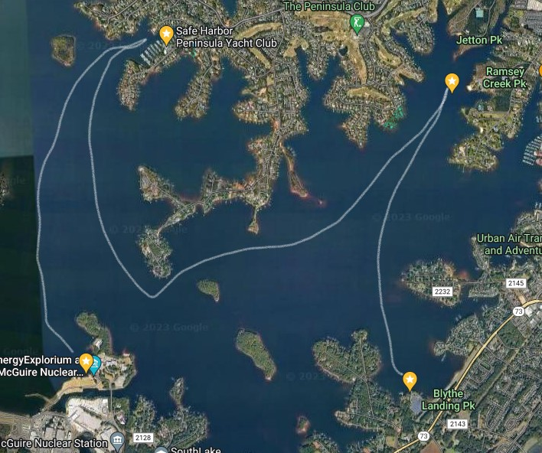

REGISTRATION FORM

2022 LAKE NORMAN CHRISTMAS LIGHT BOAT PARADE

**DECEMBER 16, 2022 4:30PM – BLYTHE LANDING**

____________________________________________________________________________

Captains Name:

Vessel Name:

Vessel Type:

Vessel Color:

Vessel Length:

NC Registration:

Captain’s Phone:

Captain’s Email:

Expected Crew Number:

Please email this page only to : [cbaycharlotte@gmail.com](mailto:cbaycharlotte@gmail.com) at least 3 days before the event.

**CREW MEMBER NAMES:**

FIRST NAME LAST NAME

|  |  |
| --- | --- |
| 1. |  |
| 2. |  |
| 3. |  |
| 4. |  |
| 5. |  |
| 6. |  |
| 7. |  |
| 8. |  |
| 9. |  |
| 10. |  |
| 11. |  |
| 12. |  |

I agree to adhere to all lake law and regulations during the parade. I will be responsible for my vessel and crew to the best of my ability. I have and will share all safety processes with my crew before the event. My vessel will have all required safety equipment including PFD’s, Navigation Lights, Horn and Fire Extinguishers.

_____________________

Vessel Captain’s Signature