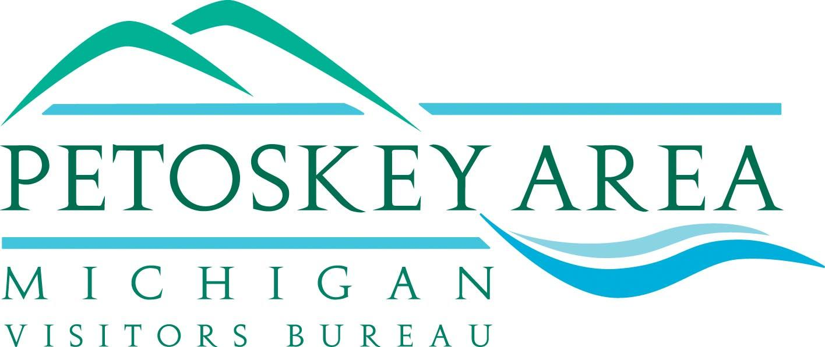

Event Underwriting Policy

Any request for funding from the Board of Directors of the Petoskey Area Visitors Bureau shall meet the following provisions:

- The request shall be made by a nonprofit organization in writing to the Board of Directors not later than ninety (90) days prior to the event.

- The mission and goals of the event are compatible with those of the Bureau to increase visitation and hotel occupancy in the Petoskey Area.

- Preferred funding consideration will be weighted towards events proposed during periods of lower visitor traffic.

- The nonprofit organization provides documentation to the Bureau showing that appropriate liability insurance is secured for the event.

- Indicate in the request for funding that such request is for ongoing assistance or for a one-time allotment.

- Provide to the Board a detailed budget, projected impact statement of the benefit to the Bureau’s membership and the advertising and/or marketing plan for the event.

- The Bureau will not provide funding in excess of fifty percent (50%) of the total budget of the event.

- Reciprocal marketing will be given by the event to the Bureau including links from their website for lodging assistance, sponsorship recognition in advertising, press releases and at the event.

January 2013

