2024 | County Tourism Grant Program
HELPFUL TIPS WHEN APPLYING FOR YOUR TOURISM GRANT

CRITERIA AND GUIDELINES
Take your time and read through your county’s grant criteria and guidelines –
Fayette County Criteria and Guidelines
Somerset County Criteria and Guidelines
Westmoreland County Criteria and Guidelines

DOCUMENTATION
Download and prepare the required documents needed for the grant application for your county and organization type –
- W-9 Form
- Grant Budget Expenditure Form
Fayette County Nonprofit Budget Form
Fayette County For Profit Budget Form
Somerset County Budget Form
Westmoreland County Budget Form
- IRS Determination 501(c)(3) letter (if a nonprofit organization)
- Board of Directors list (if applicable)

GRANT QUESTIONS
Below is a list of questions that will appear on the grant application. It is recommended that you prepare your answers to the questions prior to accessing the web-based application. Answers may then be copied and pasted into the actual application once prepared. The questions below are to help you prepare for the actual application and should not be submitted in place of or uploaded as a document with your actual digital application.
Please note that questions are subject to change and this list is not all inclusive. You may encounter additional questions on the actual application depending on the county or grant requested.
Questions with an * are required for the application.

PART 1 | CONTACT INFORMATION
Full Legal Organization Name:*
County/Type of Grant you are applying for:*
Organization's Street Address:*
Organization Website:
Contact Person:*
Title:*
Phone Number:*
E-Mail Address:*

PART 2 | ORGANIZATION INFORMATION
Please Indicate your business type:* 501(C3), 501(C6), or For profit
Federal ID #:*
Organization(s) Mission Statement:* (100 word maximum)

Brief Description of Organization:* (150 word maximum)

Did your organization received a tourism grant in 2023?* Yes/No
If yes, please indicate the total amount awarded:
If yes, please indicate the remaining balance from this grant:

Fiscal Sponsor Name: (If Applicable)
Fiscal sponsorship is a formal arrangement in which a 501(c3) public charity sponsors a project that may lack exempt status.
Fiscal Sponsor Federal ID #: (If Applicable)
Fiscal Sponsor Address: (If Applicable)

PART 3 | GRANT PROPOSAL REQUEST
Description of Project and the need: Describe the current need, problem, and/or opportunity and address how the grant will help with these issues or meet the goals stated here.* (500 word maximum)

Is this a cooperative project?*
If so, please supply the information for the additional entities below. Skip if answer is NO.
Organization Name:
Contact Person:
Contact Phone:

How will this project enhance or increase tourism in your County? (Your response to this question is vitally important to the committee's decision relative to your application)* (500 word maximum)

How will your organization measure the outcome of this project? How will the results/impact be measured? * (500 word maximum)
If you are a tourist attraction, please provide your annual visitation numbers for the past 3 years: *
2020:
2021:
2022:
How are the visitation numbers determined? * (200 word maximum)

PART 4 | GRANT PROPOSAL REQUEST – FUNDING
Please refer to your grant’s criteria for questions regarding eligible funding and match criteria
Please enter the dollar amounts for your grant below:*
Total Budget for Project:
Requested Amount:
Cash Match:
In-Kind Match:
If you are submitting volunteer services as part of your grant match, please provide a breakdown of services including the hours donated, the hourly rate, total amount and a description of the service provided.
Other funding sources and amounts include:

PART 5 | COMPLETION
This final section is for your signature and where you will upload your documentation –
A completed W9 Form (required for ALL Applicants)
A completed budget worksheet (required for ALL Applicants)
IRS 501(c3) Determination letter (if a nonprofit)
Board of Directors List with addresses (if applicable)

APPLICATION PROCESS
Make sure your web browser is updated to the latest version.
CLICK HERE TO ACCESS THE APPLICATION
If you do not have time to complete your application in one sitting, you may save your application and go back to it later. If saving your application, please click the “Sign up with Email” button and create an account.
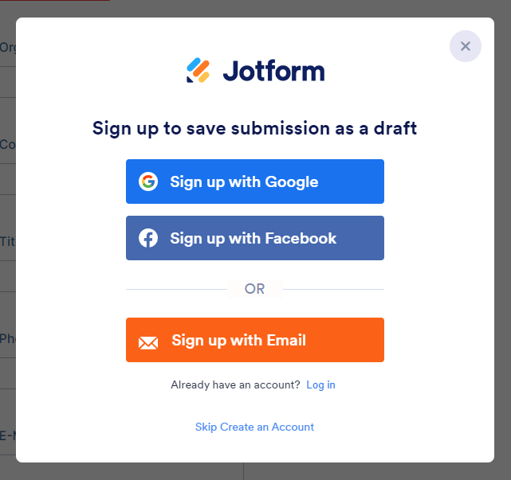

After signing up, click the “Get Draft Link” button and save the link for future reference. You will also receive a link in your email, however we strongly recommend copying and pasting the link as well due to spam filters and email restrictions.
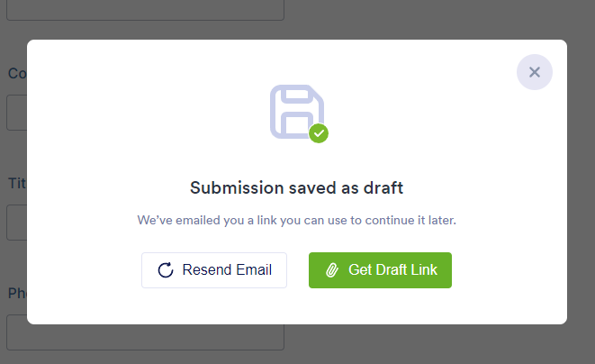
If you have any questions about the grants, please contact Georgia Robinsky at 724-238-5661, x 115 or grobinsky@golaurelhighlands.com
If you have any technical questions regarding the grant application, please contact Jennifer Benford at 724-238-5661, x 107 or jbenford@golaurelhighlands.com

