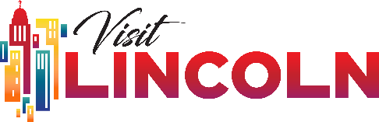
For Immediate Release
September 25, 2012
Contact: Kate Ellingson
(402) 525-0178

Arena Festival Space Event Announced for 2014

Lincoln, NE - The Lincoln Convention and Visitors Bureau is pleased to announce one of the first events that will take place in the Pinnacle Bank Arena Festival Space. In 2014 Ford Mustang will celebrate its 50th Anniversary and one of the ways they’ll celebrate is with a national Mustang car show in Lincoln, August 8-10, 2014.

"The Mustang Club of America is extremely excited to be bringing another National Show to the Midwest and are pleased to have it hosted by the Capitol City Ford & Mustang Club in Lincoln," said Steve Prewitt, President of the Mustang Club of America.

“Lincoln’s successful dedication to competition and non-competition motorsports events, made our decision easy when approaching the Mustang Club of America,” said J.P Weber, local organizer for the 2014 show. “From the day we approached the Convention and Visitors Bureau, as well as Tom Lorenz with SMG, they have done everything that a local club needs to make this an easy decision when deciding to host an event of this magnitude. The Capitol City Ford & Mustang Club and its members are ready to showcase Lincoln and the many dedicated members of our club,” Weber added.

“This show is typical of the type of event that we hope to attract with the new festival space to the northwest of the new Pinnacle Bank Arena,” said Jeff Maul, Executive Director of the Lincoln Convention and Visitors Bureau. “Access to amazing restaurants, foot traffic, proximity to Haymarket Park and the new entertainment district to the south of the Arena made this the ideal location for the Mustang Club of America. We look forward to showcasing the many changes to the Haymarket landscape and invite all of Lincoln to welcome this event to our community,” said Maul.

The show will bring 300 cars from around the country and nearly 1,000 spectators will be expected.
Throughout the three day event there will be food, music, cars and an awards ceremony Sunday afternoon. Visitors will see all years and models of Mustangs from 1964 to current. Mustang Clubs that will be helping include the Mustang Car Club of Omaha, the Platte Valley Mustangs of Columbus and the Rebels Auto Club of Lincoln.

Jeff Maul of the CVB and J.P. Weber will be available for media interviews for this story. J.P. can bring his Mustang, (seen in attached photo), for media interviews.

