2020 VISIT LONGMONT TOURISM GRANT PROGRAM OVERVIEW

The purpose of the Visit Longmont Tourism Grant Program is to assist community organizations and/or businesses by providing grant funding for promotional materials, advertising, and other marketing initiatives to enhance community events that increase visitation expenditures in the City of Longmont.

The Visit Longmont Grant Program serves the fiscal year January 1 to December 31, 2020. SEE BELOW. Grant amount available per project: up to $5,000.

PROJECT GUIDELINES (REVISED)

- Projects must be of a promotional, advertising, or marketing nature, and designed to increase visitation for the event.
- Projects must market to visitors from Ft. Collins, Greeley, Denver and Golden and beyond, requiring overnight stays.
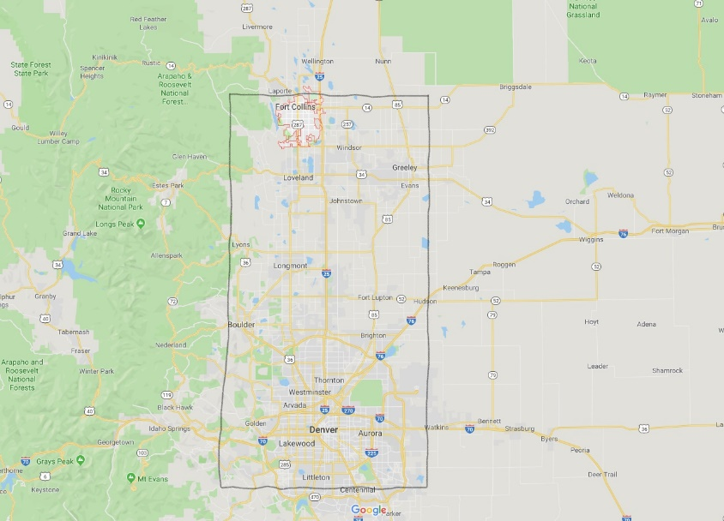

- Funding is not granted to an organization for the following costs:
a. Administrative
b. Equipment
c. Operating

- Projects must be tourism-related and will be granted only on the basis that they increase tourism to Longmont and establish Longmont as a visitor destination.

- Businesses/Organizations may submit applications for more than one project, but each project must have a separate application.

- Businesses/Organizations receiving funds from Visit Longmont must complete a Tourism Grant Evaluation form within 30 days of the completion of their awarded project. Failure to complete and return the evaluation to Visit Longmont before the deadline may disqualify your business/organization from receiving tourism grants in future years. Tourism Grant Evaluation forms will be provided with your approved grant funds.

- Businesses/Organizations receiving funds from Visit Longmont will receive 60% of the awarded grant amount approximately two (2) months prior to the event/activity, and the remaining 40% upon submission of the completed Tourism Grant Evaluation Form. Failure to quantify hotel stays and marketing outside of the established boundaries for the event/activity will result in forfeiture of the remaining 40% of funds.

- Projects must be completed between January 1, 2020 and December 31, 2020.

- All grant applications will be reviewed by the Grants Committee. The committee is comprised of members of Visit Longmont’s staff and Board of Directors.

- Visit Longmont has the final approval in all funds granted.

APPLICATION PROCEDURES & SCHEDULE

Applications will be accepted through January 10, 2020. All applicants will be notified after the Grants Committee has met regarding the approval or denial of their requests.

- Send in a completed Visit Longmont Grant Application by the stated deadline. Hand-written applications will not be accepted. Additional pages may be attached to the application.

- A grant may be awarded for less than the amount requested.

- Approved grants will be paid directly to the grant recipient ONLY. Grants will be paid approximately two (2) months prior to execution of awarded programs. Grantees will receive 60% of the total granted prior to the event or activity and the remaining 40% of the total upon submission and review of the grant evaluation.

- Applications must be received by Visit Longmont on or before 4:00 p.m. Friday,
January 10, 2020. Grants that are not received by the deadline will not be considered.

Mail/Email Applications to:
Visit Longmont
512 4th Avenue, Suite 103
Longmont, CO 80501
Email: nancy@visitlongmont.org

Tourism Grant Application 2020
(Please attach additional pages as needed)

Applicant Information

Applicant (Legal Name of Organization): ___________________________________________

Address (Street or PO Box): ____________________________________________________

City: ____________________________ State: ____________ Zip: ________________

Organization’s Federal Employee Identification Number: __________________________________

Name of Director of Program/Event: __________________________________________________

Date(s) of Program/Event: ______________ Location of Program/Event: _____________________

Telephone: _______________ Fax: _______________

Event Website: ____________________Email Address: __________________________________

Project Information

Title of Program/Event: ________________________________________________________

Total Estimated Attendance: ____________________________________________________

Total Estimated Visitor Attendance (those outside established boundaries): ____________

Total estimated number of overnight guests projected to stay in local hotels: _______________

The totals below should correspond specifically to the grant request.

Print Advertising: $ ________________ Radio Advertising: $ _______________

Television Advertising: $ ____________ Social Media: $ ____________

Other (please define): $ ______________________________________

Total Grant Amount Requested: $ _____________________________
(Maximum amount that can be requested is $5,000)

____________________________________________ _________________________
Signature Date
- Event History/Organization. Please provide a brief history of the program you are seeking funds for, and the business/organization you represent.

- Image/Tourism Impact. Explain how this event will enhance Longmont’s image as a visitor destination. Include any tourism-related activities/promotions you plan to market (e.g. partnerships with other businesses and/or attractions).

- Marketing Plan. Please describe your marketing plan. Include as many specifics as possible regarding types of media, advertising frequency and sizing, cost(s) of marketing, and target markets/demographics. Be sure to include all budgeted marketing (in addition to grant-requested funds) and justify why you chose the markets, demographics, types/placement of media, and what research led you to those choices.

- Marketing Goals. State your top three goals/objectives of your marketing plan and explain how this grant funding will assist your business/organization in meeting these goals/objectives.

- Visitation. Please indicate if this is a new or repeat event/project. Describe why you think it will attract visitors to Longmont and increase visitation to the area.

- Event Data. If this is a repeat event/project, please include the following data collected from the previous year(s). If this is a new event, include the target demographics and markets you plan to invite, and how you plan to track this information at the event.

- City/State of Visitor Origin

- Visitor Demographics (Age, Gender)

- How information was/will be collected

- Overnight Stays. Please describe how you will promote overnight lodging stays to visitors attending your event. Please include any lodging partner(s) you plan to work with along with any promotion and/or package you plan to develop to market the event.

- Visit Longmont Acknowledgement. Please describe how you intend to incorporate destination identifiers such as “Longmont” and “Visit Longmont” in your marketing efforts. Include how your business/organization will acknowledge Visit Longmont as a sponsor.

