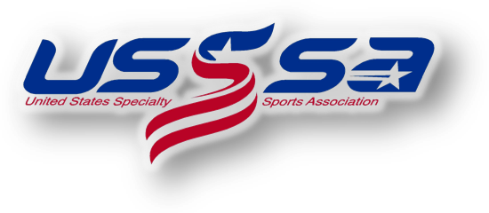

WS Checklist for Managers/Team Administrators

Required:
- Seek approval for entry as a verified “C” level team with your State Director and Tournament Director, Glen Warholic (glen.warholic@usssa.com).
- Register for the 2019 Eastern “C” National Championship event online HERE and submit entry fee upon registering. The deadline to register is June 27th.
- Maintain eligibility as a “C” level team up to and through the Eastern National Championships.
- Book hotel accommodations. Go to Visit Loudoun and follow links to the Official Event Housing Website. Lowest group rates have been negotiated on your behalf. This is a stay to play event.
- Submit Team Gate Fee form and payment. It is available at the Visit Loudoun Website. The deadline to submit the gate fee is June 27th.
- Enter team roster online at www.usssa.com, print official USSSA roster and obtain all player and parent signatures. Bring a copy of signed roster to Manager’s Check-In to turn in to USSSA staff.
- Obtain proof of insurance certificate and bring a copy of certificate to Manager’s Check-In to turn in to USSSA staff.
Optional:
- Submit team player list and photo (unofficial) to be included in the free tournament program book. Information on this is available at the Visit Loudoun website. The deadline is June 27th.
- Submit Good Luck Ad form and payment. Information on this is available at the Visit Loudoun website. Due by June 1st.
- Submit tournament t-shirt pre-order form. Teams registered online by June 1st will be emailed the t-shirt pre-order form.
- Prepare gifts for team gift exchange. More information is available at the Visit Loudoun website.
2019 USSSA Eastern “C” National Championships
Loudoun County, Virginia

