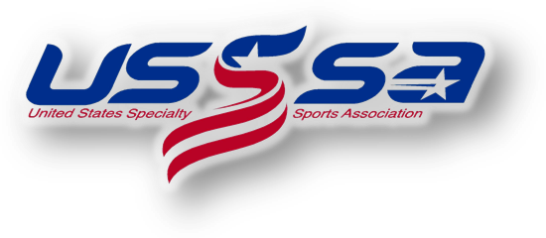
2022 USSSA Eastern “C” National Championships
Loudoun County, Virginia
WS Checklist for Managers/Team Administrators

Required:
- Seek approval for entry as a verified “C” level team with your State Director and Tournament Director, Glen Warholic (glen.warholic@usssa.com).
- Register for the 2022 Eastern “C” National Championship event online HERE and submit entry fee upon registering. The deadline to register is July 1st.
- Maintain eligibility as a “C” level team up to and through the Eastern National Championships.
- Book hotel accommodations. Go to Visit Loudoun and follow links to the Official Event Housing Website. Lowest group rates have been negotiated on your behalf. This is a stay to play event.
- Submit Team Gate Fee payment online. The deadline to submit the gate fee is July 1st.
- Enter team roster online at www.usssa.com, print official USSSA roster and obtain all player and parent signatures. Bring a copy of signed roster to the Manager’s Check-In
- Obtain proof of insurance certificate and bring a copy of certificate to Manager’s Check-In.
Optional:
- Submit tournament t-shirt pre-order form. Teams registered online by June 10th will be emailed the t-shirt pre-order form.
- Prepare gifts for team gift exchange. More information is available at the Visit Loudoun website.

