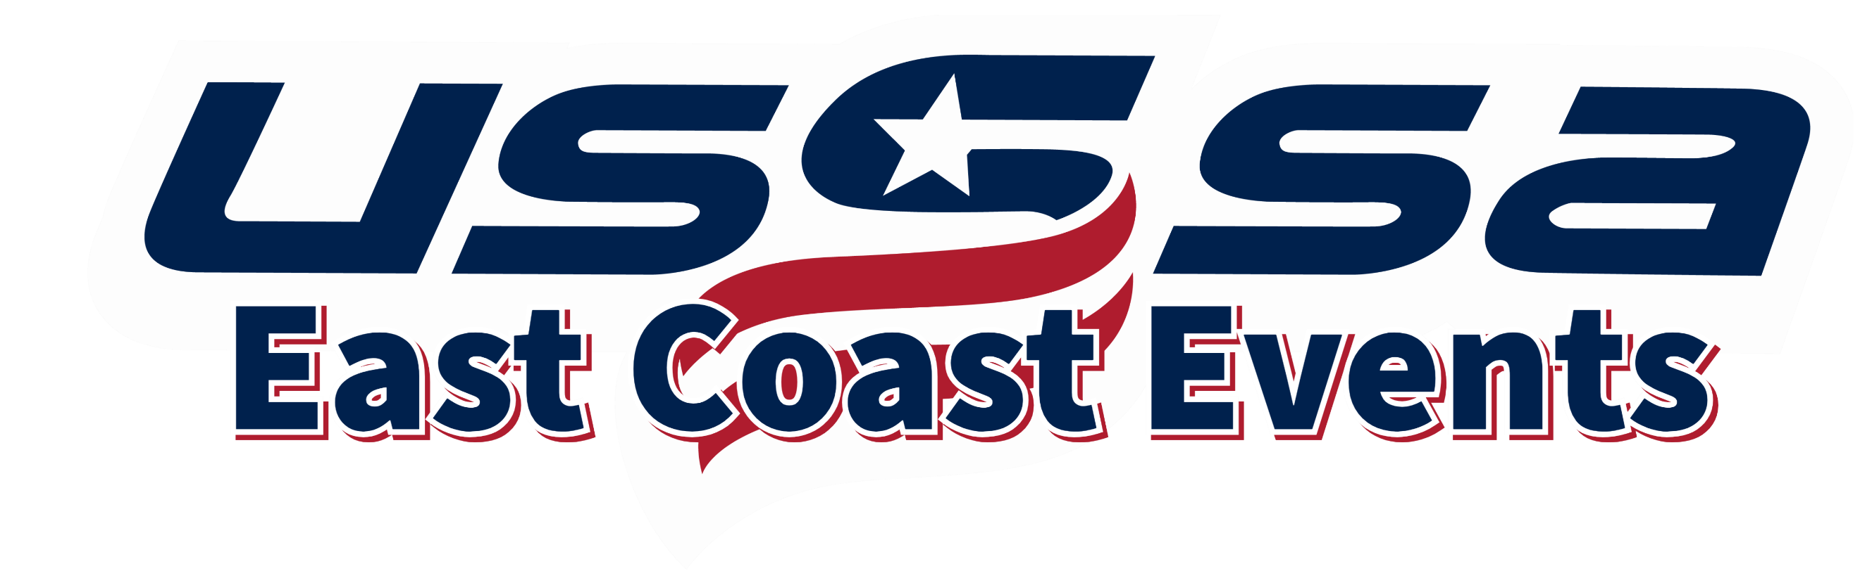
2024 USSSA Eastern “C” National Championships
Loudoun County, Virginia
WS Checklist for Managers/Team Administrators

Required:
- Seek approval for entry as a verified “C” level team with your State Director and the Tournament Director, Glen Warholic (eastcoast.events@usssa.com).

- Register for the 2024 Eastern “C” National Championship event online HERE and submit the entry fee upon registering. The deadline to register is June 24, 2024.

- Maintain eligibility as a “C” level team up to and through the Eastern National Championships.

- Book hotel accommodations. Go to Visit Loudoun and follow links to the Official Event Housing Website. The lowest group rates have been negotiated on your behalf. This is a stay-to-play event.

- Enter the team roster online at www.usssa.com, print the official USA roster, and obtain all player and parent signatures. Bring a copy of the signed roster to the Manager’s Check-In

- Obtain proof of insurance certificate and bring a copy of the certificate to the Manager’s Check-In.
Optional:
- Sign up for the Eastern Nationals Newsletter to be informed about this event!
- Submit the tournament t-shirt pre-order form. Teams registered online by June 10th will be emailed the t-shirt pre-order form.
- Prepare gifts for team gift exchange. More information is available at the Visit Loudoun website.

