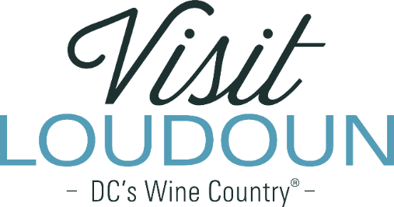

**Request For Proposal**

**Visit Loudoun Annual Award Design and Fabrication**

**Background:** Visit Loudoun is the only organization solely dedicated to maximizing brand awareness and driving visitor demand for Loudoun County, Va., located 25 miles from Washington, DC. This **not-for-profit organization** develops and implements programs that promote tourism and travel to Loudoun and its towns, to increase visitation and generate visitor spending.

One of Visit Loudoun’s five pillars of its strategic plan is to support music and the arts in Loudoun. While there are strategies outlined in the Strategic Plan, here are three key areas of focus:

1. Facilitate and support Loudoun County as a destination for music and the arts.
2. Integrate music and arts into the greater tourism assets and existing events.
3. Foster and support the local arts scene.

**Request for Proposal:** Visit Loudoun celebrates the accomplishments of the tourism and hospitality industry each year at its Annual Meeting and for the past three years, has commissioned local artists to create the awards given during the luncheon. This year, the Annual Meeting and Awards Luncheon will be held on Friday, April 25, 2025.

Visit Loudoun is seeking proposals from Loudoun County artists for ten identical awards plus one “Grand” award. Each award must include the Visit Loudoun logo as well as the ability to mount individual plaques with the award category and the winner’s name. The pineapple, a symbol of hospitality, should be incorporated, either in the overall design or as a component of the design.

The budget for the awards is not to exceed $2,500.

**Proposal Requirements:** Interested parties should submit their proposals to Visit Loudoun by Friday, February 10, 2025. Proposals can be submitted electronically via email to [Erickson@VisitLoudoun.org](mailto:Erickson@VisitLoudoun.org) or dropped off at the Visit Loudoun offices: 112-South Street, Suite 200, Leesburg, VA 20175.

Please include the following:

* Name and background of the artist, including physical address and website
* Sample design and/or concept.
* Fee structure inclusive of all related expenses
* Submissions may be supplemented with samples that are similar or relevant to this project.

**Selection Criteria**

Proposals received in response to this RFP will be objectively reviewed by Visit Loudoun staff and selection will be based on the following criteria:

* Concept and design
* The artist’s demonstrated ability to deliver the awards by April 4, 2025
* The artist’s ability to stay within the budget allotment.

All questions regarding this RFP may be addressed to Beth Erickson at 703-771-4964 or Erickson@VisitLoudoun.org.