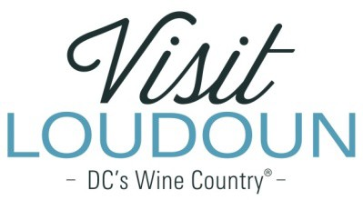

2021 Visit Loudoun Tourism Awards Entry Form
Loudoun Certified Tourism Ambassador (CTA) of the Year
Criteria: This category recognizes that our tourism industry employees and volunteers elevate Loudoun as a tourism destination. This person is someone who has completed the Loudoun CTA certification and is in current standing as a CTA. This person possesses an in-depth knowledge of Loudoun and its attractions, exemplifies excellence in hospitality and customer service and promotes the CTA ideal of ensuring that every visitor has a positive and memorable experience.

Nominee

Name:

Organization:

Title:

- How did this nominee help create a positive experience for a visitor in Loudoun?

- How did this nominee go beyond customer service expectations?

- How did this person share their knowledge of Loudoun to ensure a memorable experience?

- Please share any letters, comments or reviews (Facebook, Yelp, Tripadvisor, etc.) highlighting how this person contributed to a visitor’s experience.

Each nominee will be a guest of Visit Loudoun at the Annual Meeting & Tourism Awards program, which takes place during National Travel and Tourism Week on May 5, 2022, from 11:30 a.m.-2 p.m. (One guest per nomination.)

Please provide the following contact information for the nominee representative so that we may contact them regarding the nomination and request their RSVP at the awards luncheon. Please provide a high-resolution portrait image of the nominee for inclusion in the awards program presentation:

Nominee/Nominee Representative Contact Information

  - This address is the nominee’s business address
  - This address is the nominee’s home address.

Name:

Title:

Organization:

Mailing Address:

City:
State:
Zip:

Phone: Email:

Nominator/Submitter

Nominator Name:

Relationship to nominee:

Title:

Organization:

Address:

City:
State:
Zip:

Phone: Email:

Signature:

All nominations must be received by 4 p.m. on Friday, March 11, 2022.

Please save your nomination form using the format below “award name”_”nominee name”
Go to https://www.visitloudoun.org/tourism-industry/industry-events/annual-meeting-tourism-awards/tourism-award-categories-nomination-forms/ and scroll to the bottom of the page for submission information

