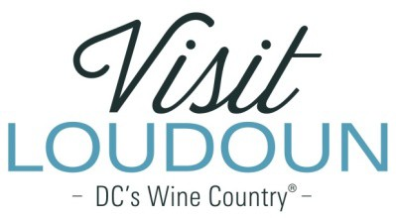

2022 Visit Loudoun Tourism Awards Entry Form
Diversity in Travel Tourism Award
Criteria: This category is open to businesses, attractions and individuals who can demonstrate actions taken to enhance engagement with diverse travelers, creating welcoming experiences for all.

Nominee:

Name:

Organization:

Title:

- What opportunities or challenges are you addressing?

- What is the lasting benefit of your actions? Was there a positive economic impact and/or improvement to the community?

- Was there an improvement to the culture of your business or an improvement in the quality of life for Loudoun’s residents?

Each nominee will be a guest of Visit Loudoun at the Annual Meeting & Tourism Awards program, which takes place on April 28, 2023, from 11:00 a.m.- 2 p.m. (One guest per nomination.)

Please provide the following contact information for the nominee representative so that we may contact them regarding the nomination and request their RSVP at the awards luncheon. Please provide a high-resolution portrait image of the nominee for inclusion in the awards program presentation:

Nominee/Nominee Representative Contact Information

  - This address is the nominee’s business address
  - This address is the nominee’s home address.

Name:

Title:

Organization:

Mailing Address:

City:
State:
Zip:

Phone: Email:

Nominator Name:

Relationship to nominee:

Title:

Organization:

Address:

City:
State:
Zip:

Phone: Email:

Signature:

All nominations must be received by 4 p.m. on Friday, March 10, 2023.

Please save your nomination form using the format below “award name”_”nominee name”
Go to https://www.visitloudoun.org/tourism-industry/industry-events/annual-meeting-tourism-awards/tourism-award-categories-nomination-forms/ and scroll to the bottom of the page for submission information

