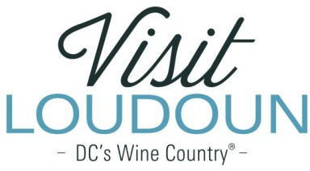
2021 Visit Loudoun Tourism Awards Entry Form Event of the Year
Criteria: This category recognizes a first-time or recurring event that had significant community support and partnership, which attracted visitors to Loudoun County and/or its incorporated towns, can demonstrate visitor spending and/or overnight rooms and was effectively promoted to out-of-county visitors.

Nominee:

Event:

Event Date:

Event Year | Attendance | Hotel Rooms Generated | Estimated Visitor Spending
2019
2020
2021

Event Organizer(s):

Community Partners (if any):

- Event description:

- Describe the level of community support through volunteers, corporate sponsorships and civic group participation.

- What is the lasting benefit the event had on the community such as positive economic impact, and improvement to the community, or an improvement in the quality of life for Loudoun residents?

- Describe the positive value of the event to the customer in terms of the event as a whole, entertainment, length of time to experience the event, desire to attend multiple days (if applicable) and cost per ticket.

- Explain why this event should be selected as the Event of the Year in terms of the award criteria.

- How and where was the event promoted to out-of-county visitors in terms of creativity, effectiveness and results? (Attach copies of promotional materials, newspaper articles, photographs, etc.)

  - No Attachments
  - Attachments Saved as Part of Nomination

Each nominee will be a guest of Visit Loudoun at the Annual Meeting & Tourism Awards program, which will take place during National Travel and Tourism Week on May 5, 2022, from 11:30 a.m.- 2 p.m. (One guest per nomination.)

Please provide the following contact information for the nominee representative so that we may contact them regarding the nomination and request their RSVP at the awards luncheon. Please provide a high-resolution portrait image or event logo to represent the nomination for inclusion in the awards program presentation:

Nominee/Nominee Representative Contact Information

- This address is the nominee’s business address
- This address is the nominee’s home address.

Name:

Title:

Organization:

Mailing Address:

City:
State:
Zip:
Phone: Email:

Nominator/Submitter

Nominator Name:

Relationship to nominee:

Title:

Organization:

Address:

City:
State:
Zip:

Phone: Email:

Signature:

All nominations must be received by 4 p.m. on Friday, March 11, 2022.

Please save your nomination form using the format below “award name”_”nominee name”
Go to https://www.visitloudoun.org/tourism-industry/industry-events/annual-meeting-tourism-awards/tourism-award-categories-nomination-forms/
and scroll to the bottom of the page for submission information

