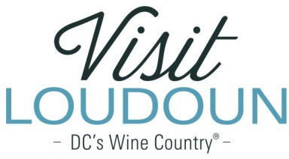
2022 Visit Loudoun Tourism Awards Entry Form Event of the Year
Criteria: This category recognizes a first-time or recurring event that had significant community support and partnership. The event should have attracted visitors to Loudoun County and/or its incorporated towns, demonstrated visitor spending and/or overnight rooms and as well as effectively promoted to out-of-county visitors.

Nominee:

Event:

Event Date:

Event Year | Attendance | Hotel Rooms Generated | Estimated Visitor Spending
2020
2021
2022

Event Organizer(s):

Community Partners (if any):

- Event description, including community support through volunteers, corporate sponsorships and/or civic group participation.

- What is the lasting benefit to the community? Examples could include room night generation, economic impact, positive impact for the community or an improvement in the quality of life for Loudoun residents.

- Provide a brief overview of how you marketed the event, including both in Loudoun and outside of Loudoun as well as the results of your efforts. (Attach copies of promotional materials, newspaper articles, photographs, etc.)

  - No Attachments
  - Attachments Saved as Part of Nomination

Each nominee will be a guest of Visit Loudoun at the Annual Meeting & Tourism Awards program, which takes place on April 28, 2023, from 11:00 a.m.- 2 p.m. (One guest per nomination.)

Please provide the following contact information for the nominee representative so that we may contact them regarding the nomination and request their RSVP at the awards luncheon. Please provide a high-resolution portrait image or event logo to represent the nomination for inclusion in the awards program presentation:

Nominee/Nominee Representative Contact Information

- This address is the nominee’s business address
- This address is the nominee’s home address.

Name:

Title:

Organization:

Mailing Address:

City:
State:
Zip:
Phone: Email:

Nominator/Submitter

Nominator Name:

Relationship to nominee:

Title:

Organization:

Address:

City:
State:
Zip:

Phone: Email:

Signature:

All nominations must be received by 4 p.m. on Friday, March 10, 2023.

Please save your nomination form using the format below “award name”_”nominee name”
Go to https://www.visitloudoun.org/tourism-industry/industry-events/annual-meeting-tourism-awards/tourism-award-categories-nomination-forms/
and scroll to the bottom of the page for submission information

