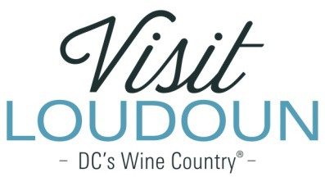

2022 Visit Loudoun Tourism Award Entry Form
“Front-of-House Hero” Tourism Employee of the Year
Criteria: This award recognizes those professionals performing above and beyond in the spirit to serve and provide outstanding hospitality while promoting Loudoun County. This person is someone who has been recognized in online customer reviews for providing superior customer service. If the nominee is a personnel manager in the “Front-of-the-House” they should be nominated under the category of Tourism Manager of the Year.

Nominee:

Name:

Title:

How many years has the employee been with the current business?

Organization:

Supervisor:

- What is the role of the nominee with the organization?

- What makes the nominee a “Front-of-House Hero”? (Going beyond performance expectations, etc.)

- Letters, comments or reviews from customers complimenting the employee and service provided.
- No Attachments
- Attachments Saved as Part of Nomination

Each nominee will be a guest of Visit Loudoun at the Annual Meeting & Tourism Awards program, which takes place on April 28, 2023, from 11:00 a.m.- 2 p.m. (One guest per nomination.)

Please provide the following contact information for the nominee representative so that we may contact them regarding the nomination and request their RSVP at the awards luncheon. Please provide a high-resolution portrait image of the nominee for inclusion in the awards program presentation:

Nominee/Nominee Representative Contact Information

- This address is the nominee’s business address
- This address is the nominee’s home address.

Name:

Title:

Organization:

Mailing Address:

City: State: Zip:

Phone: Email:

Nominator Name:

Relationship to nominee:

Title:

Organization:

Address:

City:
State:
Zip:
Phone: Email:

Signature: ___________________________________________________________

All nominations must be received by 4 p.m. on Friday, March 10, 2023.

Please save your nomination form using the format below “award name”_”nominee name”
Go to https://www.visitloudoun.org/tourism-industry/industry-events/annual-meeting-tourism-awards/tourism-award-categories-nomination-forms/ and scroll to the bottom of the page for submission information

