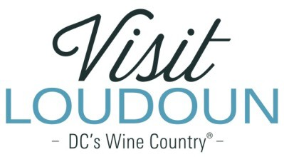

2019 Visit Loudoun Tourism Awards Entry Form #LoveLoudoun Ambassador of the Year
Criteria: Someone who has been recognized in online customer reviews for providing superior customer service, ensuring visitors and residents alike “Love Loudoun.”

Nominee

Name:

Title:

How long have they been working in the current position?

How many years has the employee been with the current business?

Organization:

Supervisor:

- Tell us about the nominee and then share what your customers have posted. Please include comments or reviews (Facebook, Yelp, Tripadvisor, etc.) You can upload posts and/or reviews separately and attach them to your nomination.

Each nominee will be a guest of Visit Loudoun at the Annual Meeting & Tourism Awards program to be held during National Tourism Week in May 2020 from 11:30am-2pm (One guest per nomination.)

Please provide the following information for the nominee representative so that we may contact them regarding the nomination, arrange to receive an appropriate image to represent the event during the awards presentation, send them an invitation to the Visit Loudoun Annual Meeting and Tourism Awards Program, and request their RSVP:

Nominee/Nominee Representative Contact Information

  - This address is the nominee’s business address
  - This address is the nominee’s home address.

Name:

Title:

Organization:

Mailing Address:

City:
State:
Zip:

Phone: Email:

Nominator/Submitter

Nominator Name:

Relationship to nominee:

Title:

Organization:

Address:

City:
State:
Zip:

Phone: Email:

Signature:

All nominations must be received by 4pm on Friday, March 13, 2020.

Please save your nomination form using the format below “award name”_”nominee name”
Go to https://www.visitloudoun.org/tourism-industry/industry-events/annual-meeting-tourism-awards/tourism-award-categories-nomination-forms/ and scroll to the bottom of the page for submission information

