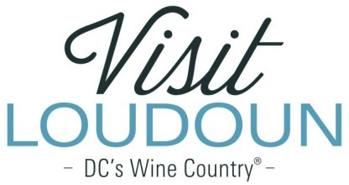

2019 Visit Loudoun Tourism Awards Entry Form Manager of the Year Award
Criteria: A dynamic and effective leader that inspires their team to provide exceptional service and, in doing so, gives back to the industry as a whole.
.

Nominee

Name:

Title:

How long have they been working in their current position?

How long have they been employed by their current business?

Organization:

Number of direct reports:

Supervisor:

- How does this leader inspire their team?

- What makes this leader effective in promoting tourism?

- Please include letters, comments or reviews (Facebook, Yelp, TripAdvisor, etc.)

  - No Attachments
  - Attachments Saved as Part of Nomination

Each nominee will be a guest of Visit Loudoun at the Annual Meeting & Tourism Awards program to be held during National Tourism Week in May 2020 from 11:30am-2pm (One guest per nomination.)

Please provide the following information for the nominee representative so that we may contact them regarding the nomination, arrange to receive an appropriate image to represent the event during the awards presentation, send them an invitation to the Visit Loudoun Annual Meeting and Tourism Awards Program, and request their RSVP:

Nominee/Nominee Representative Contact Information

- This address is the nominee’s business address
- This address is the nominee’s home address.

Name:

Title:

Organization:

Mailing Address:

City:
State:
Zip:

Phone: Email:

Nominator/Submitter

Nominator Name:

Relationship to nominee:

Title:

Organization:

Address:

City:
State:
Zip:

Phone: Email:

Signature:

All nominations must be received by 4pm on Friday, March 13, 2020.

Please save your nomination form using the format below “award name”_”nominee name”
Go to https://www.visitloudoun.org/tourism-industry/industry-events/annual-meeting-tourism-awards/tourism-award-categories-nomination-forms/ and scroll to the bottom of the page for submission information

