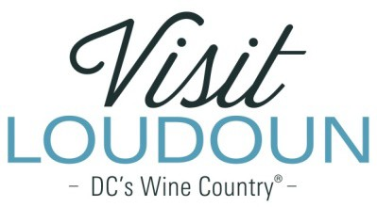

2021 Visit Loudoun Tourism Awards Entry Form
New Tourism Business of the Year
Criteria: This award recognizes excellence in the planning and development of a NEW tourism business and/or service that opened in calendar year 2021. Businesses in this category attracted visitors to Loudoun County, can demonstrate visitor spending and effective promotion of the business.

Business Name:

Address:

- Describe the rationale for opening the business and the process of development.

- Provide an overview of your business/service as it relates to the tourism product of the county.

- Provide an overview of the positive economic impact and improvement to the community.

- Describe the marketing strategies used to differentiate your tourism business. Why were these strategies chosen and what was the result?

- Describe or include materials/collateral announcing the opening or digital campaigns/ads and posts promoting the business.

Each nominee will be a guest of Visit Loudoun at the Annual Meeting & Tourism Awards program, which takes place during National Travel and Tourism Week on May 5, 2022, from 11:30 a.m.-2 p.m. (One guest per nomination.)

Please provide the following contact information for the nominee representative so that we may contact them regarding the nomination and request their RSVP at the awards luncheon. Please provide a high-resolution portrait image or logo to represent the nomination for inclusion in the awards program presentation:

Nominee/Nominee Representative Contact Information

  - This address is the nominee’s business address
  - This address is the nominee’s home address.

Name:

Title:

Organization:

Mailing Address:

City:
State:
Zip:

Phone: Email:

Nominator Name:

Relationship to nominee:

Title:

Organization:

Address:

City:
State:
Zip:

Phone: Email:

Signature:

All nominations must be received by 4 p.m. on Friday, March 11, 2022.

Please save your nomination form using the format below “award name”_”nominee name”
Go to https://www.visitloudoun.org/tourism-industry/industry-events/annual-meeting-tourism-awards/tourism-award-categories-nomination-forms/ and scroll to the bottom of the page for submission information

